Wear of PM HIP metal matrix composites – influence of carbide type
Tomas Berglund^{1, a}*, Josefine Hall^{2, b}
¹ Sandvik Powder Solutions, Sweden
² Materials Science, Dalarna University, Sweden

Keywords: HIP, wear, tribology, Metal Matrix Composites, MMC, wear resistant
Abstract. The type of hard phase in combination with matrix material has a great influence on the wear properties of PM HIP Metal Matrix Composites. The hardness and toughness of the hard phase as well as its reaction with the matrix in combination with wear mechanism can cause significant differences in performance of the material. Three materials with the same matrix alloy but different carbide types have been studied with regards to tribological behavior in low stress and high stress abrasion as well as scratch testing against a quartz stylus.
In low stress abrasion testing the material has only very small differences in the performance between the materials. The materials containing crushed or spherical fused tungsten carbide had a higher initial wear that can be explained by the microstructure of the material. In the later stages of wear the three materials preform very similar. In the scratch testing a clear difference can be observed between the materials. The material containing the fused tungsten carbide exhibits a higher degree of carbide damage at the exit side of the wear scar sliding over the carbide. This can be attributed to the much higher degree of carbide dissolution in the fused carbide compared to the MC carbide. The results from tribology testing are discussed and compared to wear mechanisms observed in parts that have been in service in a slurry pump and a crusher.

Introduction
Wear-resistant materials are important in several industrial processes including manufacturing, energy production, construction and mining tools or in nuclear, aerospace and gas turbine industry [1-6]. Wear resistant metal matrix composites are composed of hard particles like carbides, borides and nitrides embedded in a ductile metal matrix of for example Co, Ni and/or Fe [2-5]. These two components serve different purposes. The hard particles need to impede wear by grooving or indenting hard particles while the metallic matrix should provide toughness. The properties of the composite material depend on both the chemistry of each component as well as the size and amount of the hard particles.
Wear resistant composites with tungsten carbide hard phase is commonly used as an overlay material in e.g. the mining industry. The overlay process used to apply these materials on to a part e.g. Plasma Transfer Arc Welding have limitations with regards to e.g. chemistry, hard phase size, overlay thickness. The use of Hot Isostatic pressing provides an attractive alternative to these processes as it offers more freedom in the composition of the material and the wear resistant material can be applied to surfaces at an unlimited thickness.
The type and shape of tungsten carbide will affect the properties of the material. The fused tungsten carbides consisting of an approximate 80/20% mix of the W₂C and WC phase respectively has a higher hardness than MC WC. However, the benefit of the MC carbide is that it resists dissolution during consolidation much better than the fused carbide, in which the W₂C phase is more prone to dissolution [XX]. This can affect the wear resistance of the material [XX]. Furthermore. the different types of tungsten carbide have different mechanical properties that affect the tribological behavior of the materials.
The effect of carbide type and morphology on the wear resistance of HIPed metal matrix composites were investigated using high and low stress abrasion testing as well as scratch testing. The resulting wear scars were investigated using SEM/EDS. The wear mechanisms found are discussed with respect to the microstructure and material properties.

Experimental
Materials. The materials were produced at Sandvik Powder Solutions in Sweden using Hot Isostatic Pressing (HIP). The matrix and tungsten carbide powders were weighed and mixed to achieve a 50 vol.% carbide content in the material. The powders were mixed in V-blender for 3 hours. A Ni-base alloy was used as matrix for all materials. The mixed powder were filled in to a capsule (180x70x50 mm) which was then evacuated and HIP:ed at 100 MPa and 1150˚C with 2 hour dwell time. Three materials; with crushed fused tungsten carbide (80/20 mix of W₂C and WC) (F50), spherical fused tungsten carbide (FSP50) and MC WC (MC) (F50MC) respectively. The carbide particle size range was the same for all the materials although the particle size distribution in the range vary slightly. From the HIPed specimens samples were cut using Electric Discharge Machining.
Samples used in scratch testing sample were polished to 1 µm using diamond emulsion in the final step and were cleaned in acetone, water and ethanol before scratch testing. For abrasion testing the specimens were ground to remove white layer from EDM and to produce a controlled surface before testing. Resulting surface finish was approximately Ra 3,2µm
Abrasion testing. Low stress abrasion testing was performed a using modified version of procedure ASTM G65 A. When testing highly abrasion resistant materials it has been found that normally used two passes (see table 1 for test parameters per pass) is not enough to characterize the wear resistance of the material. This because after two passes the material removed in testing is only matrix material between the hard phase particles. Instead the testing has been made in 6 passes with weight loss measurement after each pass. The measured average weight loss (0,001 g precision) for three tests was then used to calculate volume loss.
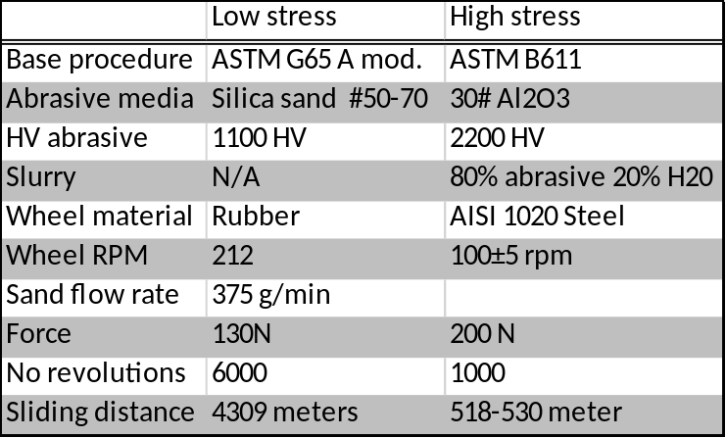
High stress abrasion was carried out with the testing parameters seen in table 1. Average weight (0,01g precision) loss of three tests was used. The basics of the test is described in standard ASTM B611 where it is also mentioned that it is the preferred test method for testing of cemented carbides.
Table 1. Test parameters for low and high stress abrasion testing.
Hardness testing. Hardness testing was performed using a CSM Micro Combi Tester for micro hardness measurement and an Leco RT-240 for macro hardness. For micro hardness measurement load was 200 g for carbide hardness and 25 g for matrix hardness. For macro hardness a HRC was used for testing and then converted to HV for presentation. The average was calculated from five tests. Test that caused significant cracking of the carbide or that made contact with underling carbides was excluded Imprints on carbides was made so that the carbide size was at least ten times bigger that imprint diagonal.
Scratch testing. A conventional scratch tester CSM Revetest® was used for scratching the sample surfaces. Three styluses used was a pyramidal quartz (SiO₂) stylus. In the quartz scratch test the scratch length was 5 mm at the speed 10 mm/ min at the load 50 N.
Results
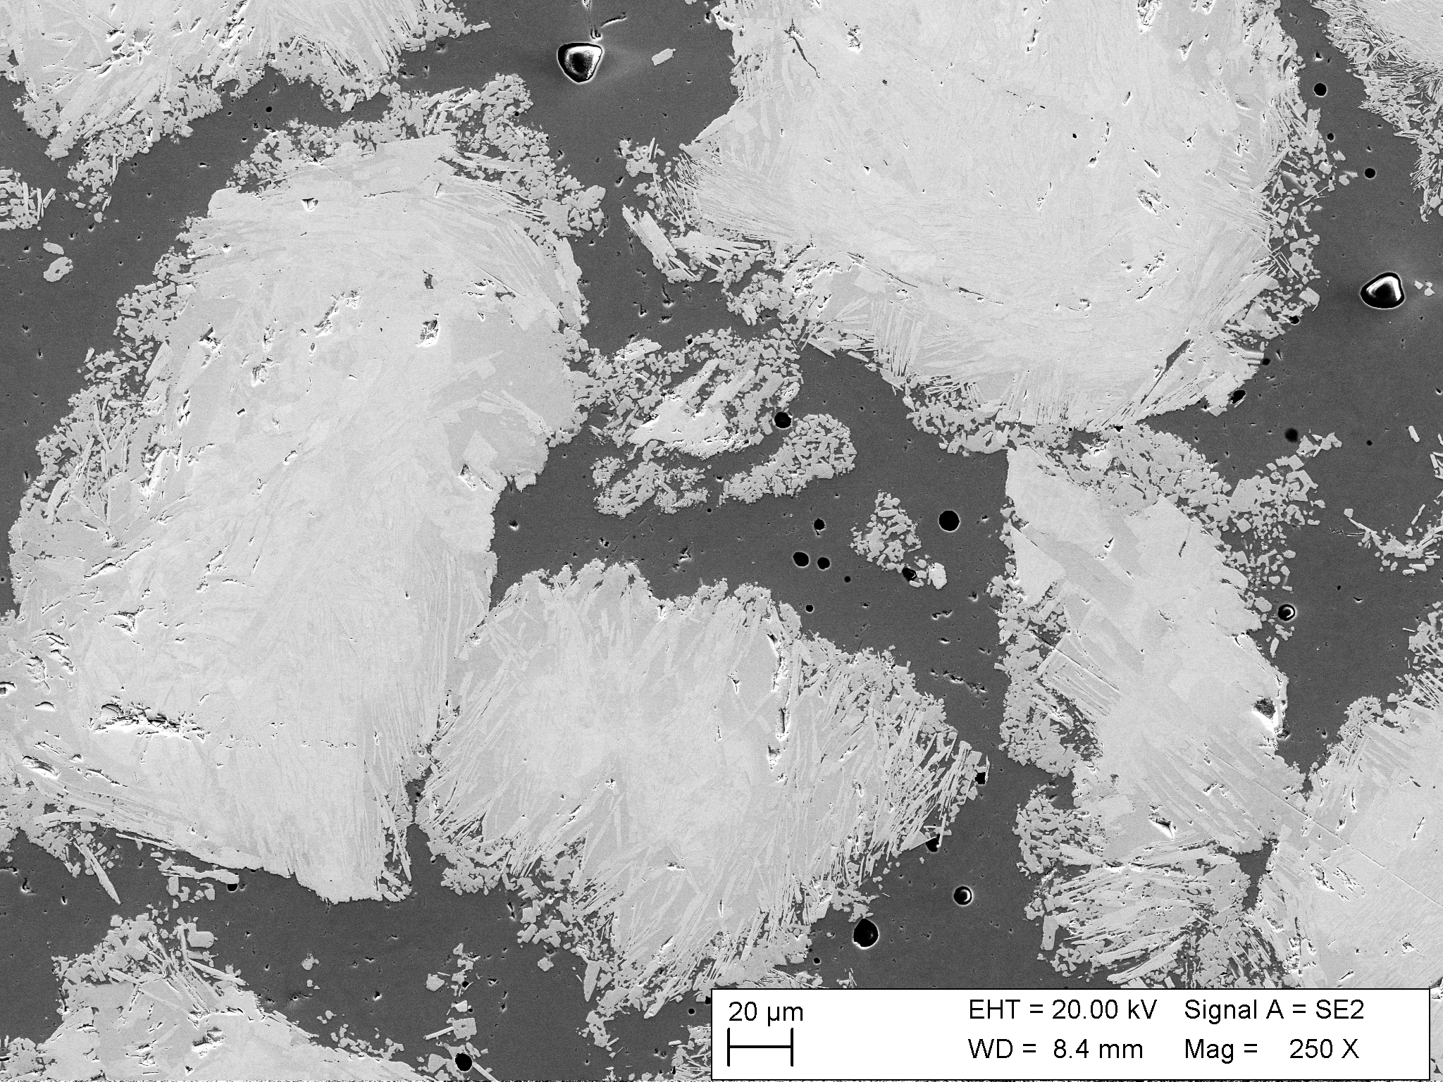
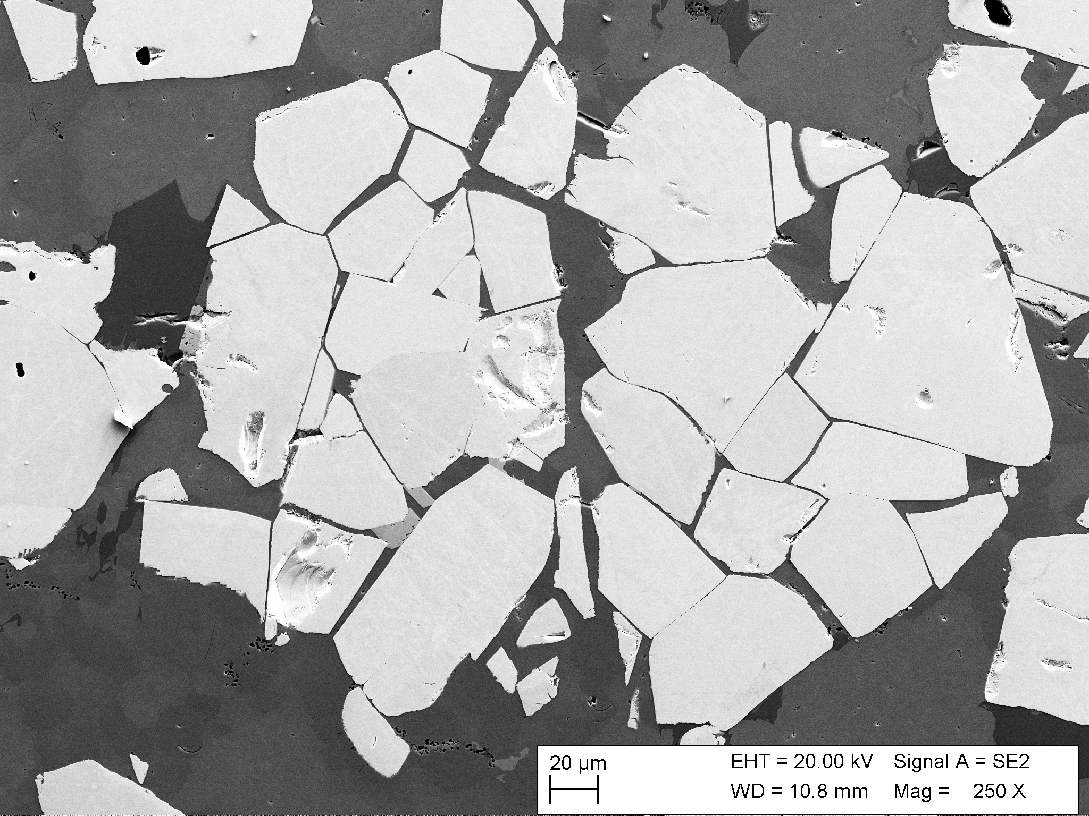
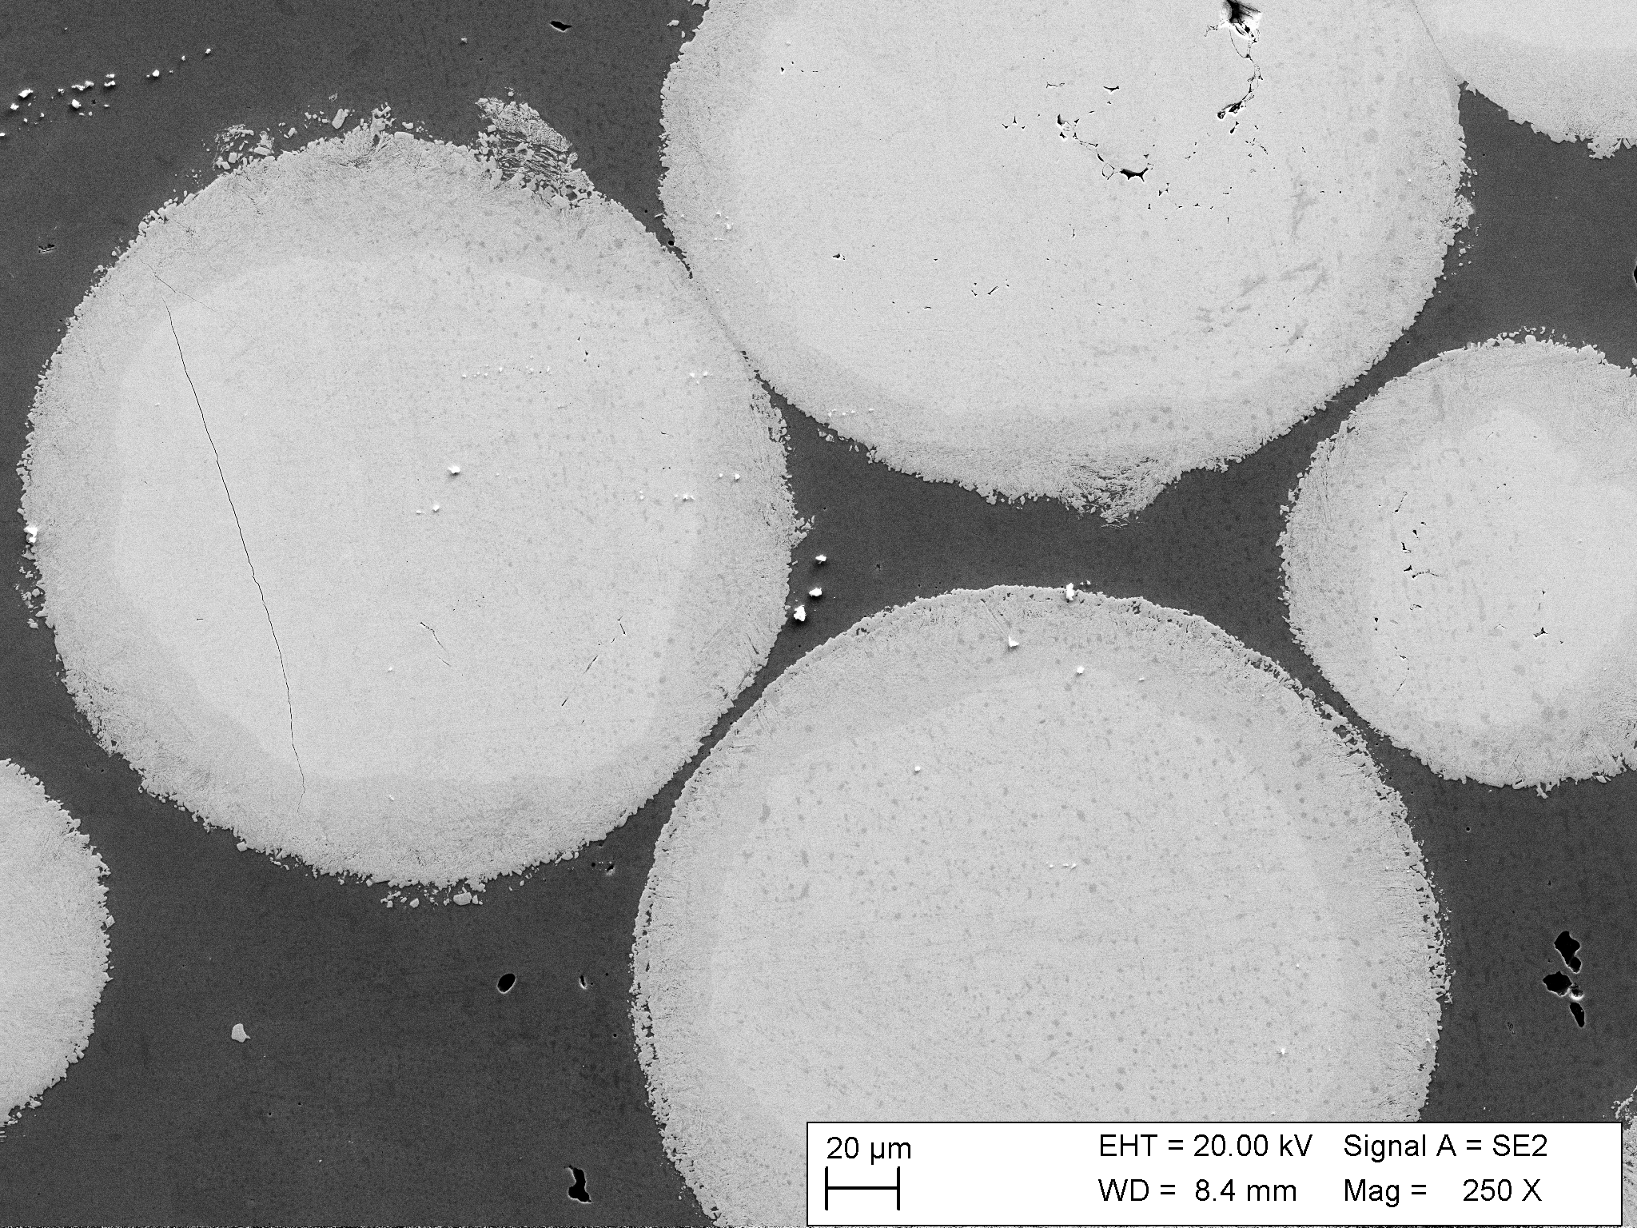
Microstructural characteristics. The microstructure of the materials is shown in Fig. 1. The F50MC material exhibits a very low amount carbide dissolution of the MC WC as well as a high degree of fracturing in these carbides. No/very small signs of dissolution could be found. It is also evident that the angular eutectic carbide has a slightly higher degree of dissolution compared to the spherical. This is due to the slightly higher amount of W₂C phase in the angular carbide, which is more prone to dissolution compared to the WC phase and partially dissolves in to the matrix during consolidation. Left behind are needle shaped WC-phase extending out in to the matrix as well as smaller particles in the matrix between the primary carbides. This dissolution increases the mean free path between the larger primary carbide particles that contribute mostly to the wear resistance of the material and this can have a negative effect on the wear resistance of the material. The dissolution of the spherical carbide is much lower and a three-layer structure has formed in the carbide. A 2µm layer of what is believed to be MC carbide, a 10-15µm transition zone 2-phase WC/W2C structure but that has coarsened slightly and in the center the original structure of the spherical carbide.
b)
a)
c)
Figure 1. Microstructure of F50 (a), MC50 (b) and FSP50 (c).
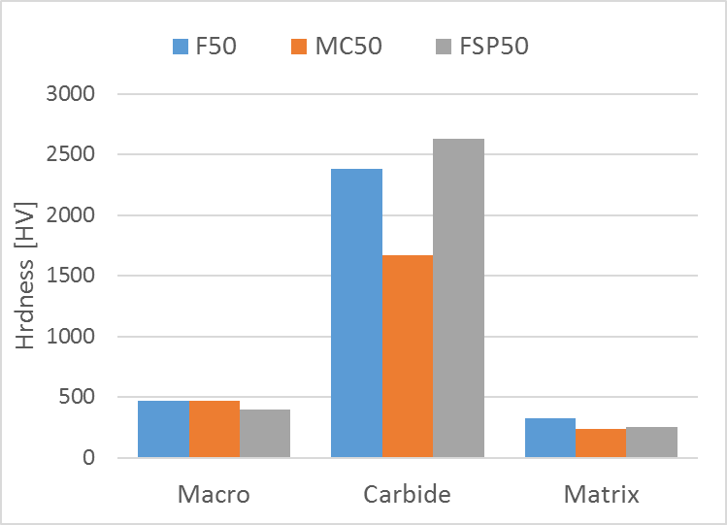
Mechanical characteristics. The macro hardness as well as micro hardness of the matrix and carbides can be seen in figure 2. As can be seen the spherical eutectic carbides are the hardest followed by the fused crushed carbides and the macro crystalline carbide. The values correspond well to what can be found in literature [DJ]. A higher amount of carbide dissolution should increase the hardness of the matrix by solid solution strengthening by C and W but also precipitating small carbides in the matrix.
Figure 2. Macro hardness of material and micro hardness of carbides and matrix.
Tribological characteristics. Figure 3 show the volume loss per pass and cumulative volume loss in low stress abrasion testing. It is evident that the F50MC material has a slightly lower initial wear compared to F50 and FSP50. This can be attributed to the lower degree of carbide dissolution in this material (see figure XX). Higher degree of carbide dissolution as in F50 increases the mean free path between the primary carbides causing abrading sand particles to easier remove the softer matrix material along with the small blocky carbides between the primary carbides easier. The higher degree of carbide fracturing during HIP in F50MC further lowers the mean free path between the primary carbides, but also reduce their effective size. The FSP50 material with spherical particles performed the worst. Most likely as a consequence of the spherical shape of the carbide particles combined with a size distribution towards the larger end increasing mean free path.
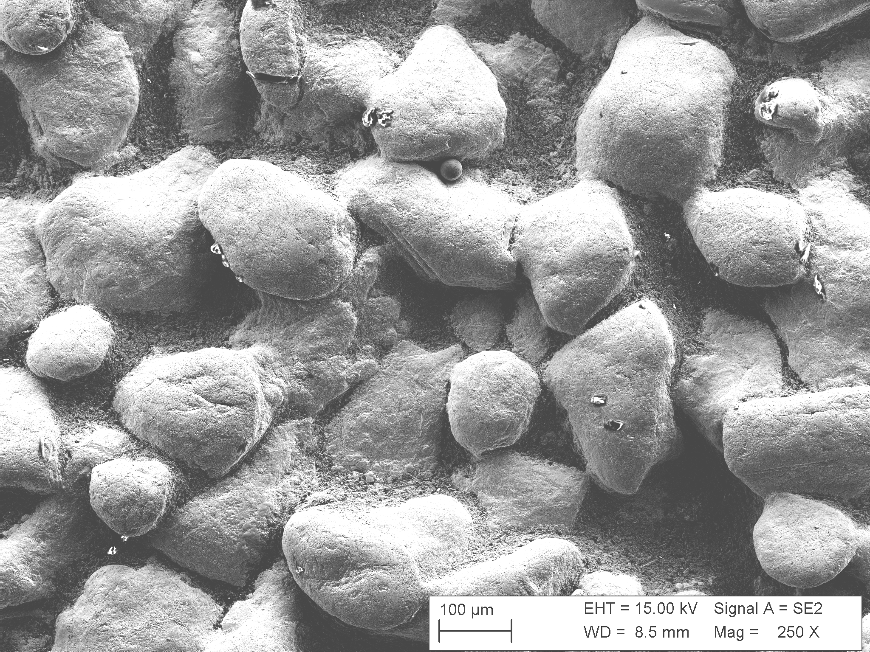
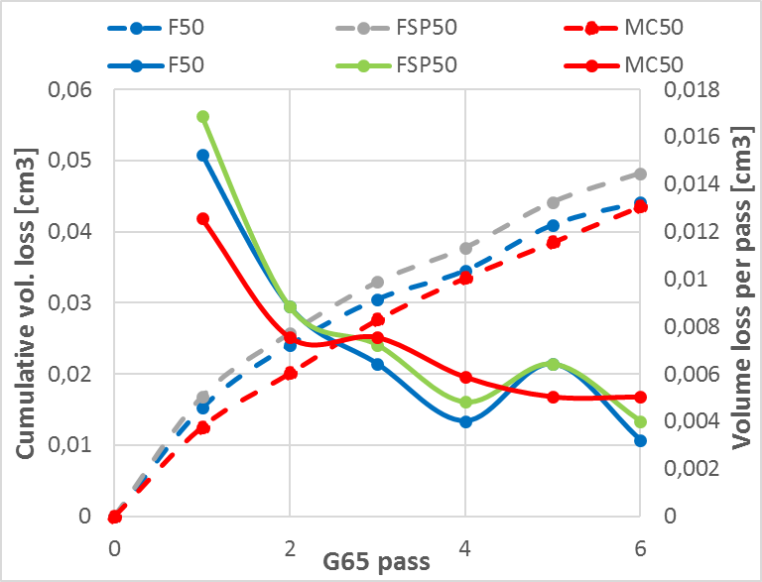
After the initial stages (pass 4) of wear where it’s mostly matrix material that is being worn away, there is very little difference between the materials, and wear rate starts to stabilize. The hardness of the abrading particles is significantly lower than all the carbides and that in combination with the low contact pressure means that all the carbides resists wear quite well. In fact, the material with the lowest hardness perform the best, although mainly due to better performance in the pass one and two. This indicates that during low stress abrasion the major controlling property is not hardness but rather mean free path of the carbides, the wear resistance of the matrix as well as the carbide-matrix bond strength. The controlling factor in the wear process is the removal of the matrix material between the carbides. When a sufficient amount is worn away the carbide particles lose their support from the matrix and can more easily be removed as wear progresses. As can be seen in figure 3 the wear rate in the material does not start to stabilize until the 4th to 6th pass of testing. Even at this stage the total depth of the wear scar is still quite low relative to the carbide size and the majority of the wear has occurred in the matrix between the carbide particles, see figure 3.
Figure 3. Cumulative and volume loss per pass in cm³ in ASTM G65 testing and to the right the worn surface after 6th pass of testing.
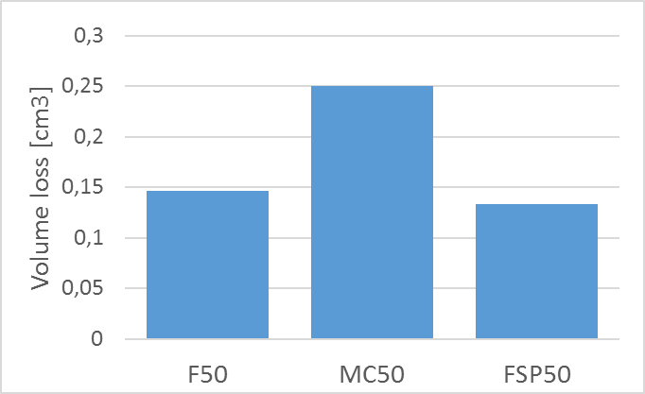
Figure 4 shows the average vol. loss in high stress abrasion testing. The harder angular abrasive particles in combination with a higher load and the harder counter surface leads to much more severe wear conditions and significantly higher vol. loss. In this test the abrasive particles generally fracture during the test and other studies have shown that the fracture particles tend to produce even greater wear than the originally added particles [X].
A clear correlation can be found between carbide hardness and wear resistance of the materials. It is evident that the softer MC carbide in the F50 MC material results in a lower wear resistance in this test. It has been shown in other studies [tribo bok] that when a materials hardness goes above 80% of the abrading particles the abrasive wear rate drops drastically. For the low stress abrasion testing the hardness of the carbides for all the materials are more than twice as high. However, for the Al2O3 particles used in the high stress abrasion testing the hardness of macro crystalline carbide used in F50 is only about 77% of the abrading particles. For F50 and FSP50 the corresponding values are 123% and 136% respectively.
Figure 2. Average volume loss in high stress abrasion testing.
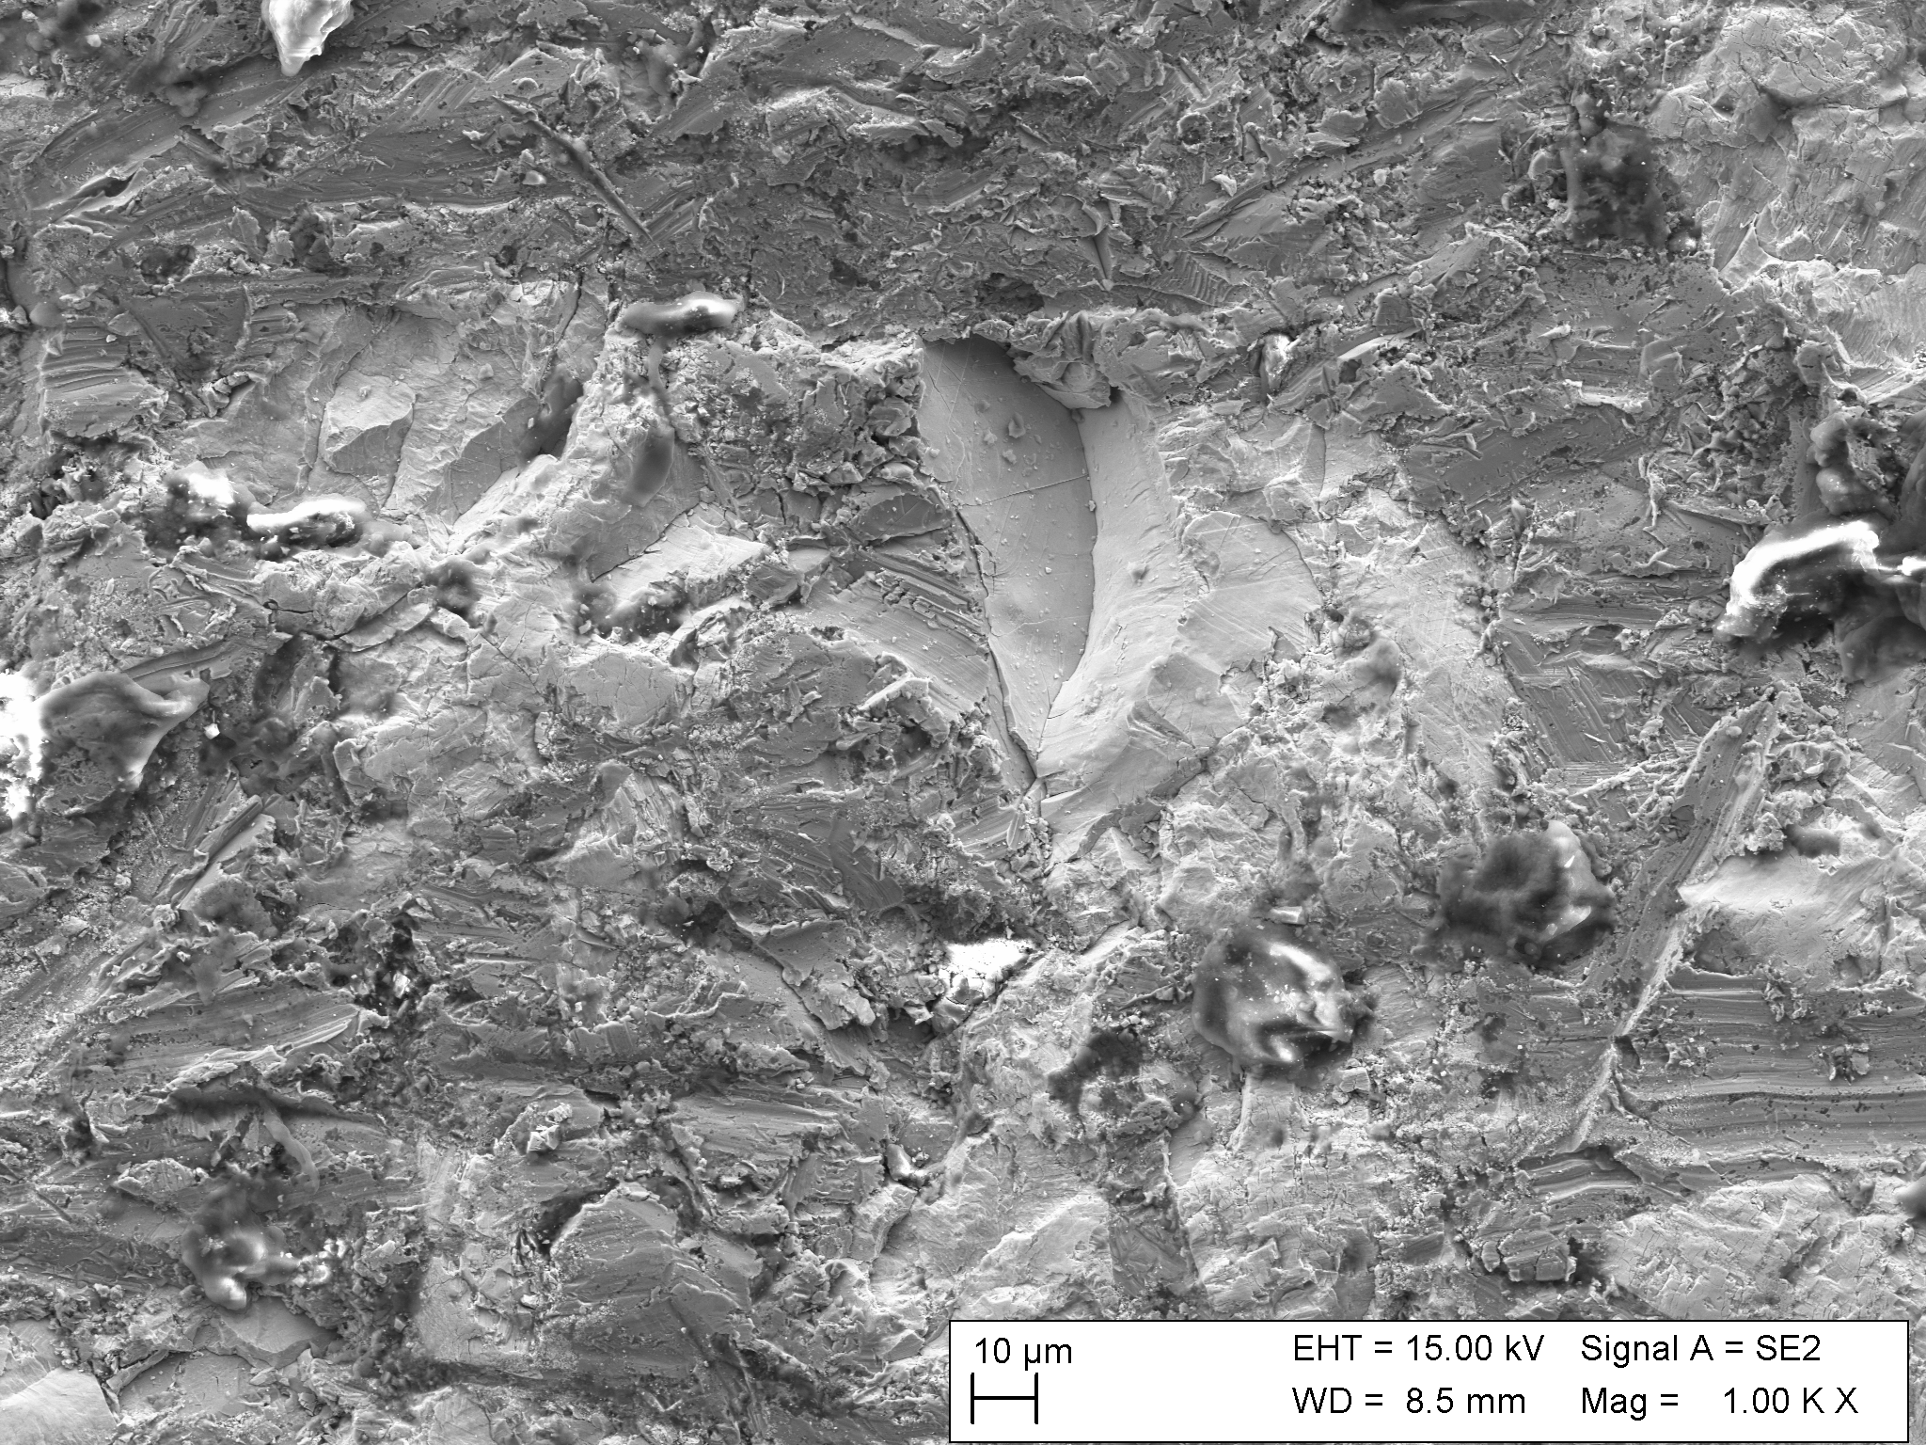
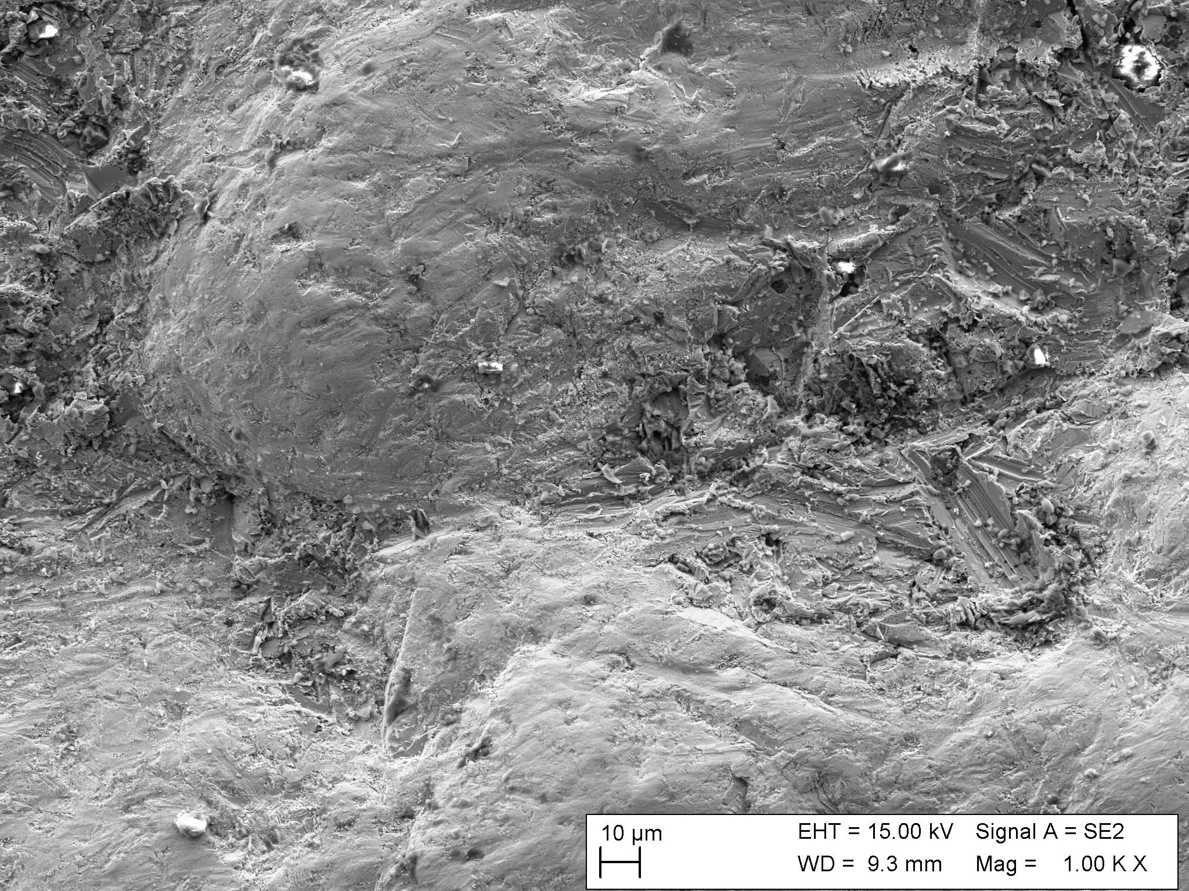
Studying the worn surface on F50MC from high stress abrasion testing (figure 5) it becomes clearer why it performs slightly worse than the others. The carbides in the F50MC material exhibit more fracturing compared to the fused carbides, that show very little signs of fracturing. Here the wear is dominated by rounding of the carbide particles followed by a gradual material removal (figure 5). There is a marked difference in topography in the wear scar comparing the materials. In the material containing the harder fused carbides the carbides protrude from the surface, a clear indication that they quite effective resisting the wear from the Al2O3 particles. The topography in the wear scar for F50MC material is much more smoother and contains more degree in the form of carbide fragments but also Al2O3 particles.
b)
a)
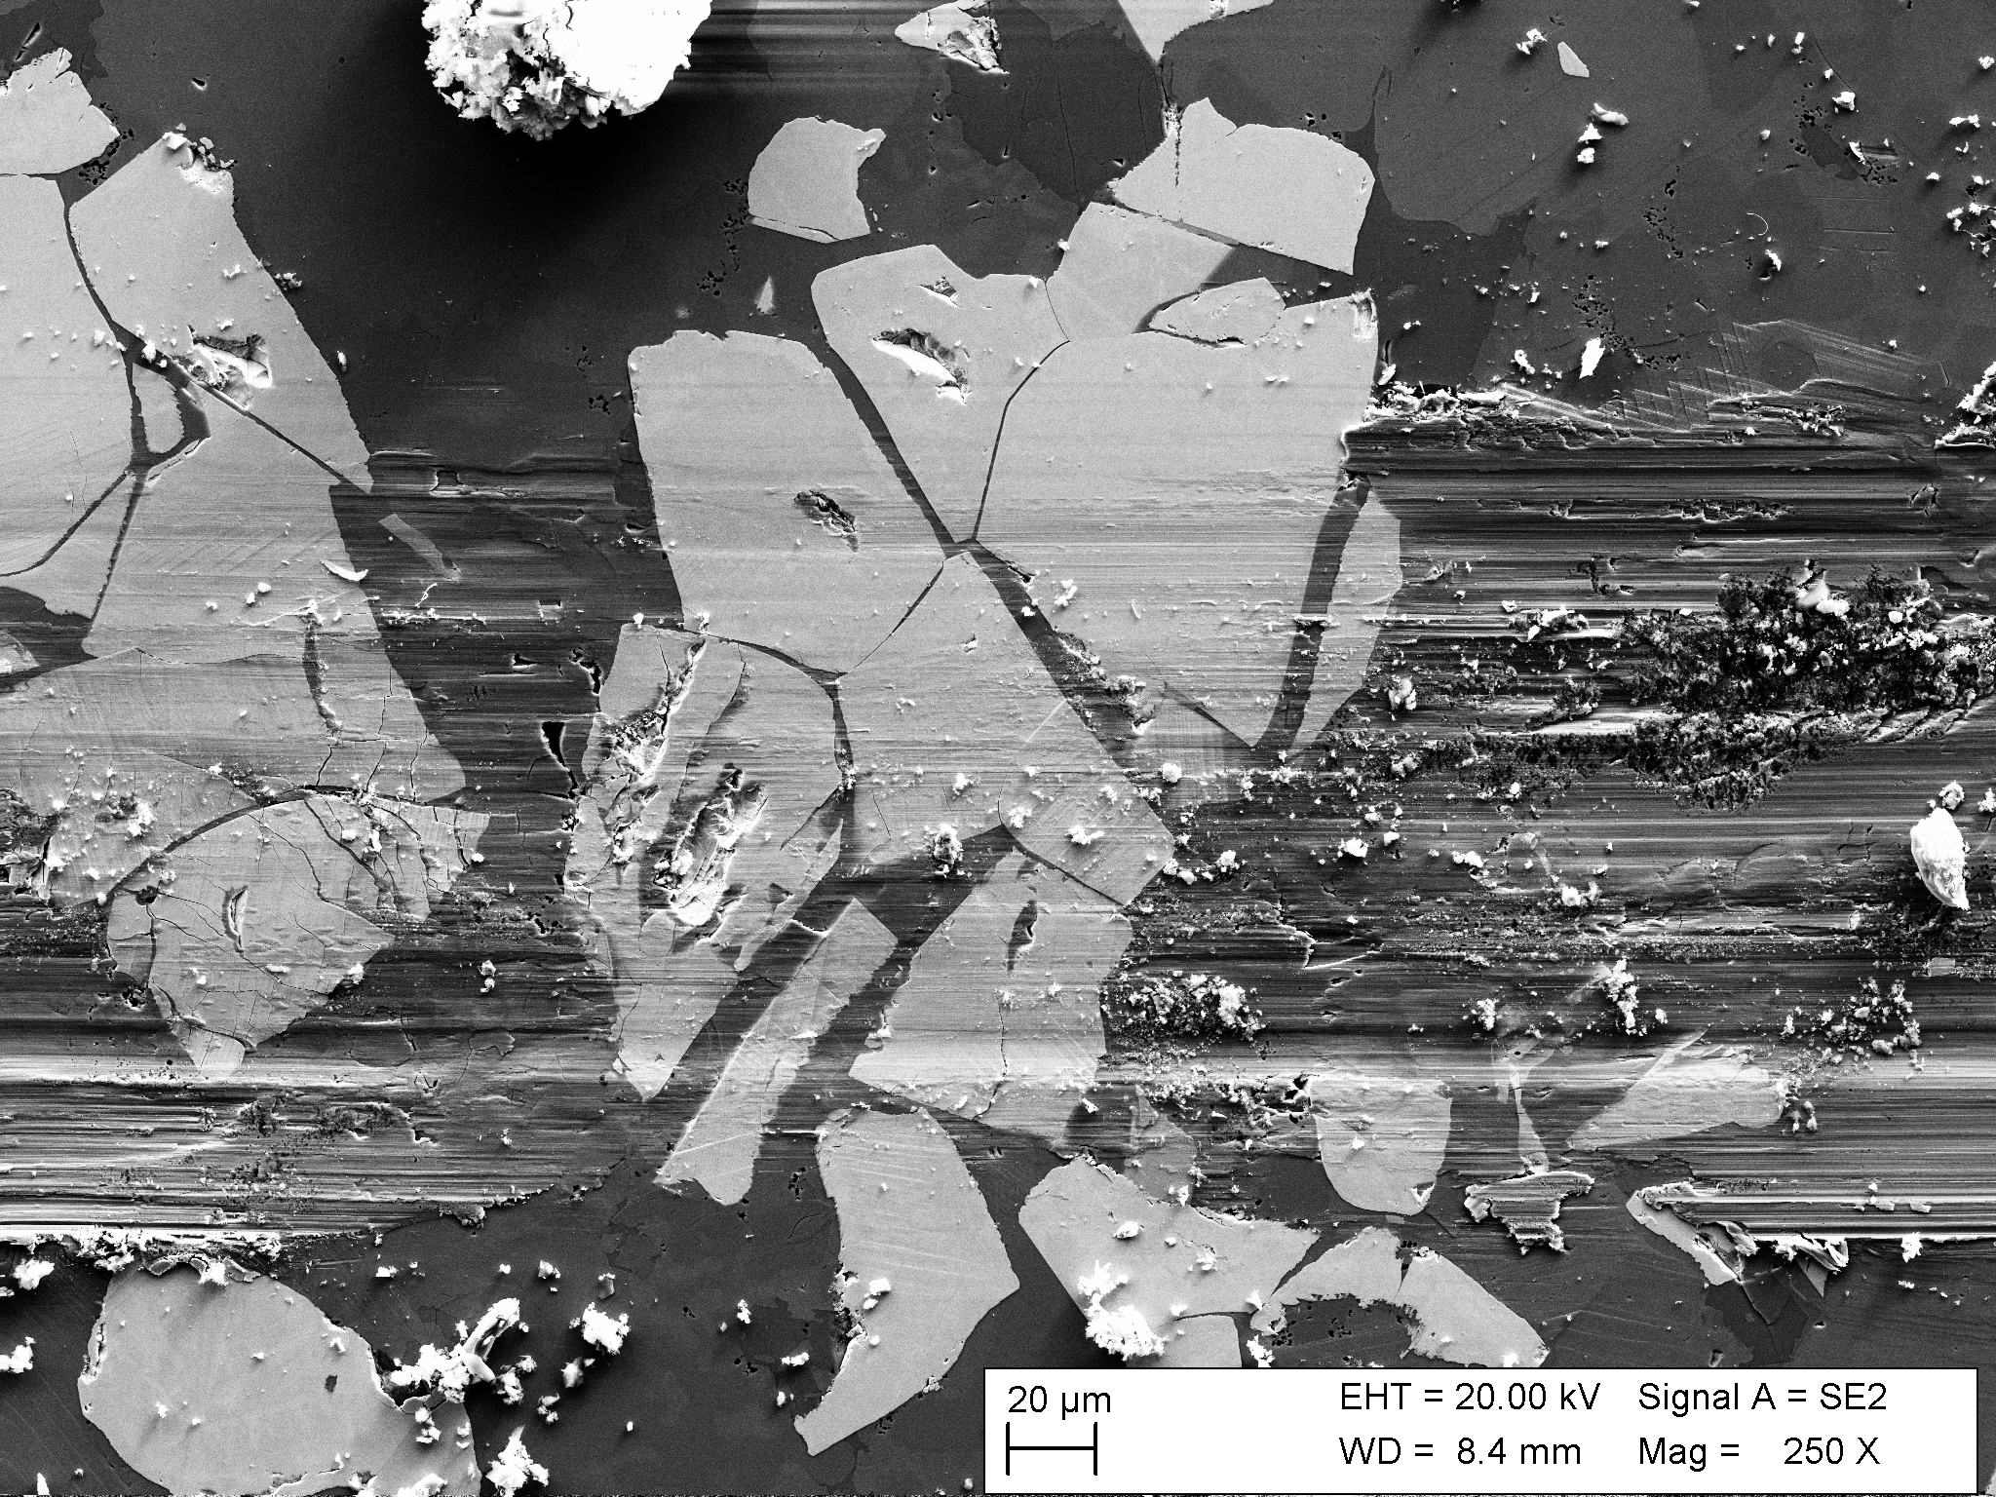
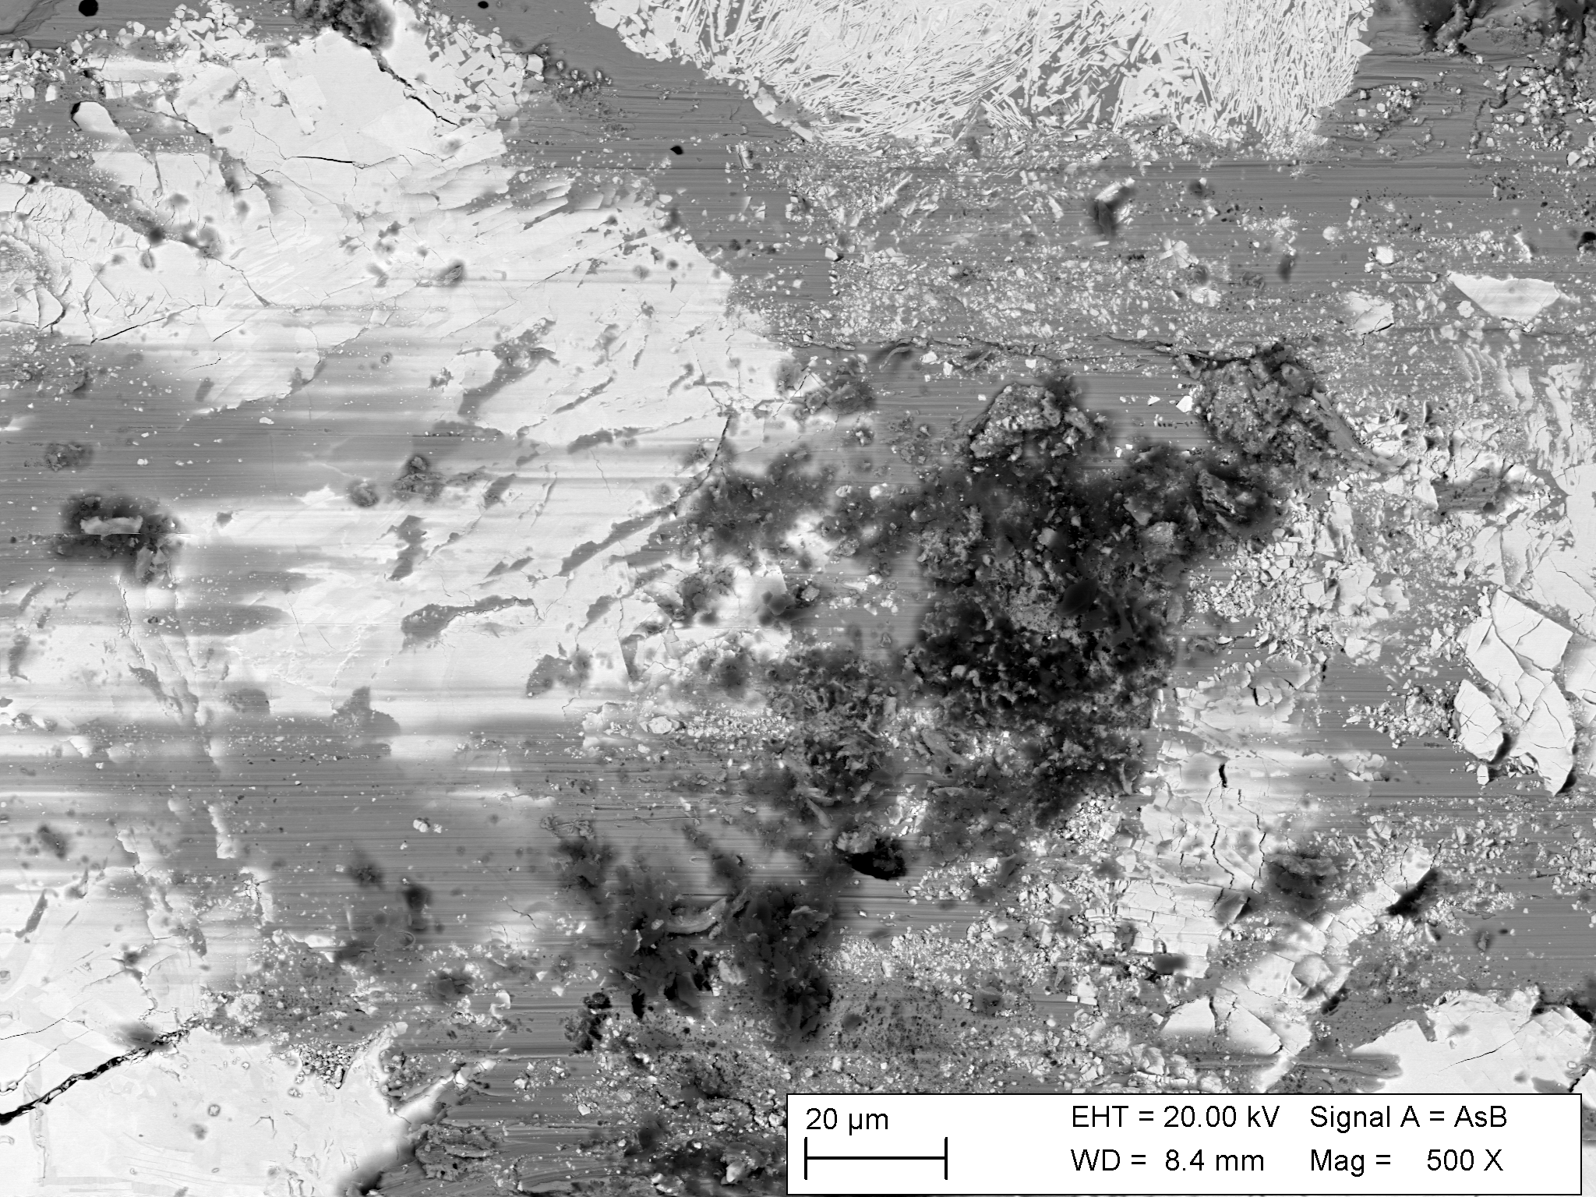
In scratch testing the MC carbide again displays a tendency to crack more in the bulk compared to the fused carbide, see figure 6. However, the fused carbide exhibit significant damage on the edges where dissolution has caused a less dens structure that readily deform and crack i.e. it increases the mean free path between the core of the primary carbides. Connect this with abrasion testing it easy to understand that this dissolution accelerates the wear in the matrix as well as the dissolution zone between matrix and primary carbide. What the MC carbide gains in lower dissolution it looses in susceptibility to cracking as well as a lower hardness.
b)
a)
Figure 3. Surface of F50 (a) and MC50 (b) after high stress abrasion testing.
The worn surfaces from lab testing has been compared to worn surfaces of parts that has been in service under different operating condition. One where much of the wear is closer to low stress abrasion (pump side liner) and one that is subjected to high stress abrasion and impacts (crusher tooth). Both parts are using a wear material that is like F50 but have an optimized matrix composition. There are some clear similarities to the lab scale testing when studying the worn surfaces. For the crusher tooth the worn surface is quite flat with lots of fractured carbides (figure 7 a), quite like what was observed in the high stress abrasion testing. The depth in to the material to which the carbides are fractured is surprisingly low for it being an application with impacts wear also, only about 0,5 mm.
Figure 4. Surface of MC50 (a) and F50 (b) after scratch testing angaint a quartz stylus.
Studying the worn surface of the pump side liner instead (figure 7b) the similarity to the worn surface from the low stress abrasion test is significant. The carbides stand proud from the surface and the matrix between them is worn away. Unlike the surface from lab testing the surface contain some carbide damage like abrasion, cracking and micro chipping, although to a quite low extent.
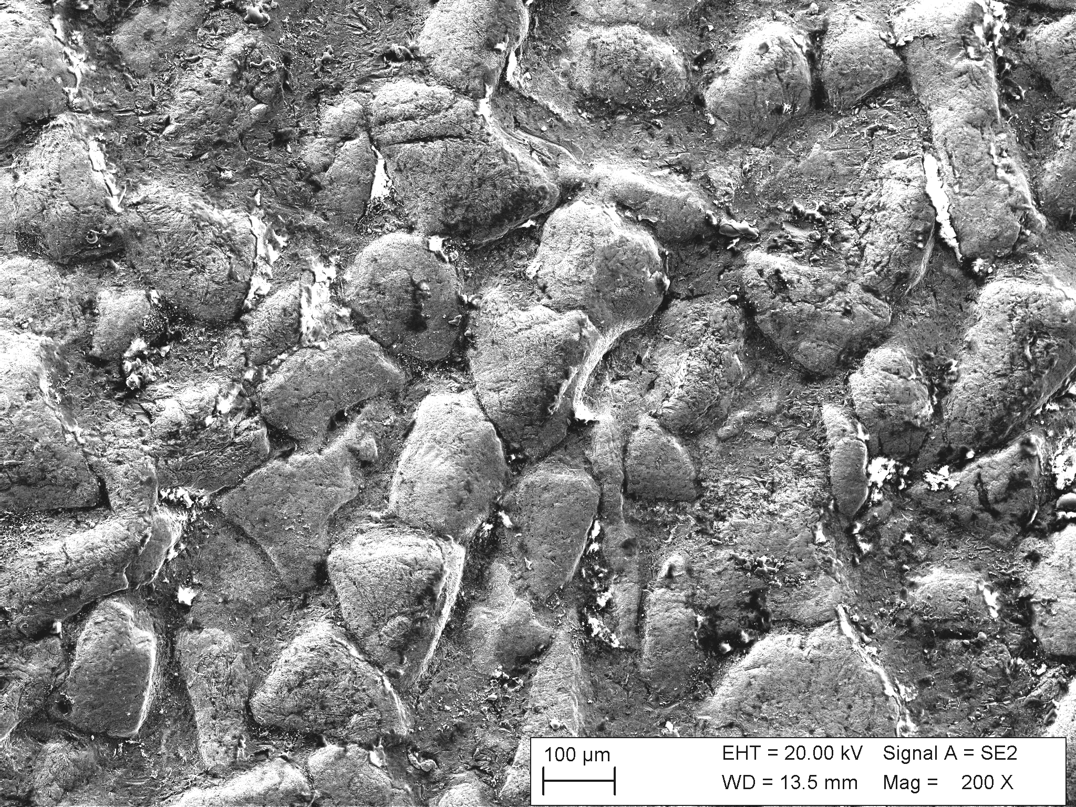
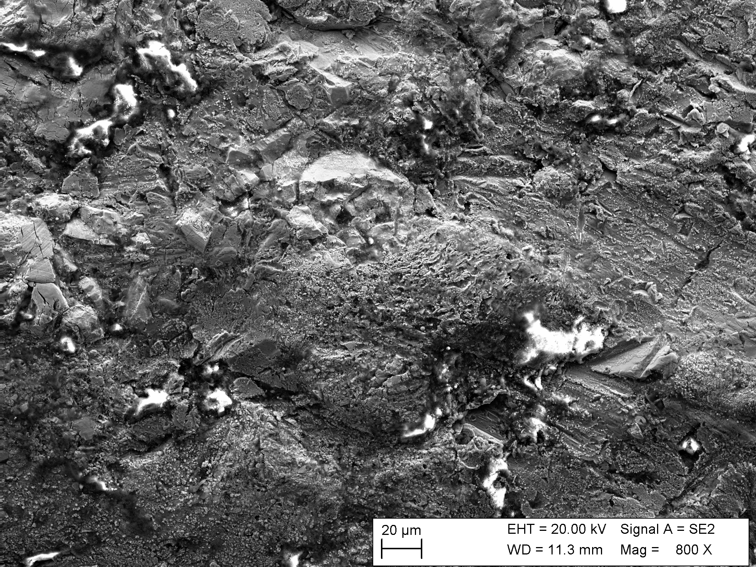
a)
b)

Figure 5. Worn surface of crusher tooth (a) and pump side liner (b).

5. Conclusions
- Angular fused tungsten carbide exhibit a higher degree of carbide dissolution compared to spherical fused carbide when HIPed at the same conditions
- Macrocrystalline carbide exhibits lowest degree of carbide dissolution compared to the fused carbides
- Lower carbide dissolution result in better wear resistance in the early stages of wear during low stress abrasion testing
- There is a good correlation between carbide hardness and wear resistance in high stress abrasion testing
- Higher degree of carbide dissolution increases the hardness of the matrix
- The wear mechanism in the pump side liner is similar to low stress abrasion
- The wear mechanism in the crusher tooth is similar to high stress abrasion

References

- Y.Pan, D. Y. Li and H. Zhang, Wear 271 (2011) 1916-19-21.
- H. Berns, Wear 254 (2003) 47-54.
- S. Bodhak, B. Basu, T. Venkateswaran, W. Jo, K.-H. Jung and D.-Y. Kim, J. Am. Ceram. Soc. 89[5] (2006) 1639-1651.
- R. M. Genga, G. Akdogan, J.E. Westraadt and L.A. Cornish, Int. J. Refract. Met. Hard Mater. 49 (2015) 240-248.
- R. M. Genga, G. Akdogan, C. Polese, J.C. Garrett and L.A. Cornish, Int. J. Refract. Met. Hard Mater. ARTICLE IN PRESS (2014).
- S. Olovsjö, R. Johanson, F. Falsafi, U. Bexell and M. Olsson, Wear 302 (2013) 1546-1554.
- S. Guadalupe Maldonado, S. Mischler, M. Cantoni, W.-J. Chitty, C. Falcand and D. Hertz, Wear 308 (2013) 213-221.
- Y. Ning, P.C. Patnaik, R. Liu, M.X. Yao and X.J. Wu, Mater. Sci. Eng. A391 (2005) 313-324
- M. Wong-Kian, L.A. Cornish and A. van Bennekom, J. South AfricanInstitute of Mining and Metallurgy, (1995) 319-334.
- M. Sebastiani, V. Mangione, D. De Felicis, E. Bemporad and F. Carassiti, Wear 290-291 (2012) 10-17.
- C. J. Heathcock and A. Ball, Wear 74 (1981-1982) 11-26.
- X S.Wirojanupatump and P.H.Shipway, Wear 271 (2000), 91-101
- Z http://www.extremecoatings.net/resources/test-results/abrasive-wear-test-astm-g65.html
- X M. Adamiak, J. Górka, T. Kik, Journal of Achievements in Materials and Manufacturing engineering, Vol 37, Issue 2 (2009), 375-380

