Oxygen content in PM HIP 625 and its effect on toughness Tomas Berglund^{1, a}*, Fredrik Meurling^{2, b}
¹ Sandvik Powder Solutions, Sweden
² Powder R&D, Sandvik Materials Technology, Sweden

Keywords: HIP, wear, tribology, Metal Matrix Composites, MMC, wear resistant

Abstract Oxygen control during powder manufacturing and handling is crucial when manufacturing HIPed parts. The influence of elevated oxygen content on mechanical properties is something that has been debated and investigated for many years. The general consensus in the industry is that oxygen has a very detrimental effect on the toughness of the material if present in excessive amounts.
The detrimental effect of oxygen content on the impact toughness of the material has resulted in HIPed specifications, both existing and under development, with limits on the oxygen content in the material. Many specify a relatively low limit on oxygen content at e.g. 120 ppm which can have adverse effects on yield in powder manufacturing which might increase costs without accomplishing the desired effect of ensuring sufficient toughness. As this study show, oxygen content and chemistry alone is not enough to describe the effect of oxygen content on the HIPed material. Setting a limit at e.g. 120 ppm will not guarantee that one gets better properties or even reaches the desired properties of the material. The study show it is important where the oxygen is located in the powder and to separate bulk oxygen content and the surface oxygen content, where the latter has a more pronounced effect on toughness. In the study four batches of alloy 625 have been investigated, all with only relatively small variations in oxygen content but with drastically different toughness and differences in how oxygen is distributed in the material.

Introduction. Powder metallurgical materials are sensitive to oxygen due to the vary large surface area of the fine powder. In some PM processes e.g. press & sinter and MIM, oxygen content can be reduced during sintering by performing it in hydrogen. However, when consolidating the material using HIP the consolidation occurs in vacuum inside the capsule which has little to no effect on the oxygen content. Therefore, oxygen control throughout the manufacturing process is important as any adsorbed oxygen cannot be removed in the later stages of manufacturing. Other studies have investigated the influence of oxygen on mechanical properties on HIPed austenitic and duplex stainless steel. In general the studies show a correlation between oxygen content an impact toughness, especially at lower temperatures [XXXX]. Usually it is toughness that suffers most from excessive oxygen in the material but also welding properties of the material can be influenced.
Currently there are few material specifications on HIPed material and most that exist are project or product specific. There are a few specifications and standards covering PM HIP material e.g. ASTM (A988, A989 and B834), ASME code cases (N-834 and 2840) as well a mention in API 6A. However, more specs are in the works and many of them specify maximum oxygen content in the material. There is a trend to set lower and lower maximum allowable oxygen content which in turn can have a negative effect on price of the produced parts. When levels is below 120ppm it gets much more difficult for powder and part manufacturer to meet this and it might not have the desired effect on mechanical properties.
Other studies have shown that properties at levels of oxygen from 120ppm and below is not necessarily connected to the amount of oxygen, in fact a material with higher oxygen content can have superior toughness to a material having significantly lower oxygen content [vår pvp]. In this study 4 different Alloy 625 materials, manufactured with Ar or N gas atomizing have been investigated with regards to microstructure and mechanical properties.

Experimental
Sample manufacturing. Manufacturing of the powders was done using gas atomization. Process and powder handling parameters was varied to achieve different distribution of the oxygen in the powder. The atomized powders were sieved at -250 µm prior to filling of the capsules. Nitrogen atomized powder are hereafter labeled N625 and Argon atomized powder A625.
The powders were filled in rectangular-shaped mild-steel capsules of outer dimensions 180x70x50mm and sheet thickness 2mm, evacuated and sealed and subsequently HIPed in a standard HIP cycle with a plateau characterized by 1150°C temperature, 100 MPa pressure and 3 hours. Testing on all materials was performed in the as-HIPed condition.
Chemical analysis. All materials were analyzed with regards to chemical composition in the as-HIPed condition. Ar-testing was done on the capsule filling pipe that was filled with 253MA material. The same procedure that is often used in the industry.
Mechanical testing. Was performed using ISO 6892-1:2009.
Microstructural characterization. Was performed using Light Optical Microscopy as well Scanning Electron Microscopy (SEM) and Energy dispersive X-ray spectroscopy (EDS).

Results
Chemical analysis. The chemical analysis for the material in the as-HIPed condition can be seen in table 1. All the material are fairly close but do contain some minor differences, especially when comparing N and Ar atomized powders. As expected the N-content in the N-atomized powder is significantly higher compared to the Ar-atomized powder. The later does contain higher amounts of the string nitride forming elements Ti and Al as well as a lower amount of Fe.
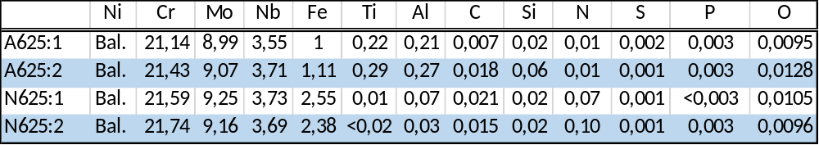
Table 1. Composition of materials in the as-HIPed condition.
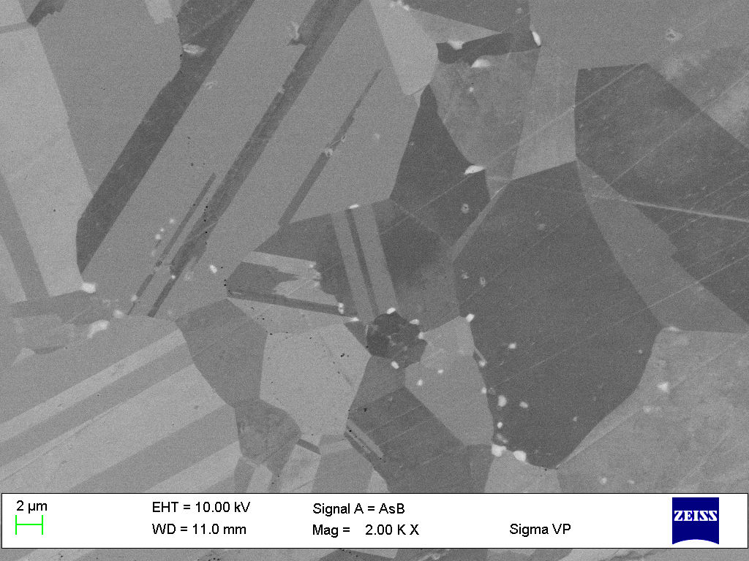
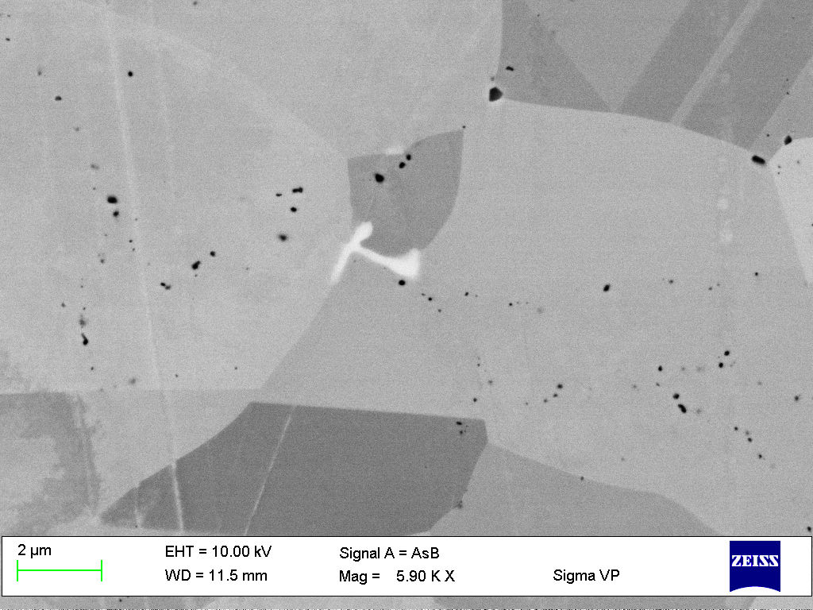
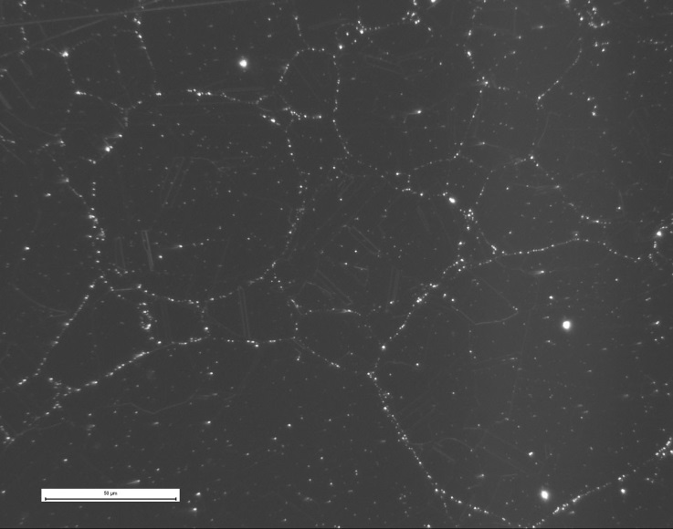
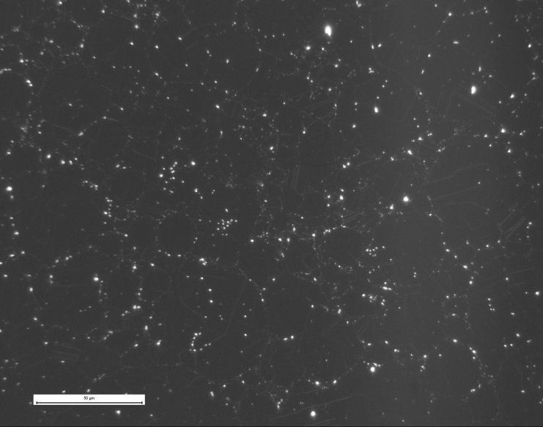
Microstructure. Figure XX show LOM micrographs of the Ar-atomized materials. In the A625:1 material several clusters of fairly large oxide particles are observed. Some of these appear to be correlated to the surface of the powder particles as they clearly highlight the shape of the powder particles. However, the individual particles were clearly larger than the otherwise occurring PPB particles. The PPBs are fairly densely decorated with particles making up a semi-continuous network. In the A625:2 material the PPB structure is much less pronounced and the particles are generally smaller. Studying the material in SEM and EDS (see figure XX) it is found that for the A625:1 material the oxide particles in the larger clusters appear to be purely alumina without traces of Ti-rich precipitates. The PPBs are decorated with alumina particles but also titanium nitrides and/or oxides as well as combinations of all these three. The occurrence of other precipitates is very limited. Some single particles rich in Mo, Cr, Nb and C are however found that might be some low-carbon containing carbide or possible an intermetallic phase. The size of these latter particles is below 1 µm. In the A625:2 material the the PPBs are decorated with alumina particles, sometimes also containing titanium. Inside the old powder particles there are small precipitates enriched in Nb, C, Ti and N, most often situated along grain boundaries and having a thickness below 1 µm.
Figure 1. LOM (a & b) and SEM (c & d) micrographs of A625:1 (a & c) and A625:2 (b & d).
a)
b)
d)
c)

Studying the microstructure of N625:1 in LOM PPB structures can clearly be seen. It is also clear that the inside of the powder particles contains a lower amount of precipitates. The N625:2 material in comparison is the opposite, the PPB structure is not as apparent and the inside of the particles contain a significantly higher number of particles. In SEM/EDS the particles decorating the PPBs can be identified as Al-rich oxides. The precipitates inside the powder particles are rich in N, Nb, Cr and Mo They are a elongated and few µm in size.
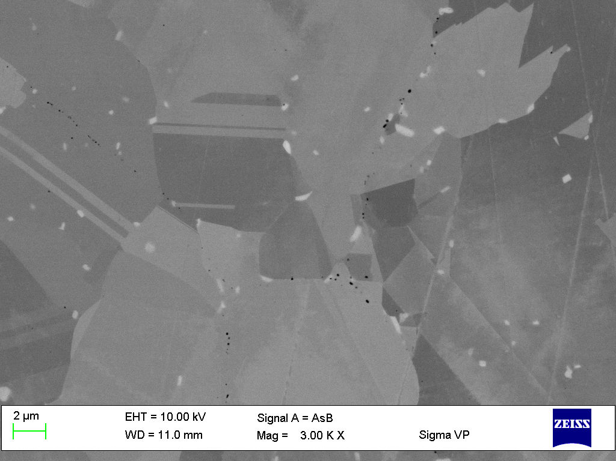
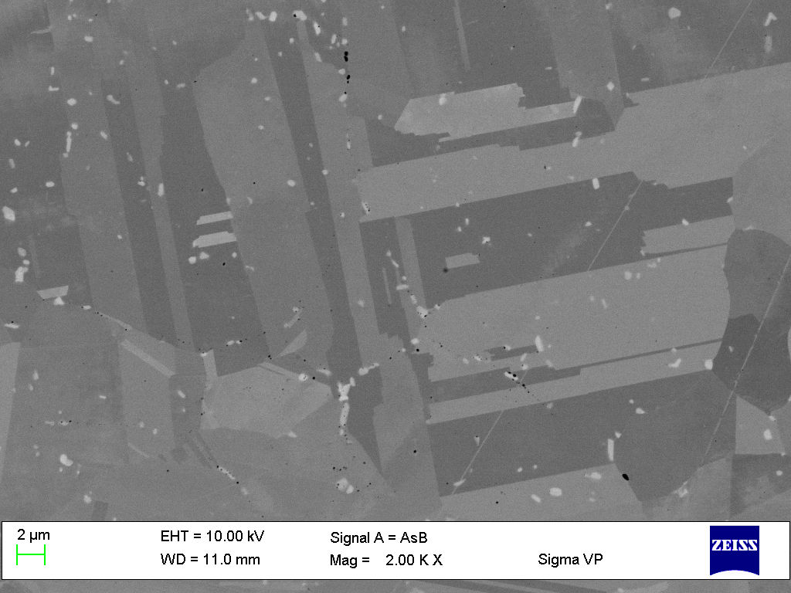
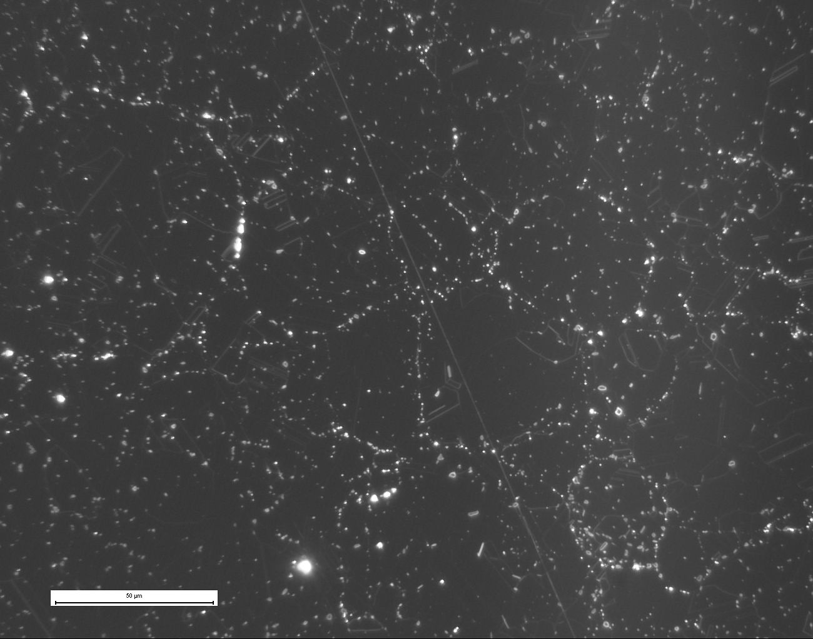
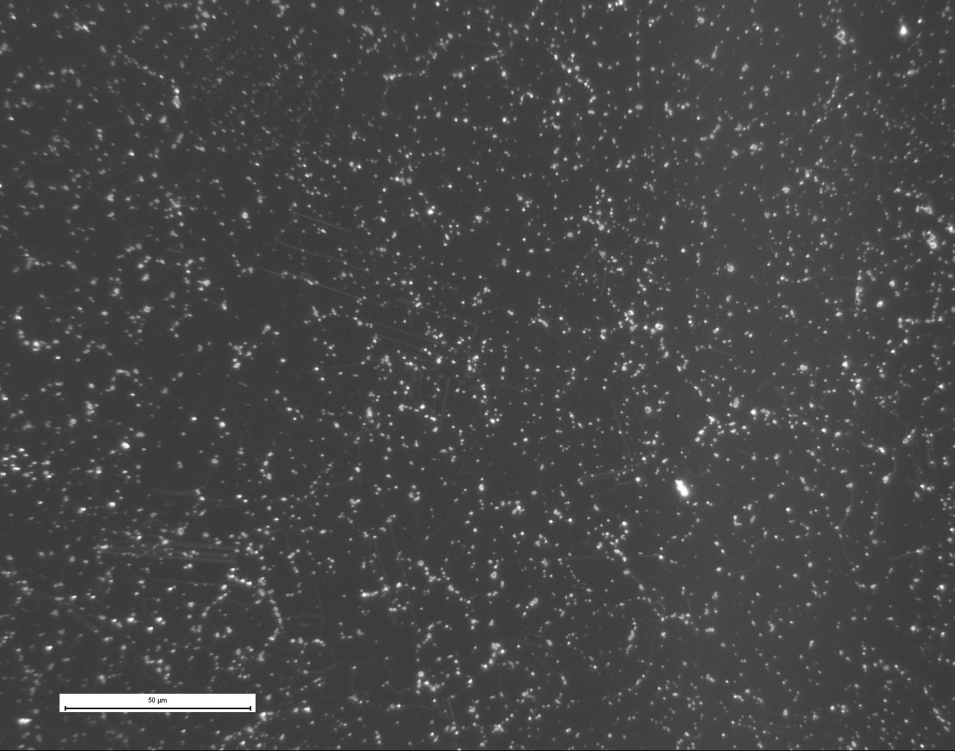
Figure 2. LOM ( a & b) and SEM (c & d) micrographs of N625:1 (a & c) andN625:2 (b & d).
a)
b)
d)
c)
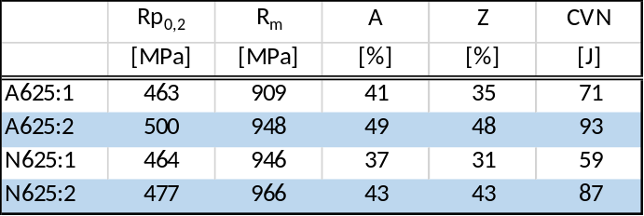
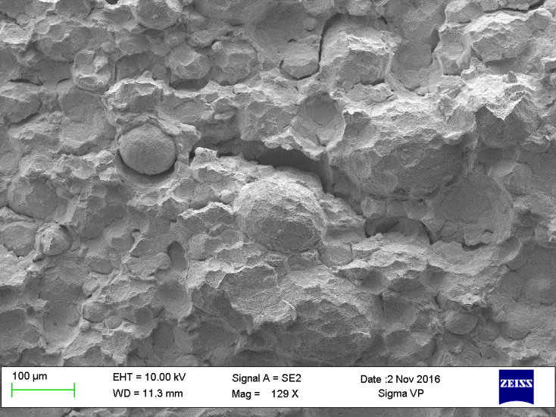
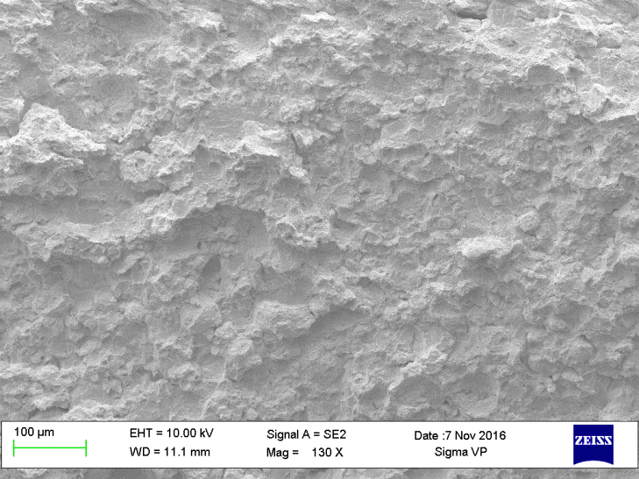
Mechanical properties. The results from mechanical testing can be seen in table XX. The strength of the materials are on a similar level. The A625:2 material has a bit high strength which most likely can be attributed to a higher C-content vs the A625:1 material as well as a higher Ti-content versus the nitrogen atomized materials. It is clear that elongation, area reduction and impact toughness are higher for the materials with higher oxygen content. This is contradictory to many other studies on Oxygen content in HIPed materials. However comparing the results to what was found in the microstructure analysis it is clear that the materials with lower impact toughness has a very pronounced PPB structure decorated with oxides. It can be concluded that the oxide network on the PPBs have a very negative effect on the ductility and toughness of the material. This is confirmed when studying the fracture surfaces from impact toughness testing, figure XX and XX.
Table 2. Mechanical properties.
Figure 3. Fracture surface of A625:1 (a) and A625:2 (b).
lectron Microscopy and Energy Dispersive Spectroscopy. portant plant for SPS to grow business in Ni-base products.
a)
b)
The fracture surface in the A625:1 material is characterized by high degree of PPB guidance of fracture, especially on larger powder particles but also on smaller. The uncovered powder particle PPB surfaces are fully covered with small dimples in which small alumina particles are found, often including elements of Ti. Both of which are strong oxide formers. In some such fracture surfaces, also larger particles enriched in Mo and Cr were observed however the alumina particles on the PPB dominate completely the fracture initiation and propagation in this materials.
The fracture in the higher O-content A625:2 is primarily transgranular at low magnification. Higher magnification reveals that the fracture is a combination of intergranular PPB guided fracture and transgranular fracture. Small dimples with alumina particles inside cover the uncovered PPB surfaces. NbC precipitates are also observed however at a much lower amount than the alumina (with Ti) oxides.
In the lower O-content N625:1 material the fracture is almost purely PPB-guided fracture where the PPBs uncovered by the impact test display dense occurrence of alumina particles. The fracture in N625:2 is a combination of transgranular, guided by Nb, Cr, Mo rich nitrides and intergranular fractures guided by both nitrides and PPB-alumina particles. The latter type of fracture appearance appears to be fairly uncommon but when it was clearly observed it appeared primarily on larger powder particles rather than on smaller powder particles.
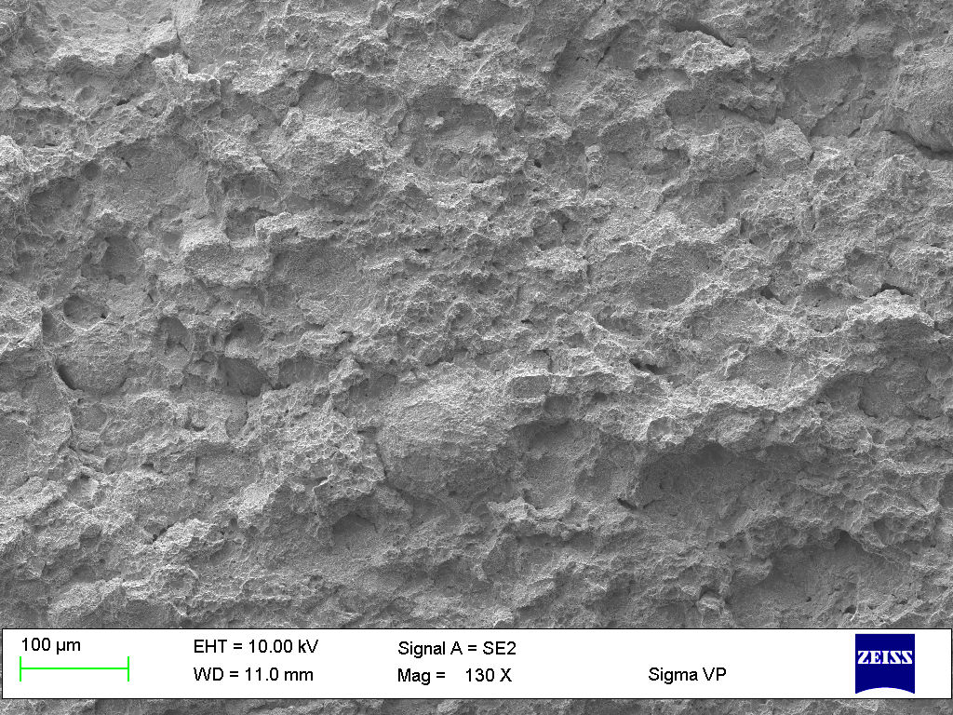
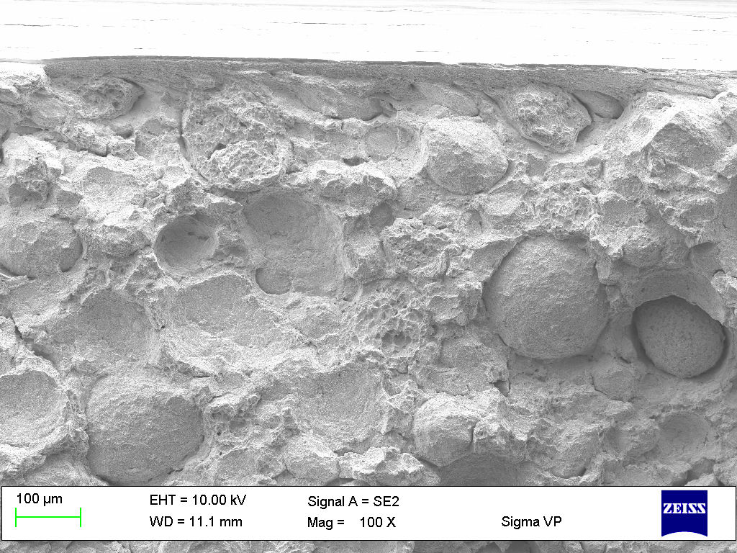
Oxygen distribution. The results in the microstructural analysis combined with the results from mechanical testing clearly show that oxygen content alone cannot be used to verify that a material will perform as desired. The distribution of the oxygen in the powder as well as the surface after manufacturing and consequently the consolidated material is of importance. Figure XX show the oxygen content in the materials for different powder size fractions. As expected the finer powder contains more oxygen, this due to a higher surface area. The black lines represent oxygen content in the melt prior to atomization i.e. bulk oxygen content which should also serve as a good indication of the bulk oxygen content in the powder. Making the assumption that the bulk oxygen content is the same for all size fraction the oxygen uptake for each size fraction can be estimated.
Figure 4. Fracture surface of N625:1 (a) and N625:2 (b).
a)
b)
The particle size distribution in the nitrogen atomized is almost identical. As can be seen in figure XX the is a large difference in oxygen uptake in the two powders for all the size fractions. The low bulk oxygen in combination with a high total oxygen content of the N625:1 material show that most of the oxygen in that material is surface oxygen. This is also confirmed by the fracture surface analysis of the impact toughness specimens where it could be seen that the fracture was almost purely PPB guided fracture in the N625:1 material. The alumina particles found in the PPB guided fracture surfaces as little to no bond to the matrix around them and cracks can easily propagate along this path, effectively lowering the impact toughness.
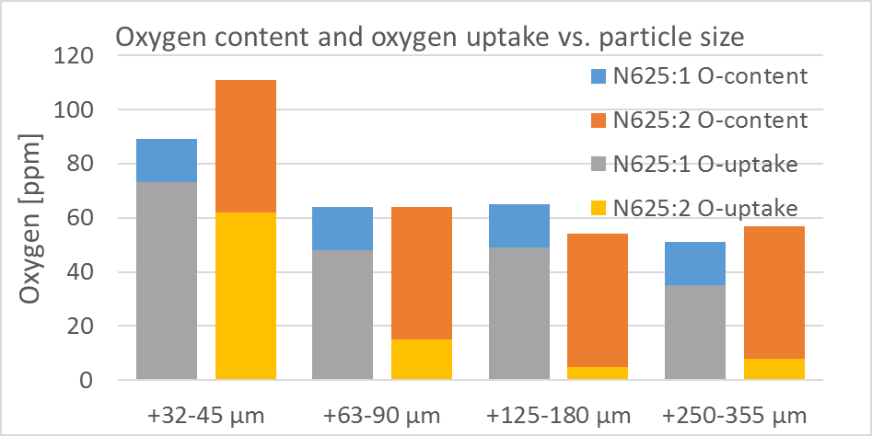
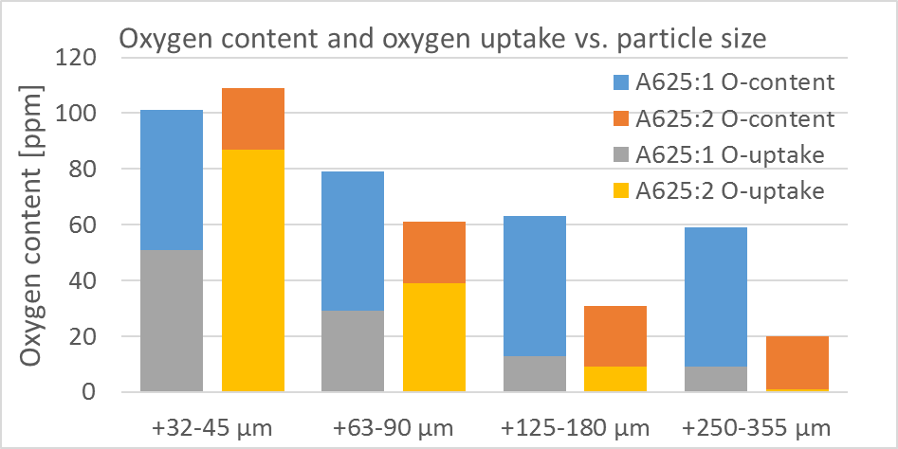
Figure 5. Oxygen content for different particle size fractions.

Compared to the Nitrogen atomized material that had similar total oxygen content in all size fractions only the two finer fractions are on the same level while the larger has a clear difference for the Argon atomized materials. The coarser powder in the A625:1 material has a significantly higher oxygen content compared to the A625:2 material although most of it is bulk oxygen. There is also a significant difference in oxygen uptake on the coarsest size fraction where the material with the lowest toughness also has the highest uptake, as with the nitrogen atomized powder, but not nearly as high. Also here the fracture in the impact toughness specimens is to the large extent PPB guided, primarily on the coarser particles but also on the finer.
Conclusions

Conclusions
- Higher oxygen content material can have higher impact toughness
- Higher surface oxygen content on powder particles has much more adverse effect on impact toughness than bulk oxygen
- Fracture in material with a pronounced PPB network occurs in the PPBs with a lower impact toughness consequently
- Fracture in material with lower surface and higher bulk oxygen content occurs trans granular with a higher impact toughness consequently
- Nitrogen atomized powder

References

[H] O. Grinder, E. Ericsson, Low-temperature oxidation of inert-gas atomized steel powder, Modern Developments in Powder Metallurgy, Proc. Of the 1984 Int. Powder Metallurgy
Conf., June 17-22, Toronto, Canada, 16, 295-327, 1984.

