TeraPi – A 3.5-meter diameter hot zone unit enables HIPing of large components
Dr. Anders Eklund^{1,a*}, Mr. Magnus Ahlfors^{2,b}
¹Quintus Technologies AB, Quintusvägen 2, SE-72166 Västerås, Sweden.
²Quintus Technologies, LLC, 8270 Green Meadows Drive North, Lewis Center, OH 43035, USA
ªanders.eklund@quintusteam.com, ^{b}magnus.ahlfors@quintusteam.com

Keywords: Tera-HIP, large components, powder metallurgy, Near-Net-Shape (NNS), forgings, energy, volume production.

Abstract. Hot isostatic pressing (HIP) has been known for more than 50 years, and is considered today as being a standard production route for many applications. The HIP process applies high pressure (50-200 MPa) and high temperature (300-2,500°C) to the exterior surface of parts via an inert gas (e.g., argon or nitrogen). The elevated temperature and pressure cause sub-surface voids to be eliminated through a combination of mechanical deformation, plastic flow and diffusion.

The largest HIP unit operated in the world today has a hot zone diameter of 2.05 meters which is very big. However, there are even bigger components produced that would benefit from a HIP treatment, but which cannot be HIPed today because of the size. These components could be pump house and valve castings for nuclear power plants, forged parts for reactors or components for aerospace engines for example.

This presentation will cover which types of components and markets that can benefit from this size of HIP. It will also be explained how it is possible to operate an extra-extra-large HIP like the TeraPi and the technical concept together with performance details.

Motivation
Quintus Technologies AB (at that time Avure Technologies) started a study in 2010 named project Novel HIP. The idea was to expand and brake the boundaries of how big a HIP can be. The question was, can a 10-meter diameter HIP be manufactured? The project was sponsored by Vinnova, the Swedish Organization for innovations and research.

New concepts and designs were invented and patented, i.e. the assembly of the frame, see Fig. 1. It was a unique light weight frame solution for easy transportation, winding at site, assembly at site and very important to have forging sizes available from the suppliers. The total weight of the frame for a diameter of 10 meter and height 8 meter is 8000 ton.

Another concept change was to develop a new pressure vessel cylinder for hot zone diameters over 2 meters. Due to the large load weights involved, 50-75 tons and the weight of the pressure vessel cylinder itself of about 300 tons, the decision was made to move the cylinders instead of the frames. Earlier concept design of HIP units from Quintus has the frames moving. Due to the fact that the frames will grow more in weight than the vessel cylinders, Tera-HIP units now has the frames positioned in a pit, and the HIP pressure vessel will be moving. The maximum operating pressure (MOP) was targeted to be 1050 Bar. See Fig. 2.

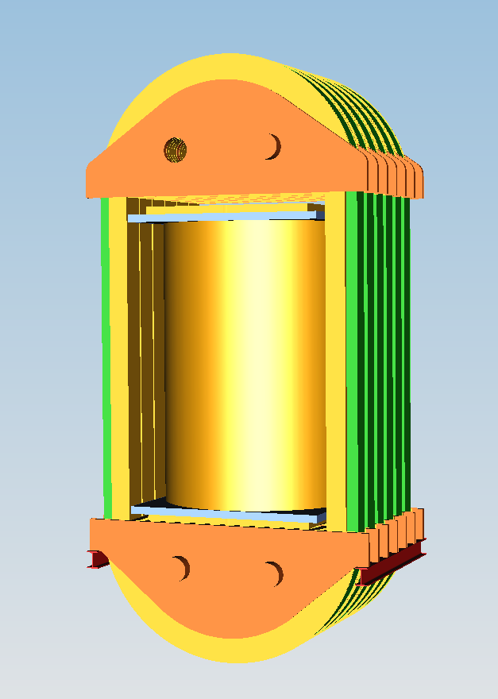

Fig. 1. Frame for pressure vessels up to 10 meters in diameter and 8 meters in height and MOP of 1000 Bar.

Also, a new furnace concept had to be developed to effectively HIP and heat treat large parts in less than 24 hours. See Fig. 3. The maximum operating temperature for the furnace was targeted to 1250 °C. That would cover most steel, stainless steel, Titanium, Inconel and Aluminum details predicted to be HIPed. The material of the furnace would be Molybdenum, since it shows great durability and form stability over long periods of usage.

To sum up, the general design requirements and goals were,
- ASME design
- Designed for greater than 98%+ uptime
- Designed for half of today’s installation time
- Manufacturing time not to exceed 24 months
- Maximum temperature deviation of +/- 10C during heating/cooling
- Minimum calculated fatigue life of 10,000 cycles…30+ years
- Total load weight of about 75 tons
- Cycle time not to exceed 24 hours
- Conventional technology!!

The outcome of the project would be the QIH TeraPi. A Tera-HIP unit with a hot zone of 3.14 meters, a hot zone height of 5.0 meters and MOP of 1050 Bar, maximum operating temperature of 1250 C, and a variable pay load of 50-75 tons. Even though many new concepts were introduced and patented and tested the TeraPi HIP units were going to use conventional technology. No new concepts were to be used for the Novel HIP.

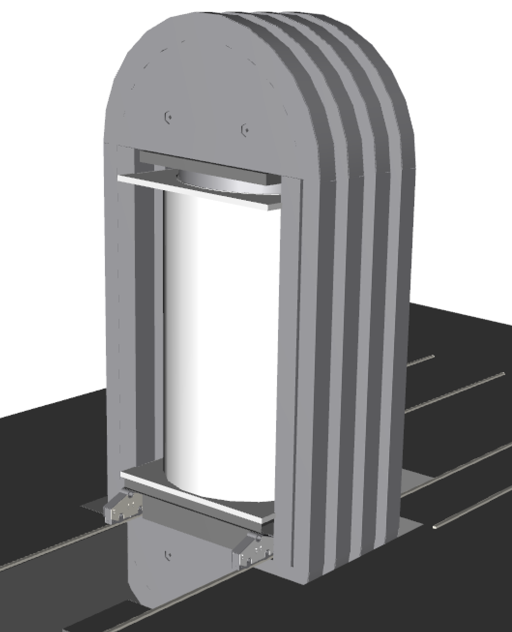

Fig. 2. Moving cylinder concept on a rail carriage, fitted with top- or bottom loading.

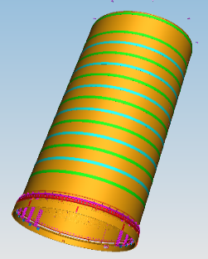

Fig. 3. Furnace concept for large Tera-HIP units with hot zone diameters over 2 meters in diameter.

Game changers
The major achievements in the project Novel HIP can be summarized as below,
- Large diameters, over 3.0 meters (3.14 m = 123” ID)
- Running cost below 1.00 SEK/kg
- Possible to modularize for easy manufacturing and installation
  - No overhead crane
  - No pit
- High degree of automation for easy handling of the loads
- New frame construction with multiple frames
- New furnace construction for handling large volumes of hot gas
- The solutions make the foundation easier
- The solutions minimize Argon risk
- The solutions have noise protected pump unit
- Separate floors for operation and maintenance
- ASME approval

In Fig. 4, one can see a layout of the TeraPi HIP unit with the introduced developments mentioned earlier. All process unit operations, i.e. furnace, gas compressors, water cooling, power supply, VRT’s, etc. are all proven technologies and the components have been tested and have been used for many years. One feature which can be seen in the Fig. 4, is that there are separate floors for maintenance and operations. Two load stations are also included for maximum productivity and efficiency of the TeraPi HIP system.

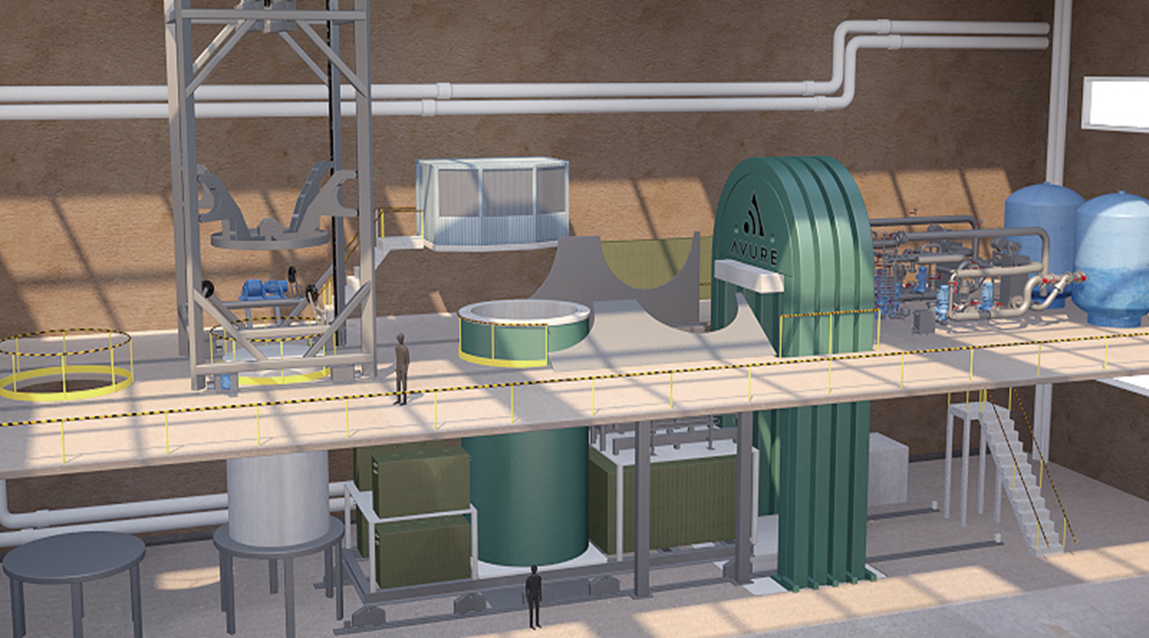

Fig. 4. The Quintus QIH TeraPi HIP system.

Other features are an automated handling system of the load and furnace to minimize operator handling errors.

Other sizes of the Tera-HIP systems have been designed after discussions with potential customers world-wide. Most notable are the QIH-T140, with a hot zone diameter of 3.55 meter and height 4.0 meter. And the QIH-Tera4me, with a hot zone diameter of 4.0 meters and height 4.0 meters. These concept designs have been modified so bottom loading is possible. This due to the large weights of the bottom closure plate and the heavy loads that will go in to these HIPs. An example of the bottom loaded Tera-HIP system can be seen in Fig.

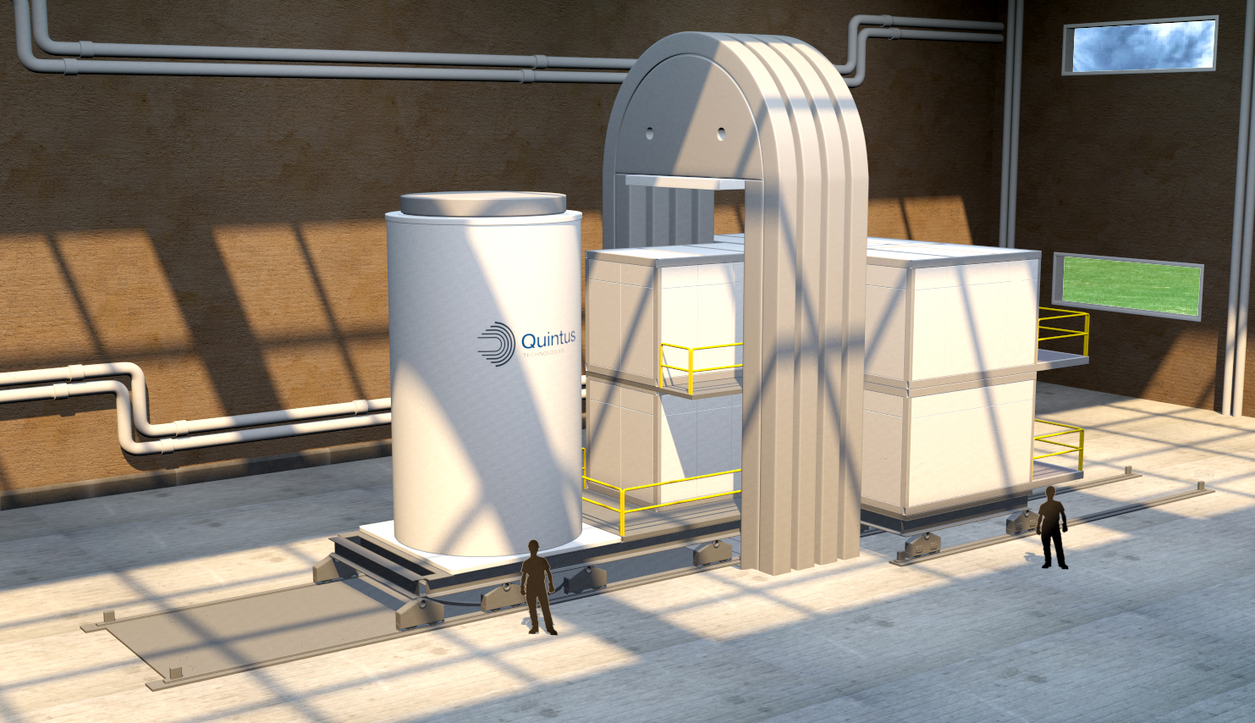

Fig. 5. Bottom loaded Tera-HIP unit for even larger hot zone sizes.

Applications
The Tera-HIP concept has an advantage when it comes to handle very large components for the Energy sector, Aerospace or Defense. Regardless if one manufactures the parts through Powder Metallurgy-Near Net Shape or by making large Castings/Forgings, the Tera-HIP systems can handle most components today that have long lead-times. The lead-times for large forgings can be years instead of months, and that is where the PM/HIP-NNS route has a huge advantage. Examples of some forged parts that instead could be produce by HIP can be seen in Fig. 6.

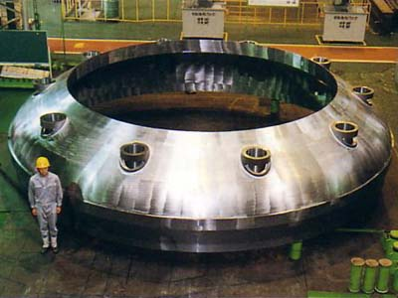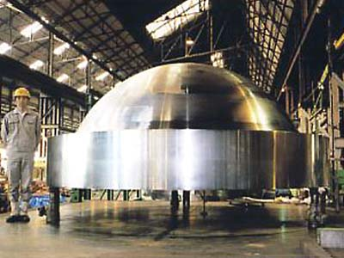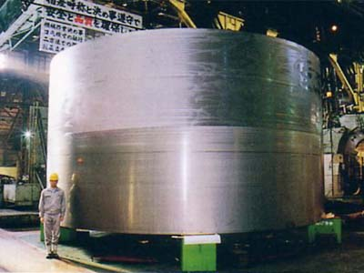

Fig. 6. Examples of forged parts for Reactor Pressure Vessels. (Left) Core region shell, (Center) Bottom petal, (Right) Closure head.

By using Powder metallurgy-HIP for Near-Net Shape (NNS) other advantages can be found. For example, alloy systems that are difficult to produce in the traditional AOD-casting route like XM13, 6-moly stainless steels, newly developed Hyper-Duplex for offshore to minimize corrosion and not yet invented alloys. An example can be seen in Fig. 7.

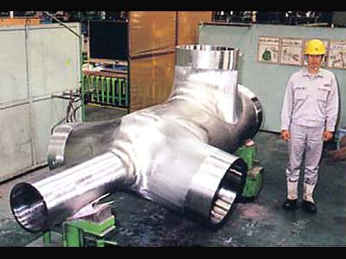

Fig. 7. PM/HIPP-NNS Offshore Deep-Sea Manifolds.

Summary and Conclusion
The Tera-HIP concept is a viable way forward to manage very large components for the Energy sector, Aerospace or Defense applications. Three different HIP system sizes have been presented. All available for manufacturing and delivery within 24 months after Contract signing.
The concept design is based on conventional proven technology used by Quintus Technologies for more than 60 years of operation. The concept is approved by international organizations, i.e. ASME, and the HIP unit can be certified to NADCAP, etc.

