Heat treatment inside the HIP unit

Nils Wulbieter^{1,a *}, Anna Rottstegge^{1,b}, Daniel Jäckel^{1,c}, Werner Theisen^{1,d}
¹Chair of Materials Technology, Ruhr-Universität Bochum, Germany
ªwulbieter@wtech.rub.de, ^{b}anna.rottstegge@reiloy.com, ^{c}jaeckel@fgw.de, ^{d}theisen@wtech.rub.de

Keywords: HIP, Heat Treatment, Phase Transformation, Hardenability, Latent Heat, Electrical Conductivity

Abstract

The possibility of combining densification or compaction of steel parts with a heat treatment has recently evolved due to the production of HIP units with a rapid quenching device. Several studies have already been performed to assess the cooling speed and show possibilities for heat-treating steels. It has already been shown that several alloyed steel grades could be hardened by quenching inside a HIP unit. This study aims to characterize the impact of high isostatic pressure during austenitization and quenching on the transformation behavior and resulting microstructure of hardenable steels. The effects of pressure during quenching was studied using two methods. The first method is to measure the latent heat during isothermal holding inside the transforming steel. The release or uptake of energy reveals information about the transformation sequence taking place. The second method is to use the electrical resistivity of a steel as a sensitive indicator for the existing phases and solution state of the steel during continuous cooling after austenitization. The two analytical methods both reveal that an isostatic pressure of 170 MPa is sufficient to shift the transformations to longer times and lower temperatures and hence increase the hardenability of hardenable martensitic steel.

Introduction
A HIP unit was recently introduced that offers the opportunity to quench inside the pressure vessel [1]. Since the introduction of this URQTM method (Uniform Rapid Quenching), various research teams have investigated the possibility to heat-treat steel inside a HIP unit. Mashl showed that hardening of a low-alloyed steel inside a pressure vessel leads to higher hardness compared to quenching in oil [2]. The same result was found by Weddeling [3,4]. Angré et al. have shown that a pressure of 170 MPa prolongs pearlite formation in steel specimens that are austenitized and subsequently held isothermally in the pearlite region [5].
These findings show that a high isostatic pressure of 170 MPa does have an influence on the phase transformations of steel. Therefore, the TTT (Time-Temperature-Transformation) diagrams of every steel are not applicable for HIP heat treatment. In order to correctly predict the hardness and microstructure resulting from an integrated heat treatment in the HIP unit, the TTT diagram as well as the pressure effect must be known. At ambient pressure, the measurement of variations in length during phase transitions (dilatometric measurements) is utilized to determine the temperature and time of a phase transition; however, this was not possible inside a HIP+URQTM unit until now.
In the present study, two methods that are capable of indicating phase transitions in theory are tested in a HIP unit and evaluated for two steels. One method, which also was utilized by Angré et al., is to measure the latent heat. The emission or absorption of heat is an indication for a phase transition. The second method of determining a phase transition is to measure the electrical conductivity. It is known from the literature that changes in the electrical conductivity during heating or cooling can be related to phase transformations or carbide precipitation [6,7]. Thus, it is of interest to evaluate the method of measuring the electrical conductivity as an indicator for a phase transition during quenching of steels inside a HIP unit.

Experimental

Materials
The latent heat was measured using a block made of X40CrMoV5-1, and the electrical conductivity was measured using 100V1. The chemical composition in mass-% of the materials is given in Table 1.

Table 1: Chemical composition of the investigated steels.
[mass-%] | C | Si | Mn | Cr | Mo | V
X40CrMoV5-1 | 0.37 | 0.93 | 0.32 | 4.88 | 1.28 | 0.92
100V1 | 1.0 | - | 0.22 | - | - | 0.1

Heat treatment in the HIP unit
The heat treatment was performed inside a hot isostatic press QIH9 with URQTM from Quintus Technologies AB. Technical details are given in [4]. The highest pressure at which quenching is possible is 170 MPa. The effect of pressure was analyzed at 25 and 170 MPa; 25 MPa was chosen as a comparatively low pressure that still offers a reasonable quenching efficiency. The heating rate was chosen to be 40 K/min, and heating and pressurizing took place simultaneously. Cooling rates could be changed in three steps (fast, medium, slow) by reducing the volumetric flow rate of the gas by changing the gas inlet nozzle.

Measurement of the latent heat during isothermal holding
The latent heat was measured using a block of X40CrMoV5-1 (Ø 70 x 20 mm) with a drilled hole for a core thermocouple (see Fig.1).

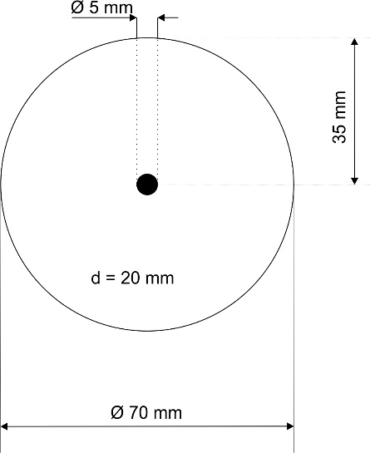
Fig. 1: Geometry of the X40CrMoV5-1 cylinder for measuring the latent heat. The black circle shows the position of the core thermocouple.
Two further thermocouples were used to control the furnace temperature. The material was austenitized at 1050 °C, held for 30 minutes, and quenched at maximum speed to the isothermal holding temperature. The holding temperatures ranged from 710 °C to 790 °C in increments of 10 °C. According to an isothermal TTT diagram of X40CrMoV5-1, the pearlite transformation takes place in this temperature region. All trials were run directly one after the other without changing the specimen or moving the thermocouples.

Measurement of the electrical conductivity
Another method of determining an in-situ phase transformation is to measure the electrical conductivity as a function of the cooling temperature. A phase transformation leads to a significant change in the measured electrical conductivity. The temperature and corresponding time at which the transformation takes place are shown by the intersection point of two tangents (Fig. 2).

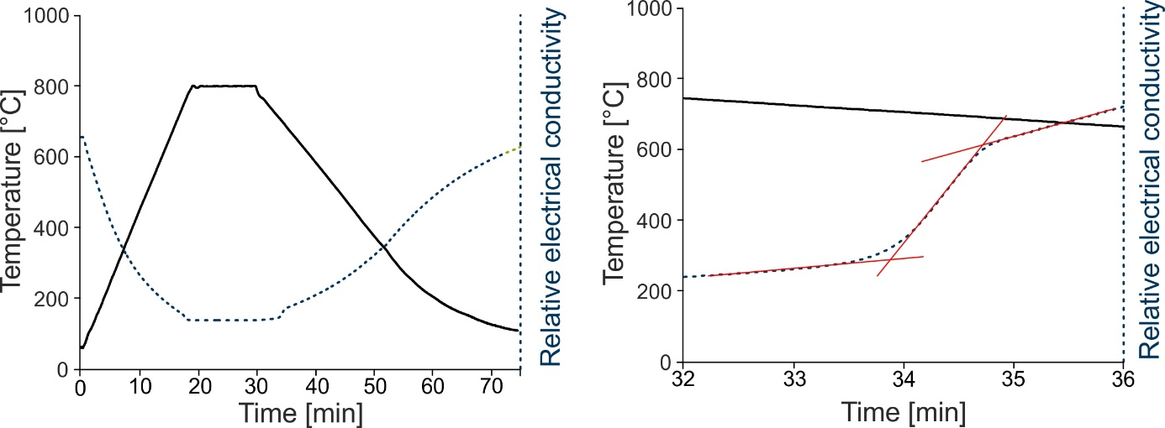
Fig. 2: Determination of the begin and end of phase transformation in the HIP unit due to changes in the relative electrical conductivity.

Steel 100V1 was used for this investigation because of its comparatively early pearlite transformation. Preliminary tests showed that the materials used for this measurement must have a significant length to increase the signal intensity. Therefore, wound 100V1 wire was used. The wire was 300 mm in length and 1 mm in diameter. The feedthroughs for thermocouples were reused as feedthroughs for measuring the electrical conductivity. To exclude the contact and conductor resistances, we opted for the four-wire technique. The electrical conductivity was measured and recorded using the nanovolt-/micro-ohmmeter Keysight 34420 A in combination with BenchVue Digital Multimeter Pro software. The contact points for introducing the current were the ends of the specimen wire, the contact points for measuring the voltage were 10 mm apart from the ends. Contacts were made with spot welding. Further technical details are given in [4]. Quenching trials inside the HIP were performed with two different pressures (25 MPa, 170 MPa) and three different cooling rates. The begin and end of this phase transformation, measured by changes in the electrical conductivity, were compared to a continuous TTT diagram of 100V1 at atmospheric pressure.

Results and Discussion

Pressure-induced delay of isothermal pearlite transformation of X40CrMoV5-1 measured via the latent heat

Fig. 3a shows the core temperature of the X40CrMoV5-1 (X40) block during quenching and isothermal holding at 760 °C under two different pressures (25 MPa, 170 MPa). It can be seen that the pearlite transformation takes place due to a significant increase in temperature during holding at 760 °C, which results from the latent heat. Furthermore, it can be seen that the maximum of the temperature peak decreases with increasing pressure and is shifted to longer times. The peak temperature correlates to the heat released during the phase transformation of austenite to pearlite. It can be concluded that the amount of released heat correlates to the amount of formed pearlite. This result shows the slowing down and delay of pearlite transformation under pressure. Whereas the begin of the phase transformation can not be measured precisely due to strong undercooling at high pressures, the end of the transformation can be precisely measured as a function of the holding temperature. In Fig. 3b, the end time of transformation is plotted against the holding temperature, which ranges from 700 °C to 770 °C. It can be seen that the end of phase transformation is clearly shifted to longer times.

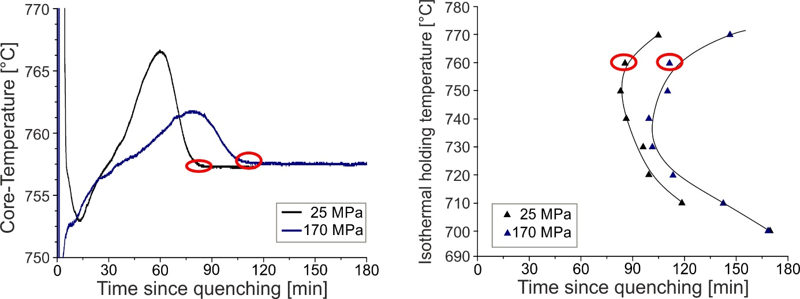

Fig. 3: a) Measured core temperature of the test block of X40CrMoV5-1 as a function of pressure at a constant furnace temperature of 760 °C. The red marks indicate the end of phase transformation. b) Shifted phase transformation under pressure at different holding temperatures.
This effect can be explained by the influence of pressure on the thermodynamic equilibrium according to further investigations at high pressure [8,9]. Therefore, a high pressure stabilizes the phase with a lower molar volume and higher density, respectively. In this case, austenite has a lower molar volume compared to martensite. This leads to an expansion of the austenite phase field and shifts the transformation line to lower temperatures. Therefore, stronger undercooling is needed to initiate pearlite transformation, while at the same time, the diffusion of elements during pearlite transformation slows down due to the lower temperature. The results can be verified with the corresponding microstructure. Fig. 4 shows the resulting microstructure after quenching and holding at 770 °C for 25 MPa (A) and 170 MPa for 1 hour (B). Sample B shows significantly smaller amount of pearlite compared to sample A, which is in agreement with the results of the latent heat measurements (Fig. 3). Furthermore, the microstructure of sample B is clearly finer. Thus, improved mechanical properties from HIP heat-treated samples are expected and will be the object of further investigations.
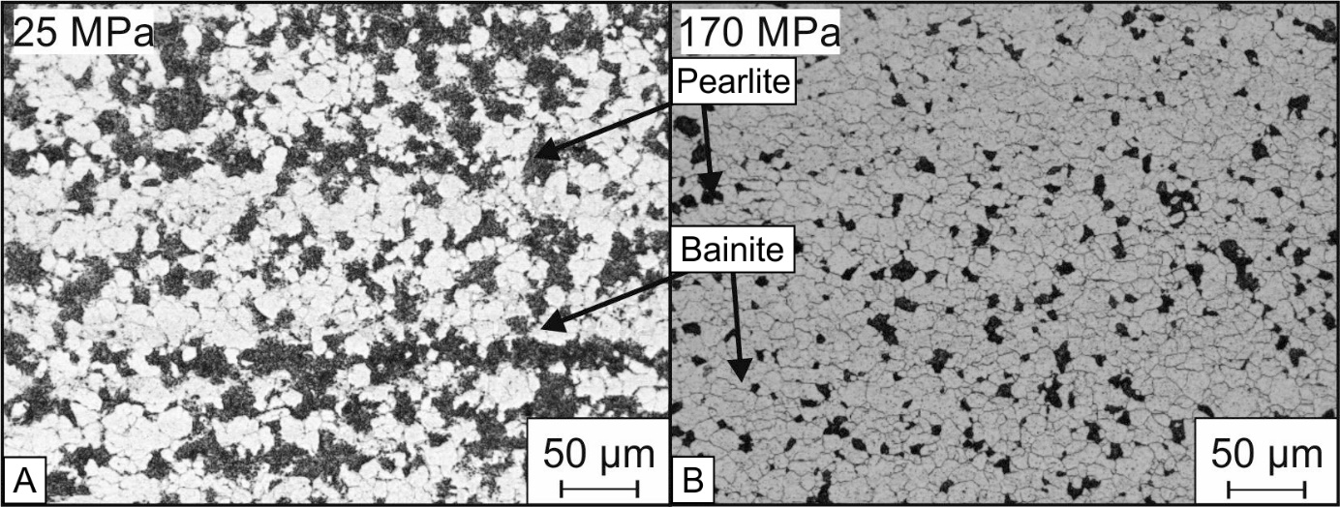
Fig. 4: Resulting microstructure of X40CrMoV5-1 after quenching from 1050 °C to 760 °C, holding for 1 hour and further quenching to room temperature under a pressure of (A) 25 MPa and (B) 170 MPa.

Pressure-induced delay in continuous pearlite transformation of 100V1 measured by electrical conductivity

Fig. 5a shows the measured cooling curves of 100V1 wire with three different cooling speeds at 25 MPa plotted into a TTT diagram of 100V1 at atmospheric pressure. The marked points represent the begin and the end of pearlite transformation measured by changes in the electrical conductivity. The measured transformation points are in sufficient agreement with the pearlite transformation curves in the TTT diagram. In contrast, Fig. 5b shows that under a high pressure of 170 MPa and high cooling rates, the phase transformation is shifted to lower temperature compared to the conventional TTT diagram. The reason for this is the same as that discussed in the previous section. The high pressure stabilizes the austenitic phase because of its lower molar volume and higher density, respectively [8,9]. Currently, from a technical point of view, it is not possible to vary the cooling speed in the QIH9 HIP unit in more steps than shown in the diagram. However, with further cooling steps it would be possible to create a TTT diagram under pressure for the steel of interest. For this reason, the measurement of electrical conductivity is a promising method to measure the begin and end of a phase transition in a HIP unit under pressure.

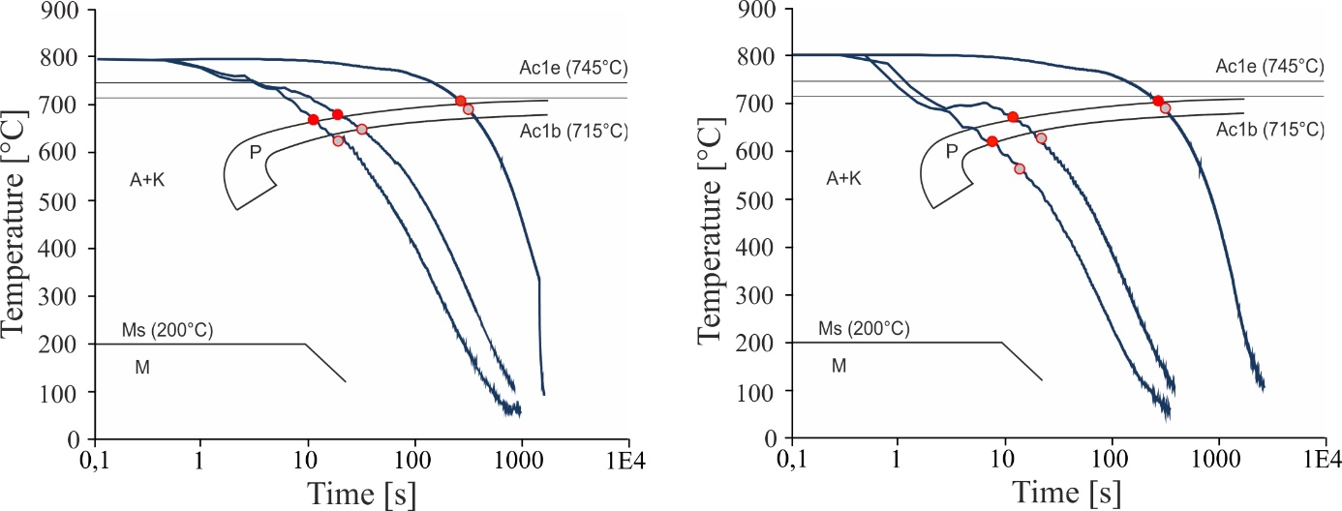
Fig. 5: Cooling curves of 100V1 as a function of three different cooling speeds and a pressure of (A) 25 MPa and (B) 170 MPa, plotted in a TTT diagram. The marked points indicate the measured phase transition due to changes in electrical conductivity.
Conclusions and Summary
Measuring the core temperature of massive parts and the electrical conductivity of wire specimens offers the possibility of detecting phase transitions during heat treatment inside a hot isostatic press. It was shown that both methods can be used to determine the austenite-to-pearlite transformation as a function of pressure in the HIP unit. Additionally, it was shown that a HIP pressure of 170 MPa is suitable for shifting the pearlite transformation to longer times and lower temperatures. Measurement of the latent heat is a comparatively simple method of determining isothermal TTT diagrams under HIP pressure. However, for the X40CrMoV5-1, the begin of pearlite transformation could not be measured precisely due to strong undercooling during quenching. Enhanced adjustment control could solve this issue. In contrast, it is possible to determine the begin and end of pearlite transformation by measuring the electrical conductivity. This leads to the possibility of generating TTT diagrams under pressure in HIP units.
The results of this investigation also show that HIP units that can quench with very high cooling rates are an interesting tool for the heat treatment of materials. This HIP heat treatment leads to better hardenability and a finer microstructure of the examined steels.
Further research needs to be undertaken to investigate the mechanical properties after such a HIP heat treatment.

References

- Ahlfors, M.: “The Possibilities and Advantages with Heat Treatments in HIP”, Proceedings of the 11th Conference on hot isostatic pressing, Stockholm (2014).
- Mashl, S.J., Eklund, A. and Ahlfors, M.: “Evaluation of Ultra-High Gas Pressure Quenching During HIP”, Proceedings of the 28th ASM Heat Treating Society, Detroit (2015).
- Weddeling A., Wulbieter, N., Theisen, W.: “Densifying and hardening of martensitic steel powders in HIP units providing high cooling rates. Powder Metallurgy 59 (1) (2016) pp. 9-19.
- Rottstegge, A.: “Strukturbildungsprozesse von Eisenbasislegierungen beim heißisostatischen Pressen”, PhD thesis, Ruhr-Universität Bochum (2017).
- Angré, A., et al.: Phase transformation under isostatic pressure in HIP. Powder Metallurgy 60 (3) (2017) pp. 167-174.
- Watson, T.W., Flynn, D.R. and Robinson, H.E.: “Thermal Conductivity and Electrical Resistivity of Armco Iron”, Journal of Research of the National Bureau of Standards 71C (4) (1967) pp. 285-291.
- Klein, S. et al.: “Diffusion process during cementite precipitation and their impact on electrical and thermal conductivity of a heat-treatable steel”, J Mater Sci 52 (2017) pp. 375-390.
- Nilan, T.G.: “Morphology and kinetics of austenite decomposition at high pressure”, Transactions of the Metallurgical Society of AIME 239 (6) (1967) pp. 898-909.
- Kakeshita, T., Saburi, T., Shimizu, K.: “Effects of hydrostatic pressure and magnetic field on martensitic transformations”, Materials Science and Engineering A 273-275 (1999), pp. 21-39.

