Experience in HIP diffusion welding of dissimilar metals and alloys
V.N. Butrim¹,^{a *}, A.G. Beresnev ^{1 a}, V.N. Denisov^{1 a}, A.S. Klyatskin^{1 a}, D.A. Medvedev^{1 a} and D.N. Makhina^{1 a}
¹ Joint-Stock Company “Kompozit”, 4 Pionerskaya Str., Korolev 141070,
Moscow Region, Russia
ª info@kompozit-mv.ru
Keywords: Welding, hot isostatic pressing, diffusion bonding, dissimilar metals.
Abstract. HIP solid-state diffusion welding is a controlled production operation at all the processing stages. Unlike other known solid-state welding techniques the HIP allows to provide strong and dense bonding with stability properties irrespective of the sizes and a configuration of the contact surfaces of materials welded. Here we present some special pilot examples of HIP diffusion welding of dissimilar metals and alloys: steel XM19-to-steel 316L, bronze Cu-Cr-Zr–to-steel 316L, copper M1–to-steel Fe-18Cr-10Ni-Ti-C, titanium alloy Ti-6Al-4V–to-steel Fe-18Cr-10Ni-Ti-C, single-crystal molybdenum-to-polycrystal molybdenum and titanium alloy-to- aluminum alloy.
Introduction
Solid-state diffusion welding (DW) is a main way to make a bimetallic structural material for space and nuclear application where a strong and dense bonding of materials with different chemical compositions is needed. This technology produces a monolithic joint resulting from a maximum closing of the contact surfaces due to their local plastic deformation at the increased temperature as well as the formation of metallic bond at the atomic level followed by a mutual diffusion of the components through the surface layers of the materials bonded [1]. Solid-state diffusion welding includes the following obligatory stages: the oxide film removal from contact surfaces, the actual contact formation, the surfaces activation, the chemical bond formation and diffusion. This sequence is true for all known methods of solid-state welding: cold bonding, explosion welding, percussion vacuum welding, friction welding, vacuum roll welding, induction and ultrasonic welding, etc. However, only the diffusion welding is the most universal and reliable method that allows controlling all four key technological parameters of process: temperature, pressure, dwell time and diffusion medium. The method of diffusion welding with use of hot isostatic pressing (HIP) can be considered as a kind of classical DW wherein technological parameters to be controlled within a wider range. Below we are examined the influence of the HIP diffusion bonding technological parameters on a bonded joint quality.

Temperature and pressure
Temperature and pressure are mutually dependent parameters in HIP technology. Specified pressure value in a HIP installation chamber is achieved by thermal expansion of working gas as the temperature increases. Thus, with computation of the necessary amount of gas at the room temperature performed, it is possible to reach the HIP operation conditions both in the temperature of 200°C to 1200°C and pressure of 20 MPa to 200 MPa ranges under any parameter combination. As the pressure is created by gas, the pressure value will be the same in any point of the HIP product contact surfaces despite the sizes and configurations of the parts bonded. As is well known [2], if all-round compression pressure is applied to a crystal the concentration of vacancies in this case will then be equal to

Ср =Со ехр (-РΩ/kТ), (1)

where: Со is the equilibrium component concentration at P=0; Ω is the atomic volume; Р is the all-round compression pressure; k is the Boltzmann's constant; T is the temperature. In this case the "minus" symbol denotes compression. That is, the amount of vacancies decreases with increase in pressure, such that the diffusive flow of atoms decreases too. In 1954 S. Storchheim et all [3] established that the phase Ni₃Al₂ was not formed even at pressure of 170-300 MPa, only the phase Ni₃Al was formed at pressure higher than 300 MPa, and intermetallic phases were not observed at a pressure about 500 MPa. Thus it is possible to increase or reduce diffusion rate with pressure increasing or decreasing. In so doing it is possible to reach such process conditions wherein the nucleation and growth of undesirable phases can be depressed at the contact zone.

Dwell time
Theoretically the duration of a HIP DW technological parameters can be unlimited and depends only on the end result required. HIP DW excludes the void volume along a boundary of the dissimilar metal diffusion bonding that caused by distinction in partial component diffusion coefficients, for example, nickel and copper (Kirkendall’s effect [3]), as owing to constantly applied pressure the formed vacancies are replaced with metal atoms having the largest diffusion velocity, here copper (Fig.1). Therefore, it is possible to create quite a wide transitional area in a contact zone of dissimilar metals (up to several hundred microns) by operating of HIP DW duration. Increasing the transitional area width will give the positive effect, for example, as damping layers between metals of greatly different coefficient of thermal expansion.
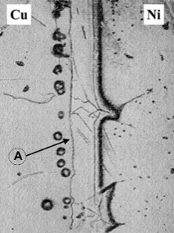 а | 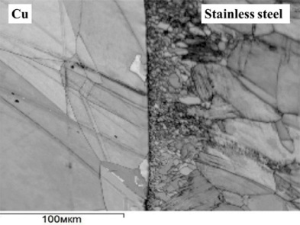 b | Fig.1 – Voids in copper of Ni-Cu diffusion bonding according to Le Claire A.D. and Barnes R.S. [3], A is the initial line of contact (a), absence of voids after HIP DW [4] (b)
Environment
Under the fine vacuum and at the high temperatures the dissolution of oxides promotes the formation of juvenile contact surfaces of the joints bonded.
Results of experiments
Steel XM19-to-steel 316L HIP Diffusion Bonding
Within an International Thermonuclear Experimental Reactor (ITER) program the diffusion welding has been performed of large-size parts of corrosion-resistant stainless steel AISI 316L and high-strength steel XM19 intended for prefabrication of the diverter attachment fitting (Fig.2a). The structural assembly mass is equal to 760 kg and the summary diffusion bonded surface area is nearly 770 cm² (Fig.2b) and 1260 cm² (Fig.2c). Failure of the bimetallic tension specimens takes place on the base metal of steel 316L outside the diffusion bonding zone (Fig.3a) as tensile strength of the HIP diffusion bonded zone is higher that tensile strength of steel 316L. In microstructure of the diffusion bonded zone steel XM19-to-steel 316L (Fig.3b) the presence of oxide phases is not detected. Besides, the common grains were observed in a contact area.
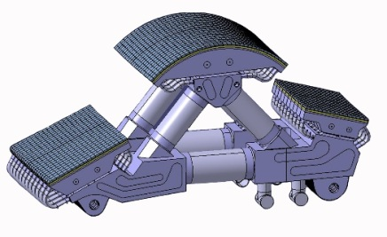 a | 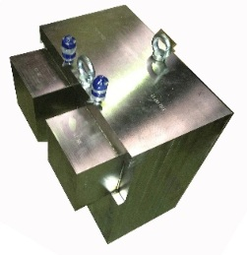 b | 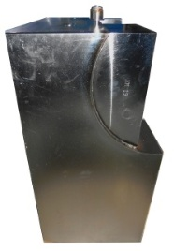 c
Fig.2 - Drawing of the diverter attachment fitting (a) and photography of the bimetallic steel XM19-to- steel 316L HIP DW assemblies (b,c).
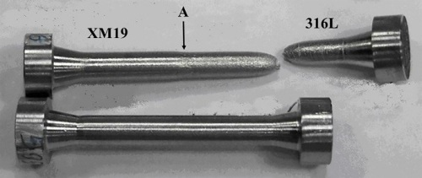 а | 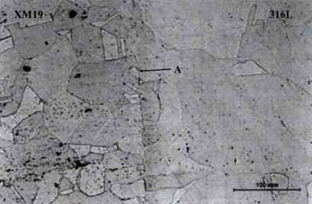 b
Fig.3 – The bimetallic tension specimens steel XM19-to-steel 316L before and after tensile testing (a), micrograph of a transitional layer (b), А – contact area [4].

Bronze Cu-Cr-Zr-to-steel 316L HIP Diffusion Bonding
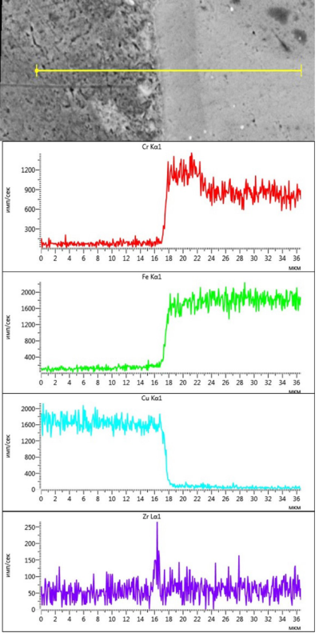
A bimetallic bronze Cu-Cr-Zr / steel 316L heat exchanger of the first ITER wall is a complicated design with internal chambers and cooling channels (Fig.4).

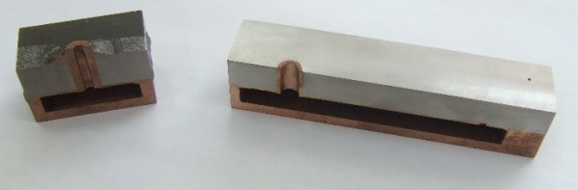 а

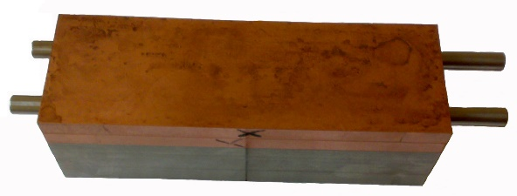 b

Fig.4 – The models of bimetallic bronze Cu-Cr-Zr / steel 316L heat exchanger of the first ITER wall with internal chambers (a) and cooling channels (b) [4] | Fig.5 – Typical electron micrograph of bronze/SS HIP DW joint, pink line shows the region of alloying element spectrum

Various welding processes for making pressure-tight contact surfaces of assembly parts prior to HIP are tested: manual argon-arc fusion welding; electron beam welding and automatic laser welding; the vacuum brazing and generally accepted one with the use of the capsule. Microstructure of the transitional layer of the HIP DW bronze-to-steel joint has much the same character despite the area and curvature of the contact surface. Thickness of a visible transitional layer is about 7μm. A chemical composition of this layer contains elements characteristic of both for steel and bronze, and the chrome content here is higher than in the steel. The diffusion depth of copper into the steel reaches 30μm beyond the transitional layer boundary. Diffusion depths of iron, nickel and chromium from steel into bronze are 50-100μm, 40-60μm and 5-7μm, correspondingly. In bronze, at a distance of 1-3μm from the transitional layer boundary a chain of inclusions takes place of up to 1μm and increased zirconium content, the nature of its formation being not determined (Fig.5). The post-HIP model of the first ITER wall was subjected to heat treatment in bronze standard mode: water hardening from temperature 980°C with the subsequent aging. Rapid water hardening did not lead to discontinuity of the DW bimetallic joint. Failure of bimetallic tension specimens takes place on the base metal of bronze. Average values of the room temperature tensile strength are over the range of 398-457 MPa, and at a temperature of 250⁰C are within 330-370 MPa.
Copper-to-stainless steel HIP Diffusion Bonding
Copper-to-stainless steel adapters (Fig.6a) were made of 100 mm-diameter HIP DW-bimetallic bar-piece blanks followed by machining. The capsules each have 4 pairs of the piece blanks. The analysis of the microstructure testifies that the transitional layer of the HIP copper-to-stainless steel diffusion bonding has 100% density, and essential grain grinding is observed on the steel side (Fig.6b). Bending test of a 7x30x80-mm test piece cut from the bimetallic blank did not lead to its failure (Fig.6с)
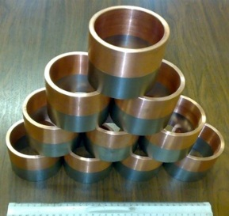 a | 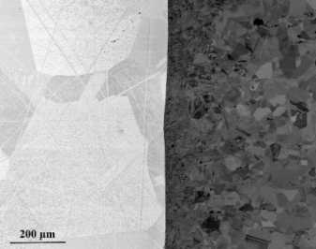 b | 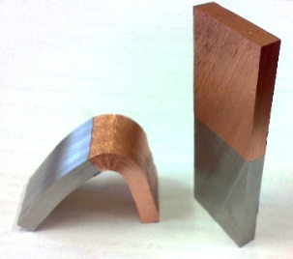.c
Fig.6 – Copper-to-stainless steel adapter (a); micrograph of the transitional layer (b); a 7x30x80-mm test piece before and after bending tests (c) [4].
Ti6Al4V alloy-to-stainless steel HIP Diffusion Bonding
Direct Ti6Al4V alloy-to-stainless steel HIP DW does not give positive results. With increase in iron concentration more than 0,1%, intermetallic TiFe and TiFe₂ are formed in titanium alloys, which embrittles the diffusion bonding transitional layer. In practice [5], niobium and copper spacer-foils are recommended for use in this case. Niobium and titanium form a continuous number of the solid solutions, and therefore, DW of them is not difficult. However, when reacted with carbon from steel niobium forms carbides along the total contact area, which embrittles the diffusion bonding transitional layer too. Carbon-tight, the copper spacer-foil located between niobium and steel does not allow forming niobium carbides. The relation between copper and niobic foil thicknesses is of 1.5 − 3.0 thereby initiating the failure on the base metal of the copper spacer-foil, which is responsible for stable strength properties and good ductility of the bimetallic joint obtained [6].
Ti6Al4V alloy-to-Fe18Cr10Ni1Ti stainless steel adapters were made of 50mm-diameter HIP bimetallic bar-piece blanks followed by machining. The capsules each have 6 pairs of the piece blanks (Fig.7a). All the HIP diffusion bonding contact zones have 100%-densities and no ply-separations and pores observed. The diffusion width of the titanium-to-niobium contact zone is up to 35μm (Fig.7b). Due to diffusion of niobium into titanium the α+β titanium solid-solution structure of Ti6Al4V alloy is transformed to the so-called β-phase. The diffusion width of the niobium to copper contact zone is up to 6μm. Structural changes in the field are not observed.
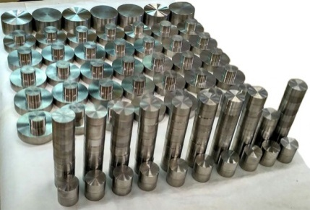а | 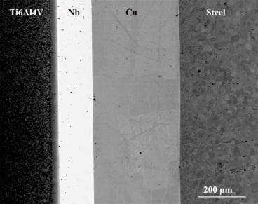 b
Fig.7 - Titanium-steel piece blanks (a), micrograph of the Ti6Al4V/Nb/Cu/SS joint [4] (b)

With diffusion from steel into copper, iron and nickel atoms diffuse into copper at the depth of up to 15μm and 5μm, respectively, of the visible contact line. The depth of copper diffusion into steel is observed up to 5μm only. Thus the common diffusion width of copper-to-steel diffusion bonding transitional layer reaches 20μm. Room temperature tensile strength (σ_{в}) of the HIP diffusion bonding Ti6Al4V alloy-to-stainless steel is equal to 439 MPa. This characteristic is stable along the total diffusion bonding area: the dispersion of values σ_{в} is equal to 0.44%. Ti6Al4V / stainless steel adapters have passed hydrostatic test at pressure of 7000 MPa for 20 min without failure.
Single-crystal molybdenum-to-polycrystalline molybdenum HIP Diffusion Bonding
Single-crystal molybdenum (Mo_{single}) is of choice material for producing the first mirrors of 200mm x100mm to be used in a diagnostics system for ITER Hydrogen Lines Spectroscopy [7]. Both the severe quality requirements and the complicated 250mm-diameter blank technology determine very high price of the molybdenum single crystals. Therefore, a composite mirror design has been proposed. In this design, the reflecting part, produced from several parts of single-crystal molybdenum with the same orientation in the crystallographic planes, is joined by HIP DW with the extra pure polycrystalline molybdenum (Mo_{poly}) of a relatively low price. The technology of joining the molybdenum single crystal with the base made of polycrystalline molybdenum should not cause recrystallization of the single-crystal molybdenum. The mechanical properties of the diffusion bonding should be higher than the loads applied while mirror manufacturing (milling and turning, grinding, and polishing, etc.) and servicing. The HIP diffusion bonding between single-crystal molybdenum and polycrystalline molybdenum was achieved through the titanium foil interlayer of 0.1mm thick (Ti_{0.1}) [7]. The titanium and molybdenum form a continuous number of the solid solutions and therefore there is no danger of forming any embrittlement phases in the contact zone. Room temperature tensile strength (σ_{в}) of the HIP diffusion bonding Mo_{single}/Ti_{0.1}/Mo_{poly} shows more than 380 MPa. Failure happens on a titanium foil interlayer and has viscous character. Loss of the mirror heat conductivity due to a titanium interlayer is less than 5%. A sharply defined contact line and a visible homogeneous light transitional zone of ~ 5-10μm-thick being a solid solution of molybdenum in titanium is observed on the both sides of the titanium foil interlayer within a diffusive zone of the Mo_{single}/Ti_{0.1}/Mo_{poly} bonding (Fig.8a). The composite single-crystal molybdenum mirrors having working surface area of 5000mm² and 8000 mm² (Fig.8b) have successfully passed the tests carried out according to a special program, including tests in the conditions of heating to a temperature of 250°C under hydraulic pressure up to 50 atm.
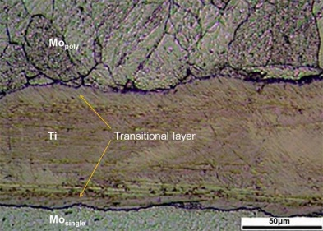 a | 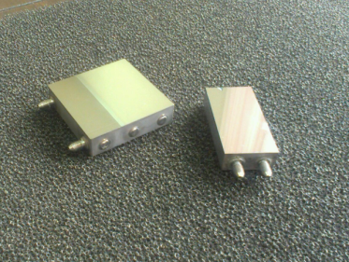 b
Fig.8 - Micrograph of Mo_{single}/Ti_{0.1}/Mo_{poly} bonding (a) and experimental composite single-crystal molybdenum mirrors(b) [7]
Titanium alloy-to-aluminum alloy HIP Diffusion Bonding
The fusion welding of bimetallic titanium alloy/aluminum alloy is impossible because intermetallic TiAl₃ and TiAl are formed in alloying zone at 1340⁰C and 1460⁰C, respectively. Ultimate solubility of titanium in aluminum is as low as 0.26-0.28% and 0.07% at 665⁰C and at the room temperature, respectively. HIP DW allows for obtaining the titanium alloy-to-aluminum alloy joint at a temperature of 500-560⁰C without formation of the intermetallic in the contact zone. To increase the thin-walled bimetallic design serviceability it has been suggested that on the surface of titanium part a relief can be carried out as a thread profile having an identical radius of curvature equal to ½ height of the thread ledge with a base size equal to doubled height of the thread ledge [8]. The role of the relief is in obtaining a more developed surface in the contact zone and its activation due to intensity of the local shear deformation along the profile thread ledges and hollows and formation of the physical contact of the metals during HIP, which finally leads to increase in mechanical properties and tightness. The existence of curvatures causes lack of stress concentrators. The positive effect is reached when the relief period quantity is not less than two of them on the bimetallic design wall thickness (Fig.9a). Shear strength (τs) of the samples with two relief periods is 119MPa, which is twice higher than that of the joint without relief (τs =58 MPa). Intermetallic phases are not detected in the contact zone microstructure (Fig.9b).
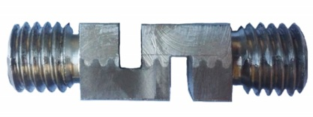a | 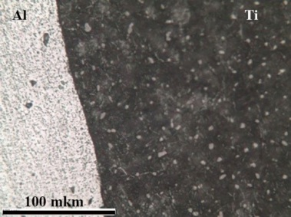 b
Fig.9 – Bimetallic Ti-Al shear-test specimen (a), a micrograph of cross section of Ti-Al bonding (b)
Conclusion
The HIP solid-state diffusion welding is a controlled production operation at all the processing stages. Unlike other known solid-state welding techniques the HIP allows for providing the strong and dense bonding with stability properties despite the area and configurations of the contact surfaces of materials welded.

Referenses
[1] G. B.Konyushkov, R. A. Musin, Special Methods of Pressure Welding, IPR-Media, Saratov,2009, in Russian.
[2] B.S. Bokstein, Diffusion in Metals, Metallurgy, Moscow,1978, in Russian.
[3] W. Seith, Diffusion in Metals, Foreign Literature, Moscow,1958, in Russian.
[4] A.S. Klyatskin, V.N. Denisov, V.N. Butrim [etc.], HIP Diffusion Welding, Perspective materials 11 (2011) 362-369, in Russian
[5] N. F. Kazakov, Diffusion Welding of Metals, Mashinostroenie, Moscow,1981, in Russian.
[6] V.N. Denisov, A.S. Klyatskin, V.N. Butrim [etc], RU Patent 2612331 (2017).
[7] V.N. Denisov, A.S. Klyatskin, V.N. Butrim [etc], Producing Composite Single-Crystal Molybdenum Mirrors by Diffusion Welding in the Hot Isostatic Pressing Conditions, Welding International, 7, (2017) 1-6
[8] V.N. Denisov, A.S. Klyatskin, V.N. Butrim [etc], RU Patent 2620402 (2017).

