High Pressure Heat Treatment - Phase Transformation Under Isostatic Pressure in HIP

Magnus Ahlfors1,a *, Alexander Angré2,b , Dimitris Chasoglou3,c and Linn Larsson4,d

1Quintus Technologies LLC, Lewis Center, OH, US

2Carpenter Powder Products AB, Torshälla, Sweden

3Höganäs AB, Höganäs, Sweden

4AB Sandvik Materials Technology, Sandviken, Sweden

amagnus.ahlfors@quintusteam.com, baangre@cartech.com, cdimitris.chasoglou@hoganas.com, dlinn.larsson@sandvik.com

**Keywords:** HIP, High Pressure Heat Treatment, URQ

**Abstract**

Modern HIP furnaces equipped with forced convection cooling enable very fast cooling rates under isostatic pressure. This does not only give shorter HIP cycles and increased productivity but also allows complete heat treatment cycles to be performed in the HIP unit. It has been shown in previous studies that extreme pressures of several thousand bar can push phase transformation towards longer times for the Fe-C system. The new URQ HIP cooling systems give the opportunity to investigate the impact of pressures up to 2000 bar on phase transformation time dependency. Two materials were used in this study and a comparison of austenite phase transformation time at 100 bar and 1700 bar was performed. The study was performed by isothermal heat treatment of specimens for a specific time followed by quenching. To evaluate the influence of pressure on hardenability, the phase fractions were evaluated using grid method on SEM images. The study found significant influence of HIP pressure on the phase transformation kinetics of the two different steels studied.

Introduction

Hot Isostatic Pressing (HIP) is a process mainly used to consolidate powder into solid high-quality parts or to eliminate internal defects in parts produced by casting, additive manufacturing or MIM by applying a high isostatic gas pressure and a high temperature. Traditionally the cooling in the HIP system is relatively slow and could take up to 24 hours. In the mid 1980’s the URC HIP furnaces was introduced with a forced convection cooling technology that significantly decreased the cooling time in the HIP system and thereby reduce the total HIP cycle time by up to 50% [1]. In 2010 the URQ HIP furnaces was introduced with achievable cooling rates up to 3000 °C/min. The URQ HIP quenching furnaces gives the possibility to perform traditional heat treatments, e.g. martensitic hardening, in the HIP furnace during the HIP cycle.

The forced convection cooling technology (URC, URQ) is based on a wire wound pressure vessel design where a thin cylinder is water cooled from the outside and a wire wound package outside the cooling channels. To protect the pressure vessel from heat during a HIP cycle, an insulated furnace within the pressure vessel is used to achieve high temperature for the load in the hot zone but a cool environment closest to the pressure vessel walls. During the forced convection cooling the hot gas inside the furnace is moved to the outside of the furnace at the same time as the colder gas outside the hot zone is pushed into the furnace chamber. This mixing of gas will lead to a cooling effect and at the same time the hot gas outside the furnace is cooled down by the water-cooled pressure vessel walls like a heat exchanger which adds to the cooling effect. In the case of a URQ furnace a heat exchanger is also placed inside the pressure vessel, outside the furnace, to increase the cooling rate even more. In Figure 1, a schematic image of a URQ furnace during cooling is presented.

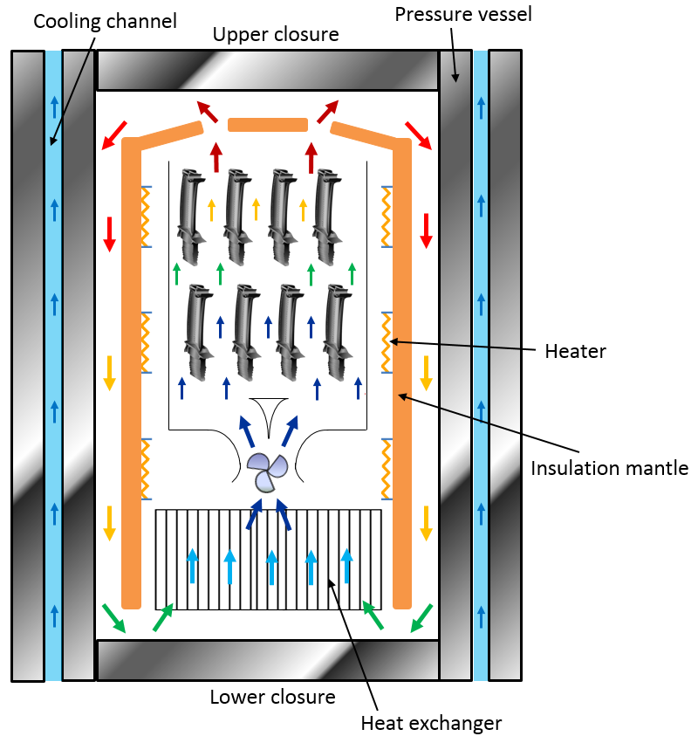

*Figure 1. Schematic image of the cooling in a URQ HIP furnace*

When looking at performing quenching of a material inside the HIP during a HIP cycle the question came up if the high isostatic pressure on the material during the quenching would make any difference from the conventional quenching methods at atmospheric pressure.

A few relatively old geological studies have shown that high pressure during cooling pushes the phase transformation from austenite to pearlite and bainite towards longer times. Most studies have been evaluating very high pressures; 20-42 kbar. Kuteliya et al. studied the effect of 20 kbar hydrostatic pressure on austenite transformation and saw that high pressure slows down the transformation of austenite. [7] In a study made by Radcliffe et al. it was shown that both the initiation and the rate of austenite transformation in iron-carbon alloys are retarded at 42 kbar, relative to the reactions at 1 atm. [8] Austenite – pearlite transformation rates at 34 kbar pressure was studied by Hilliard et al. and it was found that the effect of the pressure was a decrease in transformation rate. [9]

A.Weddeling has used the rapid quenching HIP technology to study the influence of high pressure on microstructure. Specimens of low alloyed steel were quenched under pressure in HIP and compared to samples quenched with the same cooling rate in a dilatometer at atmospheric pressure. A certain amount of bainite was formed during quenching but the specimen quenched in the HIP featured less bainite that also had finer structure compared to the dilatometer specimens. These results suggest that the bainite formed under pressure is not only formed later in time but also at lower temperatures at which nucleation is supported and diffusion is retarded compared to bainite formation at higher temperatures. [6]

The object of this study was to investigate if a typical HIP pressure of 1700 bar is enough to shift the austenite to pearlite phase transformation towards longer times and if so of what order of magnitude. Shifting the phase transformation towards longer times would imply an increased hardenability which could be very beneficial in industry.

For this study, two different steels were studied. For each material a comparison of austenite to pearlite phase transformation time at 100 bar and 1700 bar was performed. The study was performed by isothermal heat treatment of specimens for a specific time followed by quenching. To evaluate the influence of pressure on the hardenability, the phase fractions were evaluated by grid method in SEM together with hardness measurements. See Figure 2 for a schematic presentation of the thermal profiles of the different HIP cycles.



*Figure 2. Schematic presentation of experimental HIP cycles*

Experimental

Material

*4340*

Steel 4340, as well denominated 34CrNiMo6 (EN name) and SS 2541, is a widely used steel for quenching and tempering. The chemical composition of the 4340 material used in the study is displayed in Table 1.

*Table 1. Chemical composition of the 4340 material according to specification.*

|  |  |  |  |  |  |  |  |  |
| --- | --- | --- | --- | --- | --- | --- | --- | --- |
| Elements (%) | C | Mn | Si | Cr | Ni | Mo | Cu | Fe |
| 4340 | 0.37 | 0.74 | 0.26 | 1.45 | 1.50 | 0.19 | 0.16 | bal. |

*AstaloyTM Mo*

Astaloy Mo is a pre-alloyed Fe-Cr material for metal powder component production produced by Höganäs AB. The chemical composition of the Astaloy Mo material used in the study is displayed in Table 2.

*Table 2. Chemical composition of the Astaloy Mo material according to specification.*

|  |  |  |  |
| --- | --- | --- | --- |
| Elements (%) | C | Mo | Fe |
| Astaloy Mo | 0.6 | 1.5 | bal. |

The material was water atomized, uniaxially pressed and sintered into samples with the density 7.47 g/cm3 and the dimensions Ø = 25 mm and h = 25 mm at Höganäs AB, Höganäs, Sweden.

TTT diagrams

*4340*

The 4340 material was chosen among several similar steels consulting their Time Temperature Transformation (TTT) diagrams. The factors in favour for 4340 were that it was a fairly common material and that the time to pearlite start was sufficient for the experiments. Moreover, the pearlite nose seemed to be located at the same temperature as for Astaloy Mo which could allow to co-HIP the two materials and thus reduce the number of HIP cycles needed for the experiment. TTT diagrams for 4340 were found in literature and educational material and additionally JMatPro was used to calculate a diagram. As can be seen in Figure 3 and 4, the TTT diagrams vary quite a bit among themselves and this had to be taken into account deciding isothermal hold time intervals.

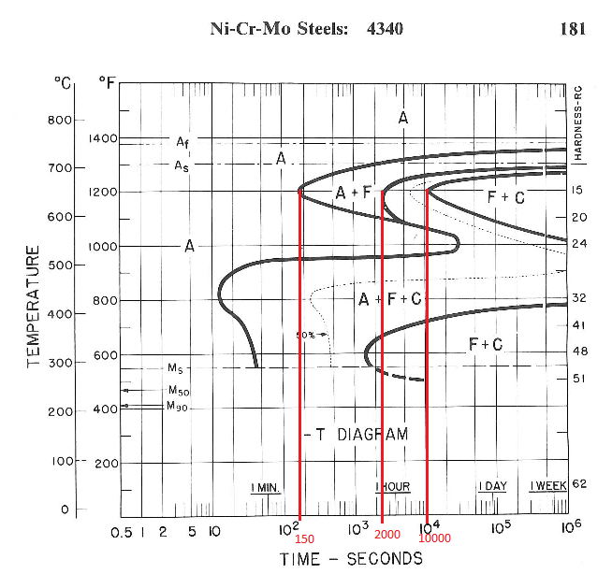

*Figure 3. TTT diagram for 4340 [10]. 1% ferrite at 150 s, 1% pearlite at 2000 s and 99% pearlite at 10000 s at 650 °C.*

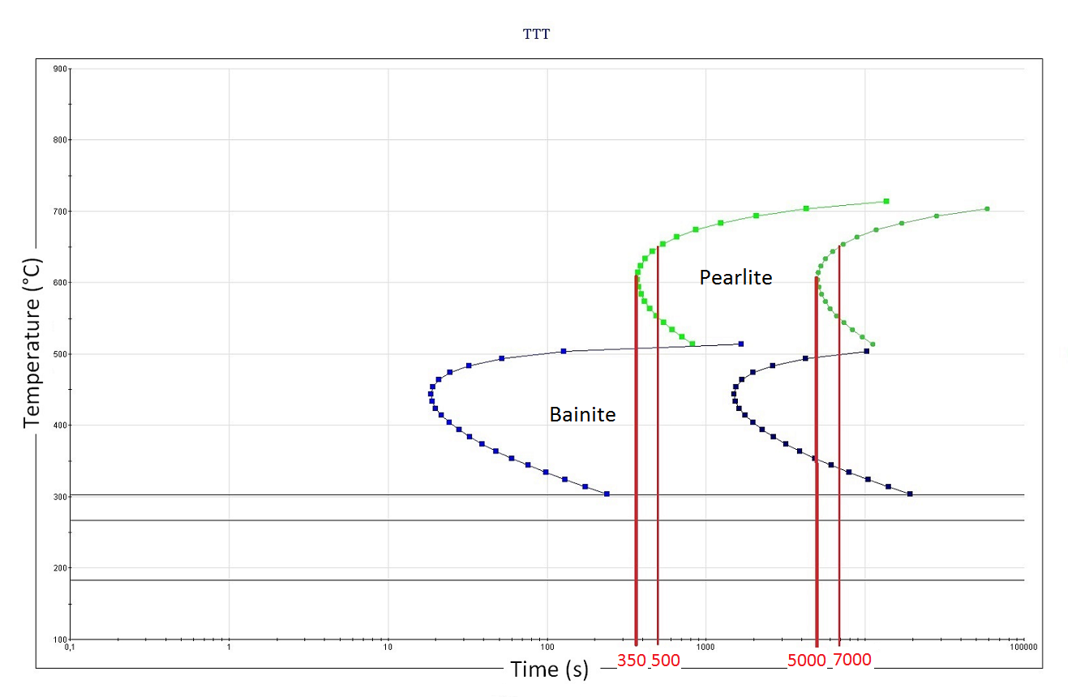

*Figure 4. TTT diagram for 4340 with grain size 15 µm, calculated using JMatPro. 0.1% pearlite at 500 s and 99.9% pearlite at 7000 s at 650 °C.*

*AstaloyTM Mo*

For Astaloy Mo, TTT diagrams for different C content were calculated using JMatPro. Increased C content shifts the curves towards lower temperatures and longer times. A carbon content of 0.6% was chosen, mainly due to sufficient time to pearlite start and also that at this C content no ferrite transformation seemed to occur before pearlite transformation, see Figure 5. Calculations using different grain size values in JMatPro showed relatively large variations with varying grain size where smaller grain size pushes the curves towards shorter times. The actual measured grain size of the samples was used as in-data.

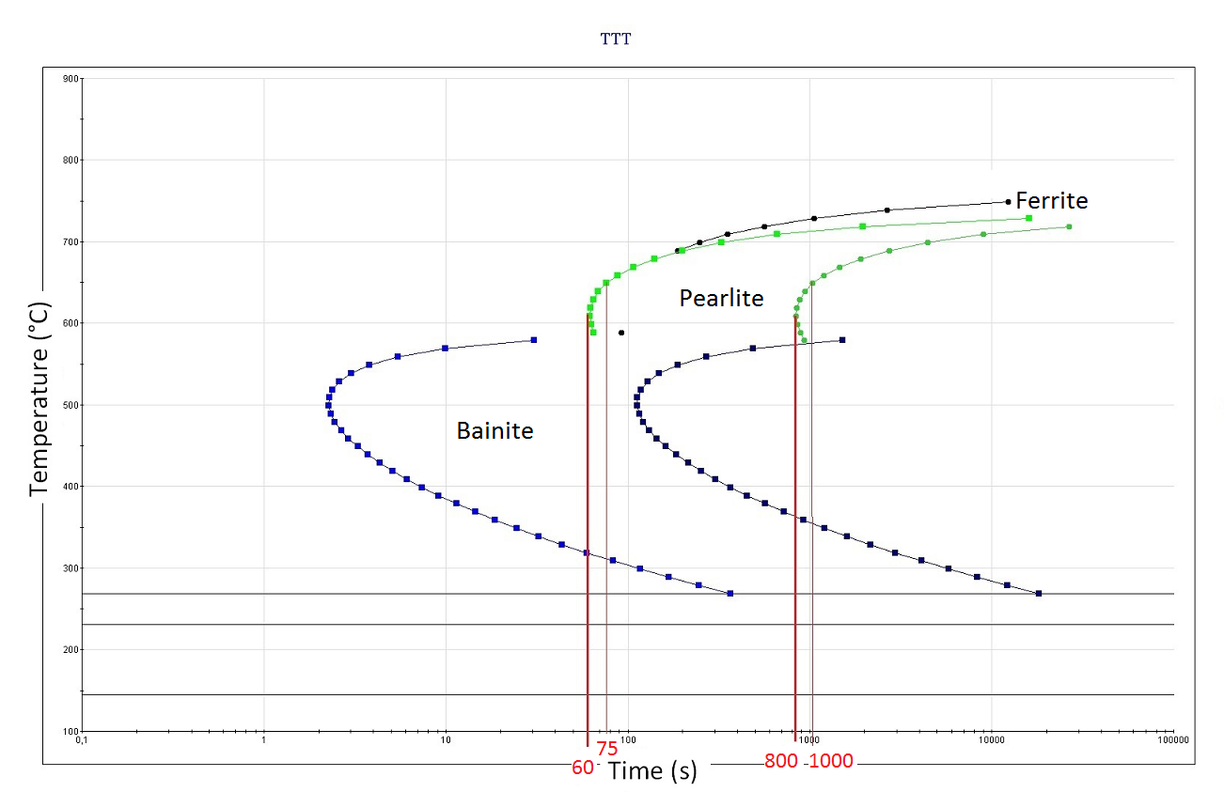

*Figure 5. TTT diagram for Astaloy Mo with grain size 20 µm, calculated using JMatPro. 0.1% pearlite at 75 s and 99.9% pearlite at 1000 s at 650 °C.*

Trials

Suitable isothermal temperature was selected consulting available TTT diagrams for the two materials. Subsequently, suitable hold times for each material were also selected based on the TTT diagrams. The HIP cycle is designed so that the material initially is subjected to austenitization temperature, 850 °C, for 15 minutes followed by fast cooling down to selected isothermal temperature, 650 °C, where the material is kept for the chosen hold time followed by rapid quenching to room temperature. All HIP cycles were performed at low and high pressure separately. The main challenge for running the HIP cycles was to achieve the same thermal profile for the materials for the two different pressures.

All HIP trials were performed with solid cylindrical specimens of the materials with size 25x25 mm. Thermocouples were placed in the gas of the HIP furnace hot zone and at least one thermocouple in the center of the specimen for all HIP trials, see Figure 6. The samples were prepared with holes, drilled halfway through the height of the sample in which the thermocouples were placed in order to measure the temperature in the center of the sample. All HIP cycles were performed in the QIH9 URQ HIP at Quintus Technologies AB, Västerås, Sweden, permitting cooling rates of up to 3000 °C/min in the gas, i.e. about 45 °C/s.

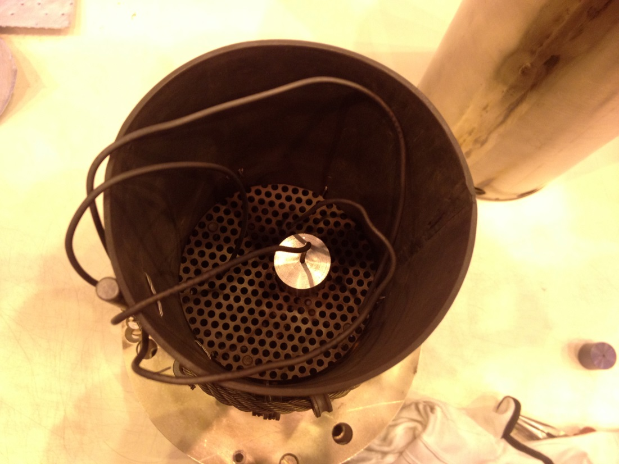

*Figure 6. Set up of sample with thermocouple in the HIP furnace.*

Table 3 shows the test matrix of all the trials performed within the project. Typical HIP log curves are presented in Figures 7 and 8, displaying the HIP log curves for 4340 with 3000 s hold time at low and high pressure respectively.

To be able to use the uniform rapid quenching feature, lower pressure than the maximum HIP pressure of 2000 bar had to be used as maximum pressure for the trials. 1700 bar was considered sufficient for the use of URQ and also high enough to give relevant results of the influence of HIP pressure on phase transformation. The low-pressure cycles were decided to be run in the HIP as well, in order to make the high and low pressure thermal profiles as similar as possible. To be able to control the HIP temperature and rapidly quench the material 100 bar had to be used as minimum pressure.

*Table 3. Matrix of the trials performed within the project.*

|  |  |  |  |  |  |
| --- | --- | --- | --- | --- | --- |
| Sample | Austenitization temperature [°C] | Austenitization time [min] | Isotherm [°C] | Pressure [bar] | Hold time [s] |
| 4340 | | | | | |
| 4340 1000s | 850 | 15 | 650 | 100 | 1000 |
| 4340 1000s P | 850 | 15 | 650 | 1600 | 1000 |
| 4340 1500s | 850 | 15 | 650 | 100 | 1500 |
| 4340 1500s P | 850 | 15 | 650 | 1700 | 1500 |
| 4340 2000s | 850 | 15 | 650 | 100 | 2000 |
| 4340 2000s P | 850 | 15 | 650 | 1700 | 2000 |
| 4340 3000s | 850 | 15 | 650 | 100 | 3000 |
| 4340 3000s P | 850 | 15 | 650 | 1700 | 3000 |
| 4340 6000s | 850 | 15 | 650 | 100 | 6000 |
| 4340 6000s P | 850 | 15 | 650 | 1800 | 6000 |
| Astaloy Mo, 0.6% C | | | | | |
| AstMo 500s | 850 | 15 | 650 | 100 | 500 |
| AstMo 500s P | 850 | 15 | 650 | 1700 | 500 |
| AstMo 1000s | 850 | 15 | 650 | 100 | 1000 |
| AstMo 1000s P | 850 | 15 | 650 | 1600 | 1000 |

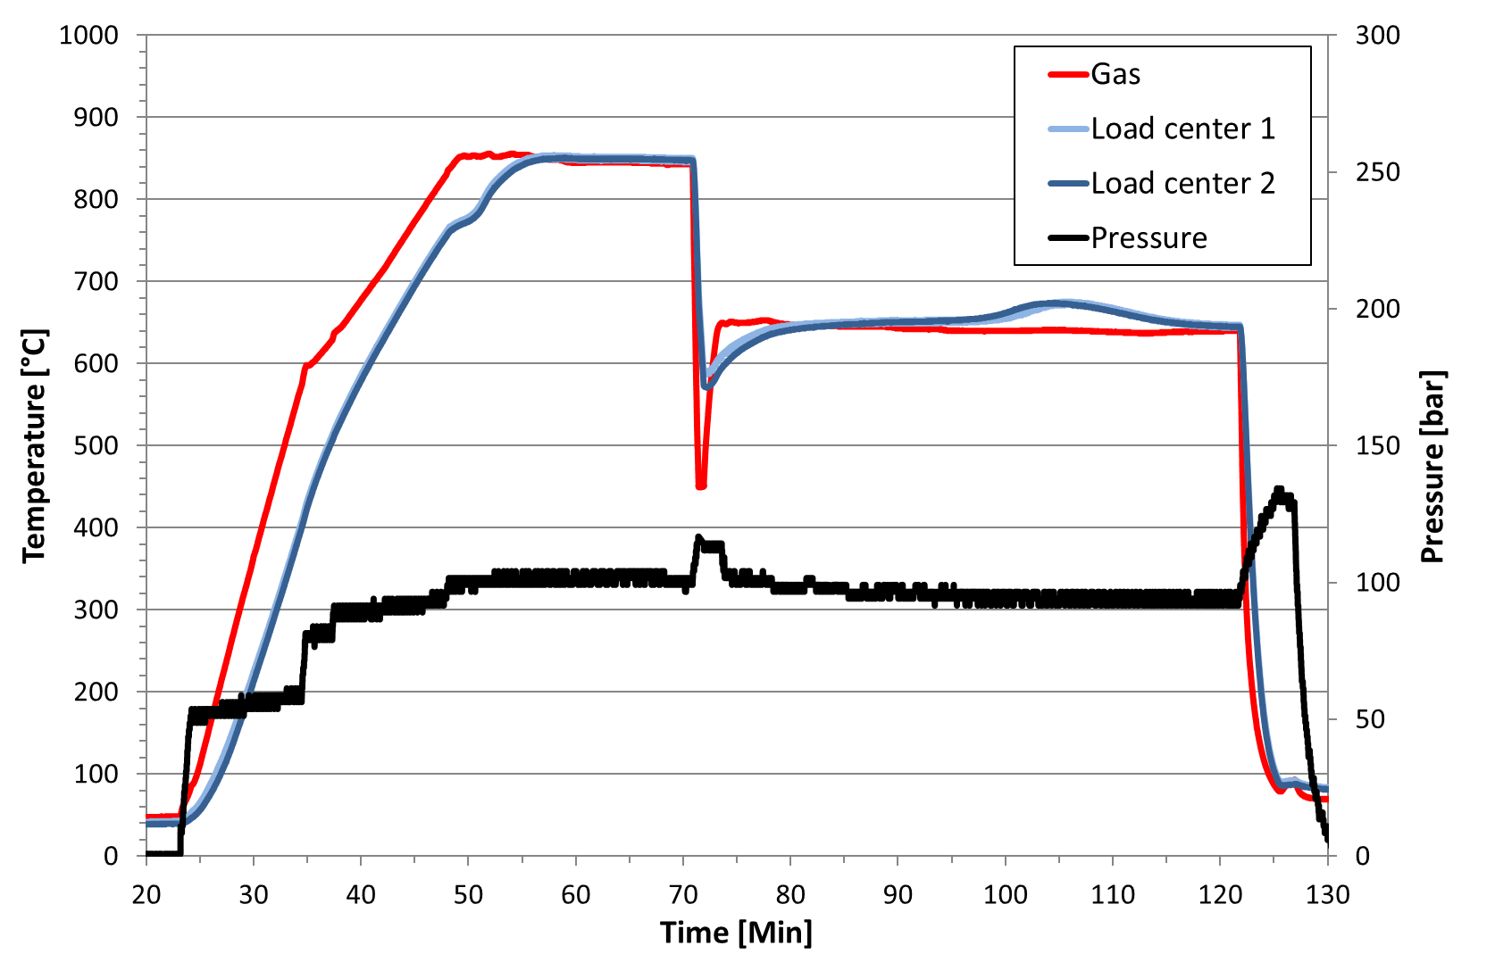

*Figure 7. HIP log curve for 4340, 3000 s, 100 bar.*

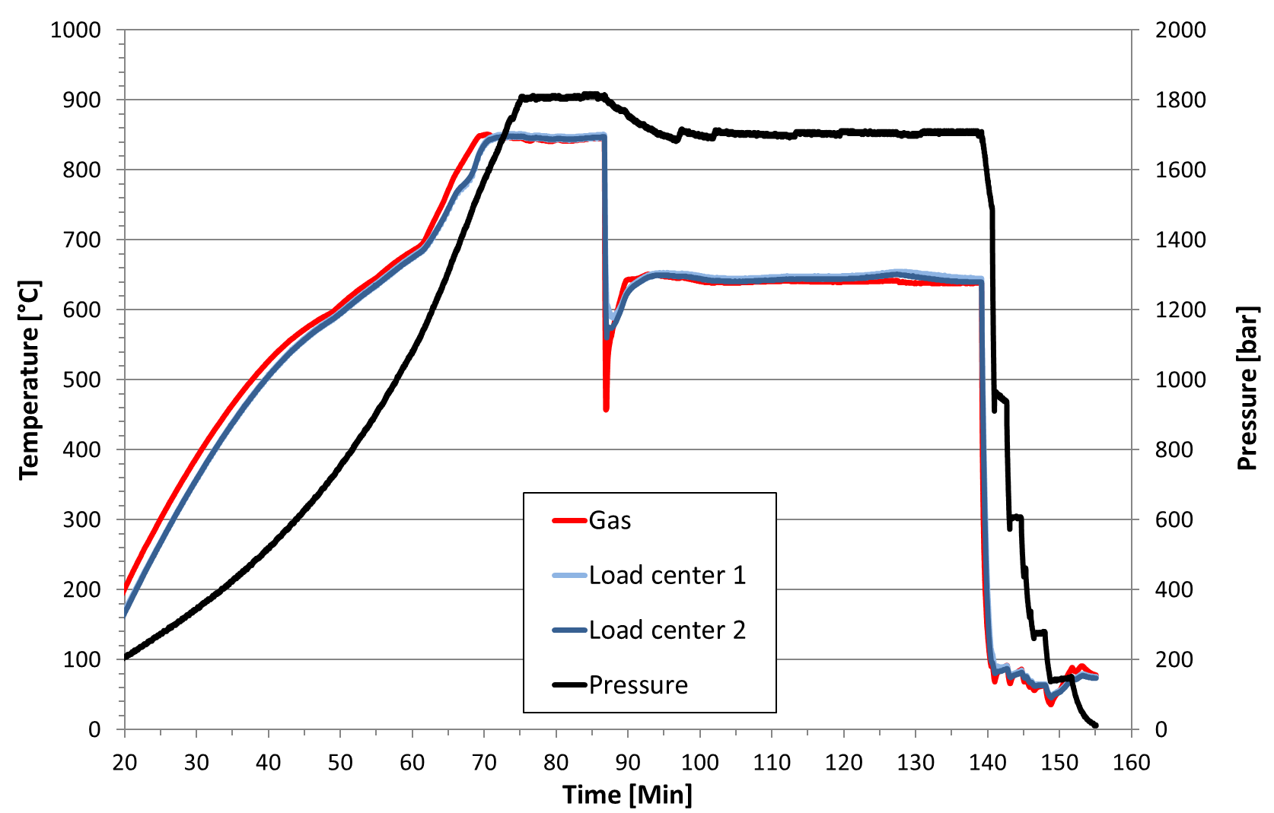

*Figure 8. HIP log curve for 4340, 3000 s, 1700 bar.*

Phase fraction evaluation

The phase fraction evaluation was performed at Swerea KIMAB AB, Kista, Sweden. Prior to evaluation, each specimen was wet ground, polished with diamond paste to 0.25 µm and subsequently electrolytically polished (20V, 20s). The phase fraction evaluation was performed using the grid method on SEM images. The FEG-SEM equipment used in this work was a LEO 1530 with Gemini column, upgraded to a Zeiss Supra 55 (equivalent). The SEM settings used was 5 kV with aperture 30 µm and the InLens detector. The micro Vickers hardness testing was performed in a Qness Q10 A+ hardness tester with a load of 1 kg.

Results

Figure 9 and 10 display the results for 4340 in form of comparisons of phase amount transformed to pearlite and hardness, at low and high pressure, respectively. The graphs displaying the equivalent results for Astaloy Mo are shown in Figure 11 and 12.

To illustrate the pearlitic/martensitic microstructures of the samples, SEM images for 4340 with 2000 s hold time at low and high temperature are displayed in Figure 13 and 14 respectively.

For all the HIP log curves with longer isothermal times a “bump” in temperature can be seen during the 650 °C isotherm for the temperature measured inside the specimen although the temperature in the gas stays constant. This is most likely representing the exothermal austenite to pearlite transformation. See Figure 6 for example.

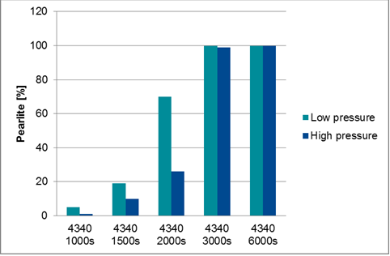

*Figure 9. Comparison of phase amount transformed to pearlite, at low/high pressure, for each of the 4340 samples.*

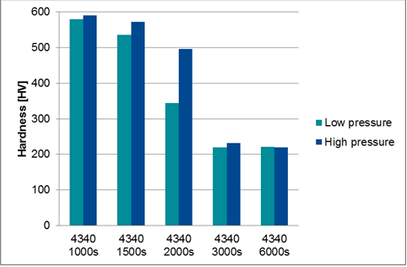

*Figure 10. Comparison of hardness, at low/high pressure, for each of the 4340 samples.*

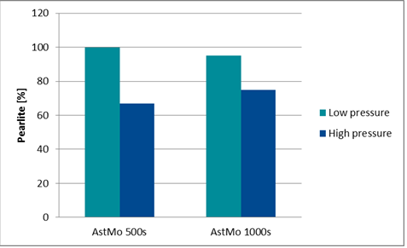

*Figure 11. Comparison of phase amount transformed to pearlite, at low/high pressure, for both Astaloy Mo samples.*

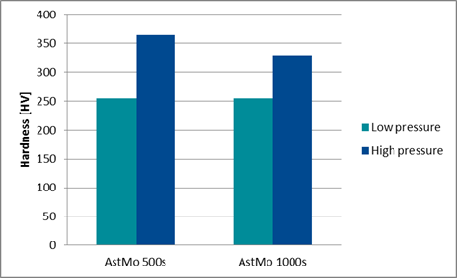

*Figure 12. Comparison of hardness, at low/high pressure, for both Astaloy Mo samples.*

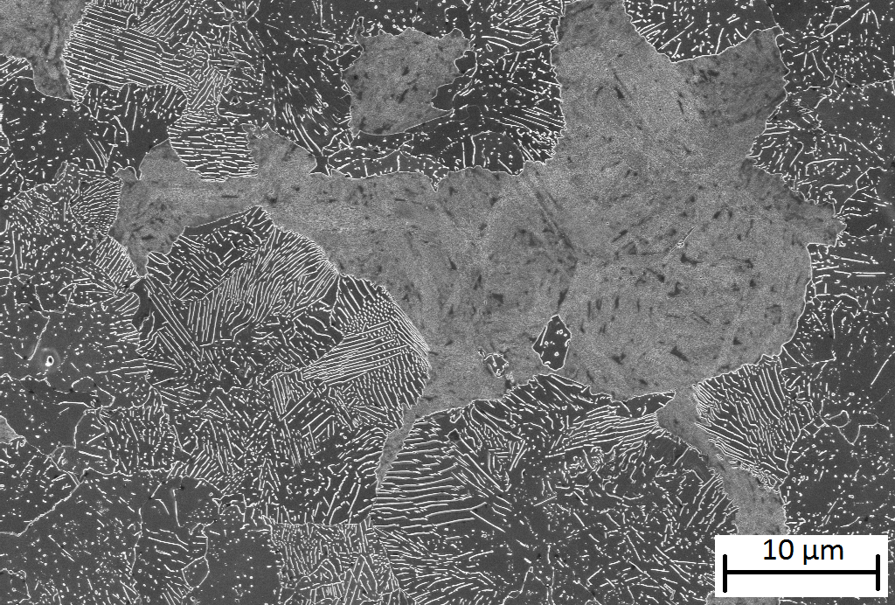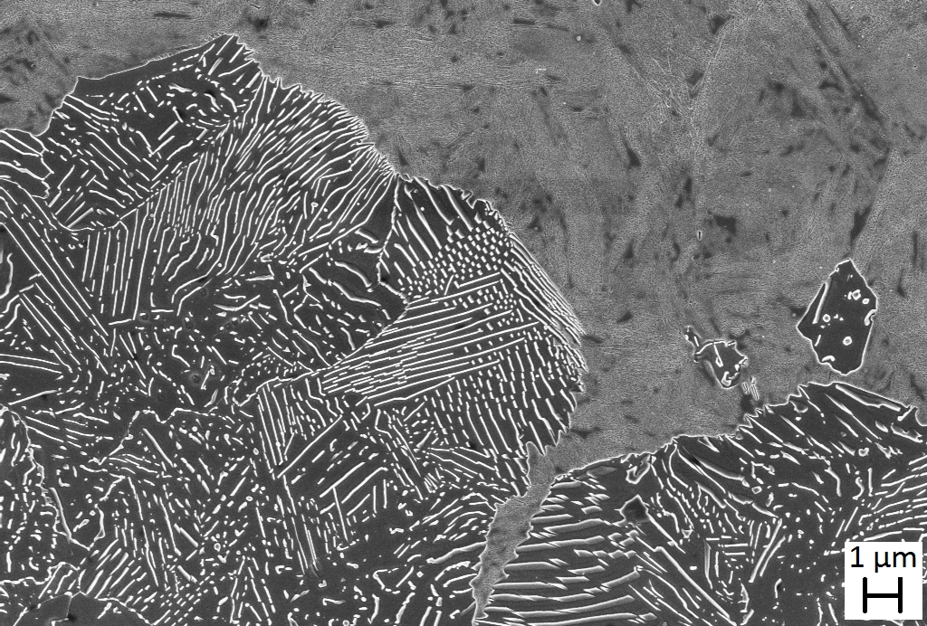

*Figure 13. SEM images of 4340, 2000 s, 100 bar. Left: SEM magnification setting x5000. Right: SEM magnification setting x10000.*

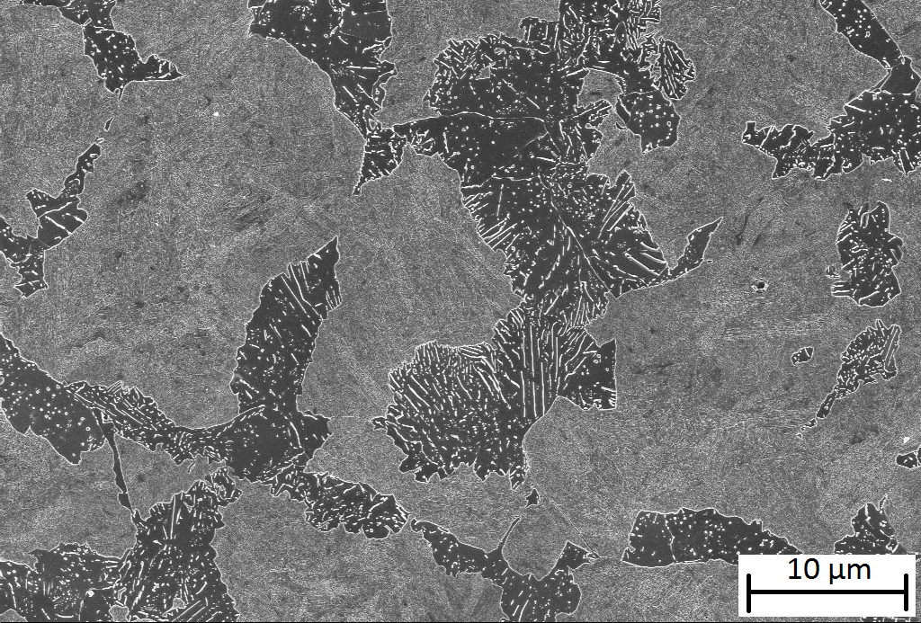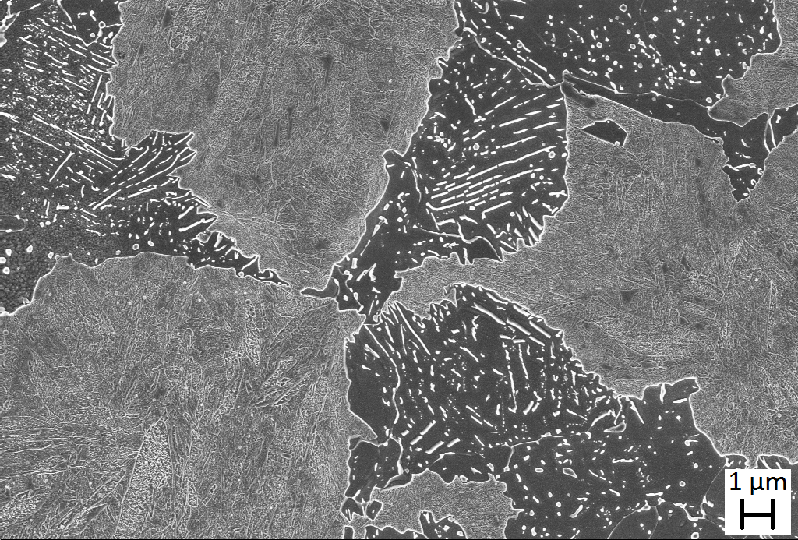

*Figure 14. SEM images of 4340, 2000 s, 1700 bar. Left: SEM magnification setting x5000. Right: SEM magnification setting x10000.*

Discussion

The phase fraction evaluations unanimously show that HIP pressures influence the phase transformation from austenite to pearlite by pushing it towards longer times. For 4340 the 1500 s and 2000 s samples give the clearest results where the 2000 s sample subjected to low pressure contains almost three times as much pearlite as the sample subjected to high pressure. The 1000 s and 3000 s samples indicate the same influence but to a less numerical extent due to low and high transformation degree respectively. The transformation degree is even greater for the 6000 s sample, giving 100% transformation at both pressure levels. Thus no information regarding influence of pressure can be drawn from the 6000 s sample. The hardness testing supports this conclusion for all samples. The hardness values are higher for the high pressure samples due to less pearlite phase transformation, i.e. higher amounts of martensite. For Astaloy Mo the phase transformation evaluation and the hardness measurements for both HIP cycles, 500 s and 1000 s, show that HIP pressure increases hardenability.

The 4340 HIP cycle logs display an increase in the load center temperature during the isotherm at 650 °C, although the gas temperature stays constant, most likely representing the exothermic austenite to pearlite phase transformation. As can be seen in the HIP cycle logs, the bump appears both larger and earlier in time at low pressure than it appears at high pressure. Not only does this phenomenon strengthen the thesis that HIP pressure pushes the austenite – pearlite phase transformation towards longer times but it also suggests that the pressure suppresses the rate of the phase transformation.

It is interesting to note that the results from the HIP trials are quite far from the TTT-diagrams found in literature and calculated using JMatPro, particularly for 4340. The results suggest that the 4340 material is fully pearlitic after 3000 seconds at 650 °C at 100 bar. This is quite far from the 5000 to 10000 seconds proposed by the TTT diagrams at atmospheric pressure. According to the thesis and the obtained results, the 100 bar pressure would, if anything, push the pearlite transformation towards longer times, not shorter. If the isothermal temperature of the HIP trials differed from the actual transformation peak temperature, this would also have resulted in longer time periods for pearlite phase transformation, and not shorter. What stands out for Astaloy Mo is that the material is fully martensitic after 500 s already. Possibly, an explanation to this is that the temperature, during the 500 s HIP trial, went quite low during the drop from 850 °C and then never reached 650 °C for the isotherm before final quenching. However, the TTT diagrams were used as base for selecting the experimental parameters. To determine exact time and temperature limits for phase transformation was not the scope of this project. For that, dilatometer trials with smaller specimens are more suitable.

These studies show that an increased hardenability for two steels are achieved when performing the quenching under pressure in an URQ HIP for examples. This is an interesting fact for industry since increasing a material’s hardenability often is a very positive thing. For example, less alloying elements can be used in the to make a leaner and cheaper material. Thicker sections for a specific material that weren’t possible to through harden before can now be just that. For distortion and crack sensitive components the quenching rate can be decreased to decrease the risk of cracking and distortion but still achieve the same quench effect on the microstructure.

**Conclusions**

All phase fraction evaluation results support the theory that HIP pressure pushes austenite – pearlite transformation towards longer times.

All hardness measurement results support the theory that HIP pressure pushes austenite – pearlite transformation towards longer times.

The bump in the temperature HIP log during the isotherm, representing the austenite – pearlite transformation, indicates that HIP pressure pushes austenite – pearlite transformation towards longer times and also that the HIP pressure suppresses the intensity of the austenite – pearlite phase transformation.

**Acknowledgments**

This work has been financed by the member companies of the Powder Materials Member Research Consortia at Swerea KIMAB and RISE. The members of the research committee of the project:

Magnus Ahlfors at Quintus Technologies AB

Stefan Sehlstedt at Quintus Technologies AB

Dimitris Chasoglou at Höganäs AB

Linn Larsson at AB Sandvik Materials Technologies

Martin Östlund at AB Sandvik Materials Technologies

are greatly acknowledged for their contribution and for stimulating discussions.

References

[1] A. Åkerberg, The Difference Between URQ and U2RC, Proceedings HIP’14 11th International Conference on Hot Isostatic Pressing, Stockholm, Sweden, June 2014.

[2]. A. Åkerberg, P. Östlund, Numerical Calculations of New Innovative Heat Treatment, Proceedings from HIP’14 the 11th International Conference on Hot Isostatic Pressing, Stockholm, Sweden, June 2014.

[3]. A. Åkerberg, Temperature Accuracy in HIP Furnaces, Proceedings from HIP’14 the 11th International Conference on Hot Isostatic Pressing, Stockholm, Sweden, June 2014.

[4]. A. Ahlfors, The Possibilities and Advantages with Heat Treatments in HIP, Proceedings from HIP’14 the 11th International Conference on Hot Isostatic Pressing, Stockholm, Sweden, June 2014.

[5]. R. Larker, P. Rubin, Uniform Rapid Quenching Enables Austempering Heat Treatment in HIP, Proceedings from the 6th International Quenching and Control of Distortion Conference, Chicago, USA, September 2012.

[6]. A. Weddeling, N. Wulbieter, W. Theisen, Densifying and Hardening of Martensitic Steel Powders in HIP Units Providing High Cooling Rate, Proceedings from EuroPM 2015, Reims, France, October 2015.

[7]. É.R. Kuteliya, L.S. Pankratova and É.I. Estrin, Isothermal Transformation of Austenite under High Pressure, Translated from Metollovedenie i Termicheskaya Obrabotka Metallov, No. 9, pp. 8-13, September, 1970.

[8] S.V. Radcliffe, M. Schatz and S.A. Kulin, The Effect of High Pressure on the Isothermal Transformation of Austenite in Iron-Carbon Alloys, Journal of the Iron and Steel Institute, pp143-153, February 1963.

[9] J.E. Hilliard and J.W. Cahn, The Effect of High Pressure on Transformation Rates, Progress in very high pressure research 1961, pp. 109-125, General Electric Research Laboratory, USA.

[10] American Society for Metals, Atlas of Isothermal and Cooling Transformation Diagrams, Metals Park Ohio, USA, 1977.

[11]http://personal.teknik.uu.se/hugon/Konstruktionsmaterial/Konstr_mat_HT2006/Laborationsinstruktion_H%C3%A4rdning.pdf