
Australian Centre
for Neutron
Scattering

Clip Day
2019

Abstracts

Contents
1. Potential Dependent Adsorption of Polymeric Ionic Liquids to Gold 2
2. Dye–TiO₂ interfacial structure in dye-sensitized solar cells 3
3. In situ Neutron Diffraction Study on Layered Oxides Na_{0.5}Ni_{0.25}Mn_{0.75}O₂ 4
4. Laser metal deposition of high chromium white iron powder: the effect of pre-heat and laser scan speed on microstructure 5
5. Engineering Elongated Polymeric Nanocapsules for Prolonged Circulation and Improved Controlled Release 6
6. Inelastic Neutron Scattering of Lanthanoid-Semiquinonate Single-Molecule Magnets 7
7. The role of casein protein structure on digestibility 8
8. Using neutron reflectometry to understand MLKL’s membrane permeabilisation mode 9
9. Observing the synthesis of a polymer brush, molecule by molecule 10
10. Layer gliding and distortions in K_{x}MnO₂ and influence of Co doping 11
11. Bismuth-NSAIDs as colorectal cancer chemopreventives 12
12. Quantifying the effects of surface and bulk proton transport in Olivine 13
13. Residual Stresses, Metallurgical and Mechanical Properties of Laser Cladded Rail Components 14
14. Anti-cancer properties of flavonoids and bismuth flavonoids: Do their interactions with lipids mirror there in vitro cytotoxicity? 15
15. Detailed Phonon Dynamics Approach Reveals Origins of the Hot Carrier Effect in Perovskites 16
16. Understanding Mg doping effects on spinel LiNi_{0.5}Mn_{1.5}O4 high-voltage cathode for lithium-ion batteries 17
17. Developing Modified Layered Oxides for Sodium Battery Application 18
18. Linking structure to rheology for wormlike micelles during shear via rheo-SANS 19
19. Phase transitions and the evolution of the ferroic orders in the coupled honeycomb system (Fe, Co, Mn)₄Ta₂O₉ 20
20. Transition Metal Metaphosphates as Novel Electrode Materials for Lithium & Sodium Ion Batteries 21
21. Non-monotonic structure of pH and temperature responsive copolymer brushes as determined by neutron reflectometry 21
22. Initiation of Localised Degradation of Rail Flash Butt Welds in Heavy Haul Railways 23
23. Diffusion in Modified Solid Ionic Conductors for Energy Applications: Structure and Dynamics 24
24. Interaction of Antimicrobial peptides and cell membrane 25
25. Theoretico – Experimental Study of the Electronic Structure of Lanthanoid-Dioxolene Single-Molecule Magnets 26
26. QENS Study of Diffusion in Superionic Compound Cu_{2-x}Se 27

1. Potential Dependent Adsorption of Polymeric Ionic Liquids to Gold

^{1*}Zhang, Y., ¹Li, H., ²Le Brun, A., ¹Atkin, R.
*yunxiao.zhang@research.uwa.edu.au
¹University of Western Australia
²Australian Nuclear Science and Technology Organisation

Polymeric ionic liquids (PILs)¹ are a new class of ionic liquids which comprise a polymer backbone containing tethered cations (or anions) and associated counter ions. They combine the attractive properties of ILs with the sequence complexity and the mechanical characteristics of macromolecules. PILs have a variety of properties that allow them to be applied as potential lubricants under extreme conditions. For example, PILs are electrically conductive and are thus suitable for electrical applications. PILs can also prevent electrical arcing, which causes decomposition of sliding contacts, and the thermal conductivity of PILs is greater than that of PFPEs, so they are better able to dissipate heat. Additionally, as the PIL ions interact strongly with oppositely charged surfaces, they resist ‘squeeze out’ as surfaces are compressed². However, fundamental PIL properties critical for lubrication, such interfacial nanostructure are unknown, which restrict their applications.
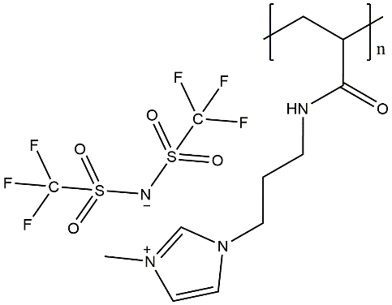
We have already completed initial studies on PIL adsorption. At room temperature, PILs tend to have very high viscosity (which is advantageous for use as electrolytes) making studies of the pure PIL challenging. To mitigate this, we have examined 1 wt% solution of a PIL the structurally similar conventional IL. Normal force measurements via AFM were probed on a gold substrate at -1V, OCP and +1V. Pure exhibited stepwise forces curves³. However, when 1 wt% PIL is added, the steps are replaced by a polymer compression on approach and, strikingly, multiple saw tooth pull offs on retraction, c.f. Fig. 1. The magnitude of these forces was potential dependent. This confirms PIL adsorbs to the substrate.
Figure. 2 Poly(3MAPIm) TFSI.
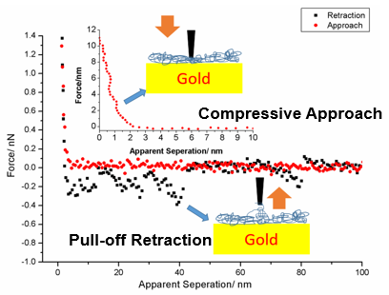
Figure. 1 Force-separation curves of PILs on gold at OCP
While this is important fundamental information towards developing PILs as tribotronic lubricants, it provides limited information on the PIL adsorbed layer thickness, and adsorption density, which are critical for lubricity. This proposal will address this knowledge gap via neutron reflectivity experiments to determine how the adsorbed layer structure of a 1 wt% solution poly(3MAPIm)TFSI, chemical structure is shown in Fig. 2 dissolved in EMIm TFSI at a gold surface varies between -1V, OCP and +1V.
1.Ionic Conduction in Nanostructured Membranes Based on Polymerized Protic Ionic Liquids. Macromolecules 2013, 46 (4), 1543-1548.
2.Layering and shear properties of an ionic liquid, 1-ethyl-3-methylimidazolium ethylsulfate, confined to nano-films between mica surfaces. Phys. Chem. Chem. Phys. 2010, 12 (6), 1243-1247.
3.Pronounced Structure in Confined Aprotic Room-Temperature Ionic Liquids. The Journal of Physical Chemistry B 2009, 113 (20), 7049-7052.

2. Dye–TiO₂ interfacial structure in dye-sensitized solar cells

^{1,2}*McDonald, S., ¹Holt, S.A., ²Cole, J.M.
*samilam@ansto.gov.au
¹ Australian Nuclear Science and Technology Organisation
² University of Cambridge

Dye-sensitized solar cells (DSCs) are a next-generation source of clean, renewable energy that use adsorbed dye molecules on semiconducting metal oxides (e.g. titanium dioxide (TiO₂)) to collect sunlight energy and convert into electricity.^{1,2} DSCs can be fabricated easily into transparent, flexible devices which perform better than traditional silicon-based solar cells in ambient or dim light. This provides buildings with solar windows that could generate power even in cloudy weather.

Researchers are working to optimise energy efficiency to make DSCs more cost-effective and competitive with traditional solar cells. The interface between the dye and the TiO₂ semiconductor is crucially important as it injects the photoelectron into the solar cell. The dye molecular structure can be tuned to improve efficiency and reduce dye aggregation by changing the electron donor, electron acceptor and linker groups and by adding bulky, hydrophobic alkyl chains. However, little is known about the impact of monolayer formation or aggregation on DSC efficiency.

This study investigates dye‒TiO₂ interfacial structure using X-ray reflectometry (XRR) and atomic force microscopy (AFM) instruments at ANSTO, Australia for a series of dye molecules.^{3,4} Aggregates were found for all dyes except for the largest and sterically bulky dye studied. This study demonstrates the importance of dye size and structure on interfacial properties in DSCs, and may be used to design dyes to optimise solar cell efficiencies.

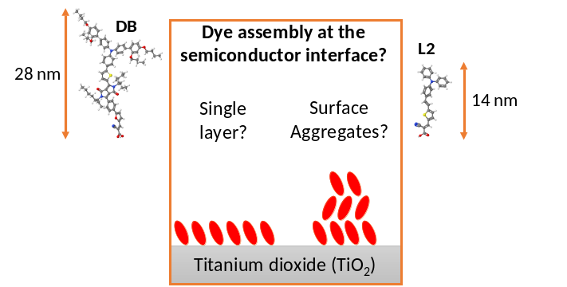
Figure 1. Atomic force microscopy images 15 x 15 μm scan size for two organic dyes: one large and bulky dye (DB, left) that forms a smooth monolayer on the surface and one small and planar dye (L2, right) which aggregates on the surface. Dye lengths are derived from fits to XRR reflectivity profiles.

1. O'Regan, B.; Grätzel, M. Nature 1991, 353, (6346), 737-740.
2. Grätzel, M. Accounts of Chemical Research 2009, 42, (11), 1788-1798.
3. McCree-Grey, J.; Cole, J. M.; Holt, S. A.; Evans, P. J.; Gong, Y. Nanoscale 2017, 9, (32), 11793-11805.
4. Cole, J. M.; Gong, Y.; McCree-Grey, J.; Evans, P. J.; Holt, S. A. ACS Applied Energy Materials 2018, 1, (6), 2821-2831.

3. In situ Neutron Diffraction Study on Layered Oxides Na_{0.5}Ni_{0.25}Mn_{0.75}O₂

¹*Liu, J., ²Didier, C., ¹Ling, C., ²Peterson, V.
*jiatu.liu@sydney.edu.au
¹The University of Sydney
²Australia Nuclear Science and Technology Organisation

Layered oxides based on first-row transition metals dominate cathode materials for commercial batteries and remain highly interesting as well as challenging in their structural study during electrochemical reactions. Neutron diffraction is a powerful method to obtain periodic structural information complementary to that obtained by X-ray diffraction. Although inferior to X-ray diffraction in signal resolution, neutron diffraction reveals more reliable structural evolution as the whole bulk of materials are fluxed with neutron beam. Na_{0.5}Ni_{0.25}Mn_{0.75}O₂ is a potential sodium ion battery cathode due to its high operating voltage 3.2 V vs Na⁺/Na and high capacity 130 mAh/g. Its stoichiometry is designed to only utilize the redox couple Ni⁴⁺/Ni²⁺ to avoid the unstable redox couple Mn⁴⁺/Mn³⁺. The high voltage phase for this material has been under debate. The fact that sodium-containing layered oxides are highly hydroscopic, especially at low sodium content, makes it hard to study the final phase ex situ. In the work presented here, we have pushed the signal resolution of in situ neutron diffraction to the limit by loading the optimized material mass at the positive side and the corresponding amount of amorphous hard carbon at the negative side of a pouch cell. The result is the first robust proof of the reversible structural evolution from P3, O3 to O1 on charging and back to O3, P3 on discharging.
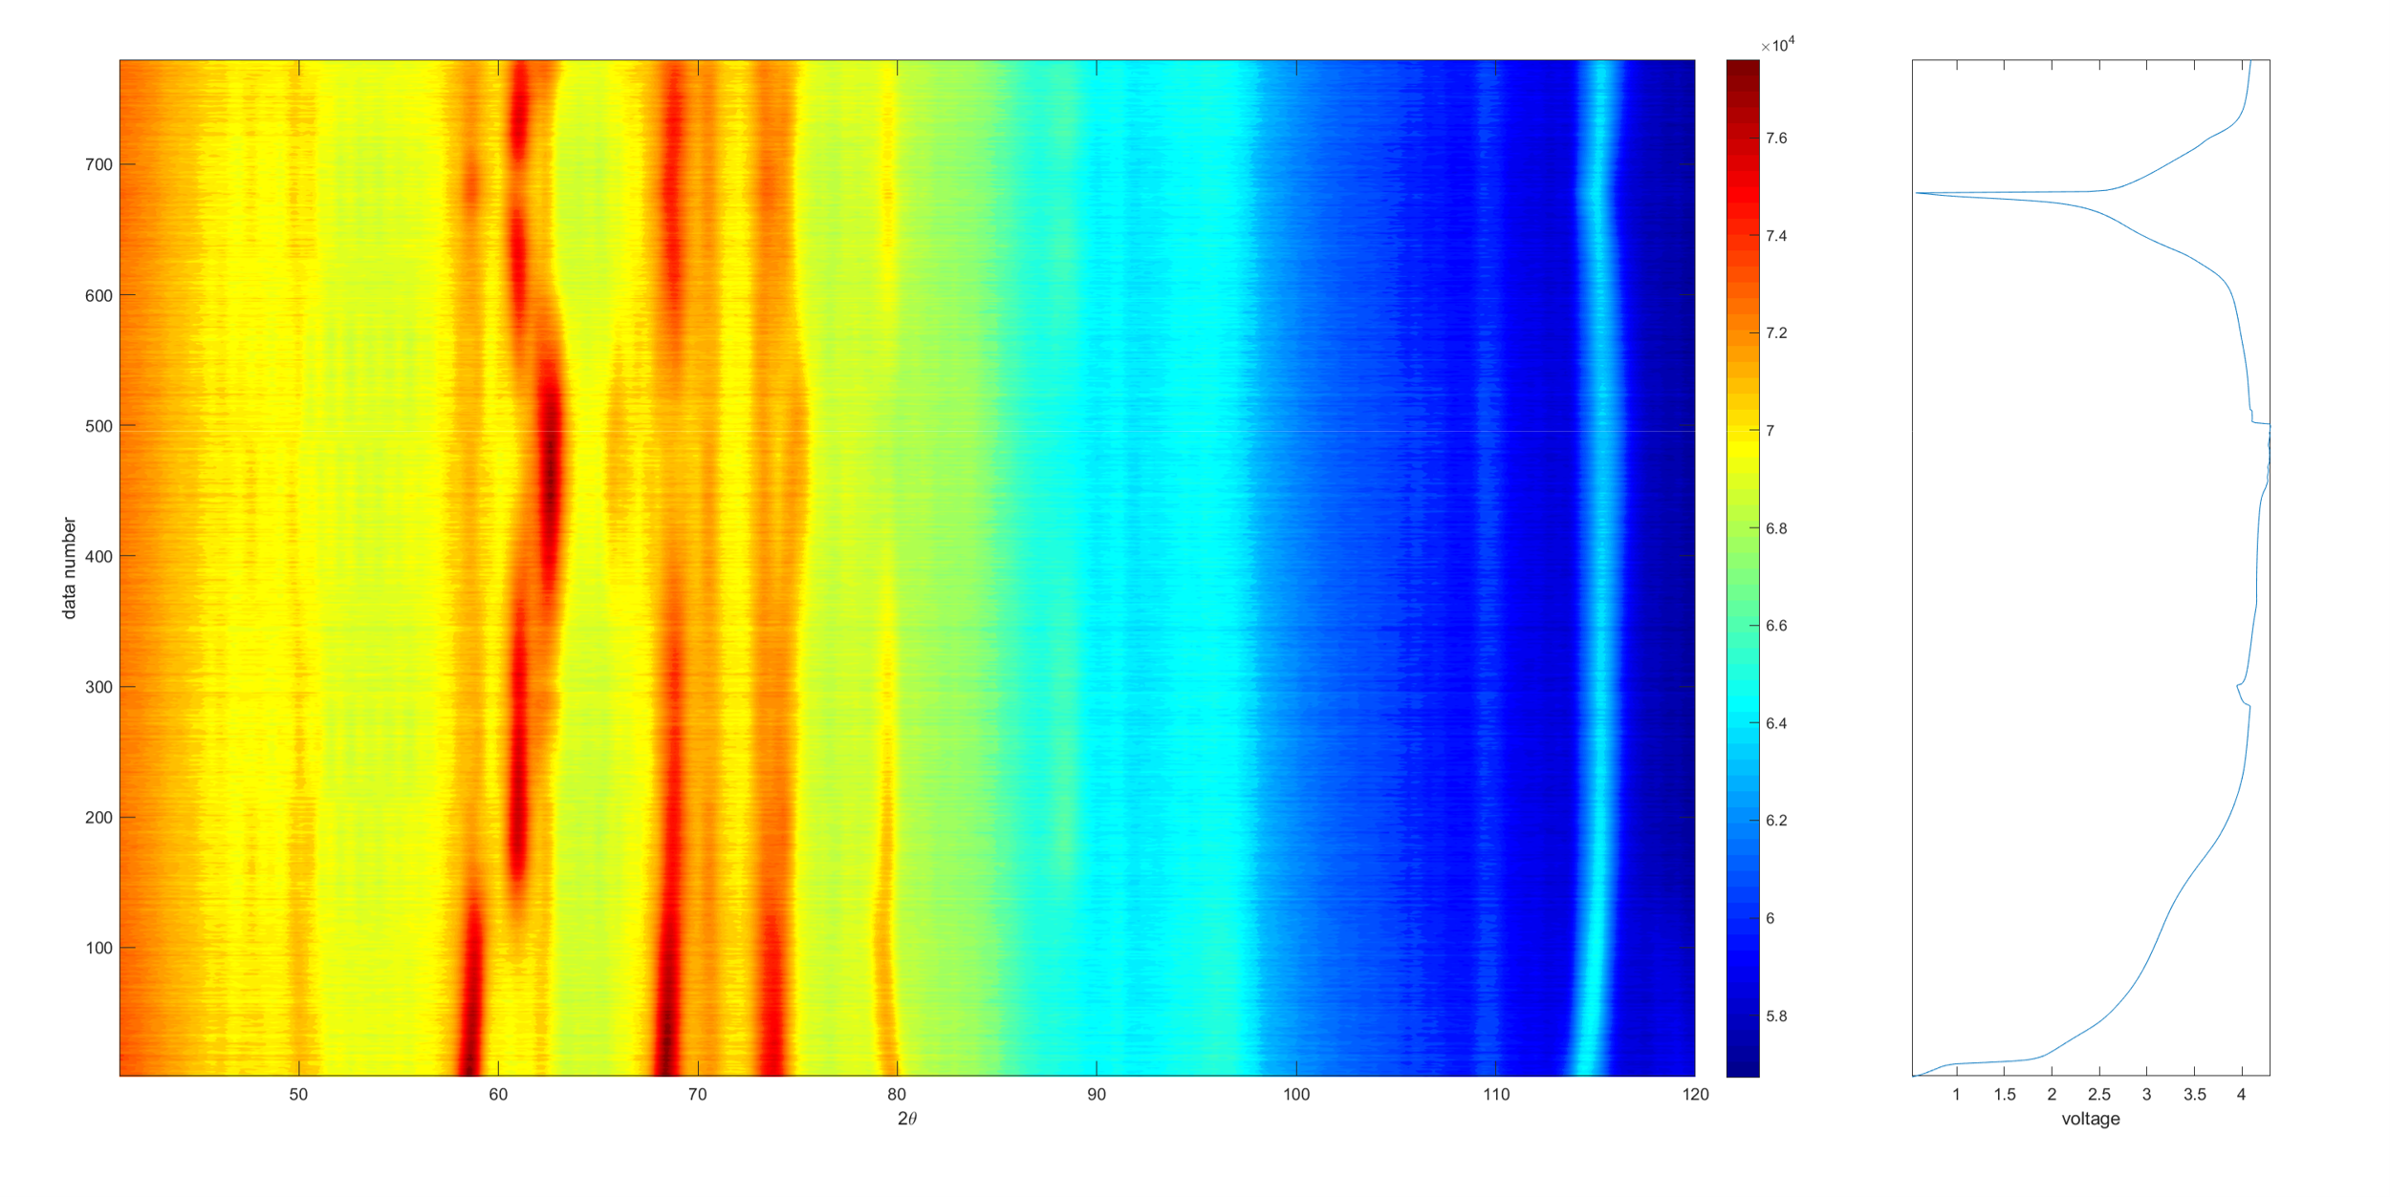
Figure 1. In situ neutron diffraction contour plot of a pouch cell using Na_{0.5}Ni_{0.25}Mn_{0.75}O₂ as electrodes (left), and corresponding voltage-time profile (right).

4. Laser metal deposition of high chromium white iron powder: the effect of pre-heat and laser scan speed on microstructure

¹*Zhu, C.B., ¹Sun, S.D., Fordyce, I., ²Paradowska, A.M., ¹Leary, M., ¹Easton, M., ¹Brandt, M.
*s3673151@student.rmit.edu.au
¹RMIT University
²Australian Nuclear Science and Technology Organisation

High chromium (Cr) white irons are commonly used in a wear-resistant parts. Using high Cr white iron as a deposited material presents opportunities in repair, fabrication of high wear resistant parts, and surface coating with superior wear resistance.

The aim of this project is to investigate the effect of substrate pre-heat and laser scan speed on the microstructure, hardness and residual stress of laser metal deposited high Cr white iron. Controlling the key processing parameters plays a crucial role to achieve a crack free deposited layer with a refined microstructure. Especially, with the high hardness and brittle properties of high Cr white irons, any rise in tensile residual stress may produce micro-cracks in the clad layer.

The microstructure, phases, and microhardness were analysed. Interestingly, no micro-cracking was observed in the clad layer for all combinations of substrate pre-heat temperatures and laser scan speeds. The general structure formed was a dendritic primary austenite in a matrix of M₇C₃ carbide eutectic. A very fine microstructure was achieved for high scan speeds and lower pre-heat temperatures, due to the very rapid cooling rates. The hardness associated with the very fine microstructure was 635 HV.

The strategy to complement the industry-driven project by utilising neutron scattering techniques in my research will be also discussed.

5. Engineering Elongated Polymeric Nanocapsules for Prolonged Circulation and Improved Controlled Release

^{1,2}*Xiao, Y., ^{1,2}Tan, A., ^{3,4}Jackson, A.W., ¹Clulow, A.J., ⁵Sokolova, A., ⁵Gilbert, E.P., ^{1,2}Boyd, B.J.
*Yunxin.xiao@monash.edu
¹Monash Institute of Pharmaceutical Sciences
²ARC Centre of Excellence in Convergent Bio-Nano Science and Technology
³Functional Molecules and Polymers, Institute of Chemical and Engineering Sciences
⁴Agency for Science, Technology and Research
⁵Australian Nuclear Science and Technology Organisation

Nanoparticles have been widely investigated for medical applications in the past decades. However, most nanoparticles suffer from low treatment efficiency partially due to the short circulation time in the body. Furthermore, most immediate-release carriers dissemble quickly upon administration and release all drug substances, resulting in serious side effects and high dosage frequency. This project, aims to increase the circulation time of nanoparticles and achieve controlled release of drug substances by engineering polymeric nanocapsules with an elongated geometry. Elongated shape was found to be able to minimise the internalisation of nanoparticles by macrophages and hence increase the circulation time.¹ Using polymeric material provides a thicker and less permeable membrane so a smaller amount of drug can be released over a longer period of time. As a result, the dosage frequency can be dramatically decreased, lower dose will be needed and the side effects can be minimised.

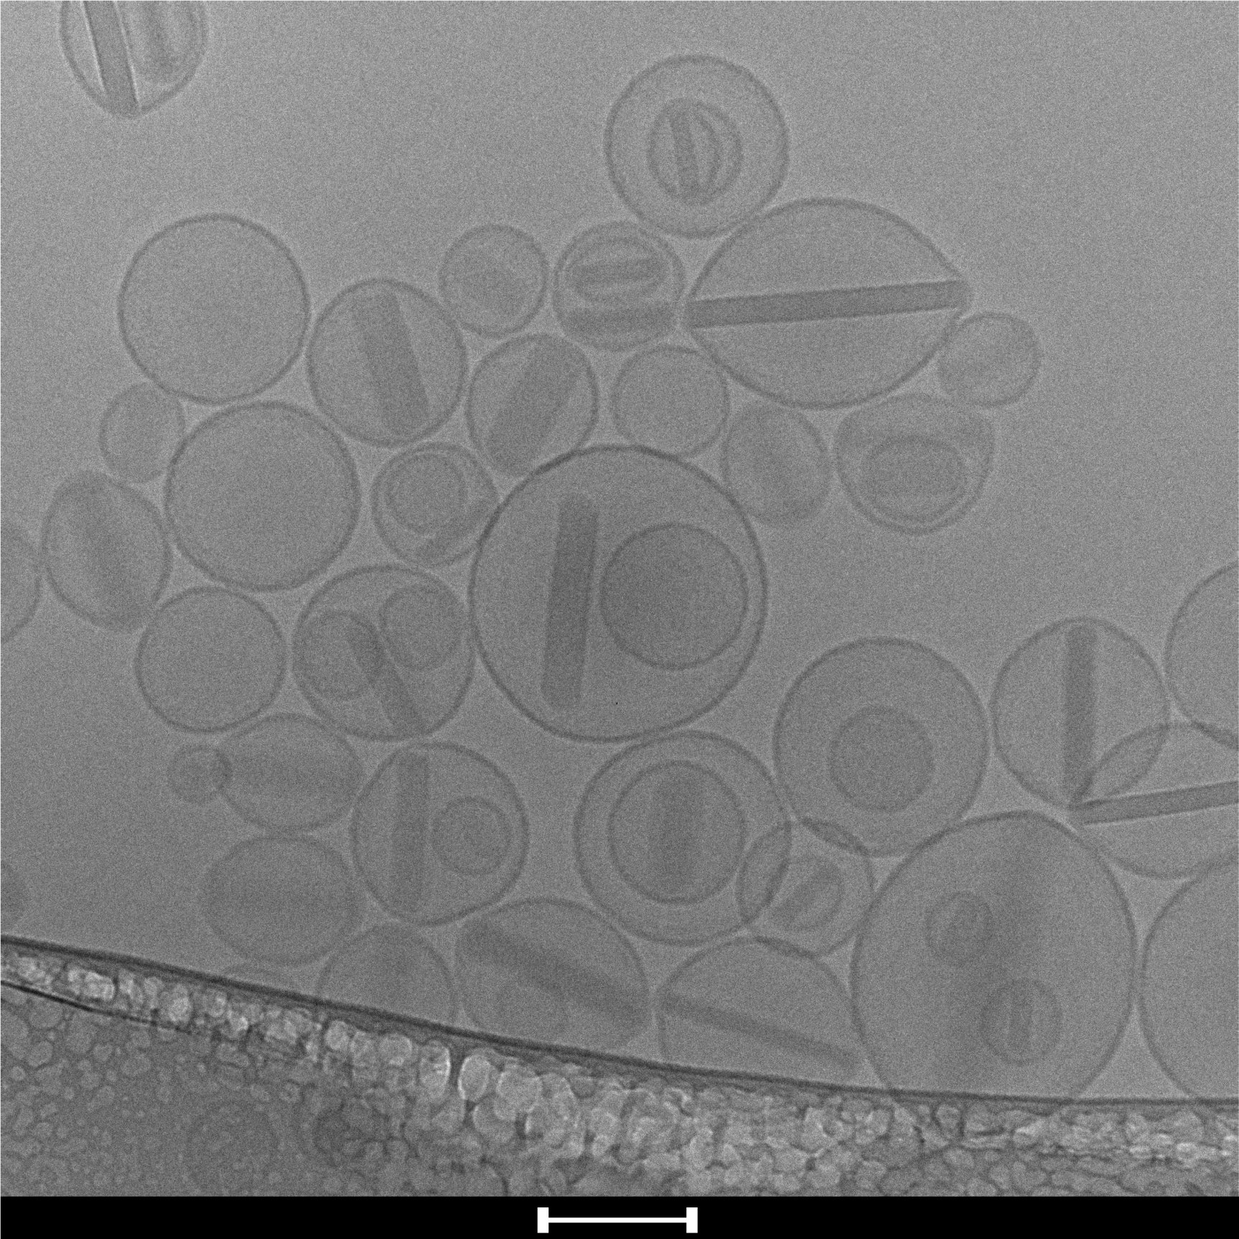
To prepare the elongated nanocapsules, a vesicle templating method was combined with reversible addition-fragmentation chain transfer (RAFT) polymerisation,² in which elongated liposomes were used as the template³ and polymers were directed to grow on the surface of the vesicles. Due to the multi-layer characteristic of the system, with the drug nanocrystals, the liposome template, and the polymeric shell, it is extremely important to investigate the nanocapsules relatively independently from other parts of the system, which is only possible with the use of contrast match method and small angle neutron scattering (SANS). The size and geometry of the elongated liposome templates with the encapsulated drug nanocrystals have been investigated with SANS (Figure 1)³ and further investigation of the in-situ change of geometry upon extraction of the elongated drug template will be performed.
Figure 1. (a) SANS and USANS data illustrating the elongated geometry of elongated liposome templates with dashed lines indicating the power-slope fitting. (b) Cryo-TEM images showing elongation of liposomes templates in complement of neutron scattering techniques
(a) (b)

1 Albanese, A., Tang, P. S., and Chan, W. C. Annu. Rev. Biomed. Eng. 2012, 14, 1-16
2 Rusli, W., Jackson, A., and van Herk, A. Polymers 2018, 10, 774
3 Xiao, Y., Liu, Q., Clulow, A. J., Li, T., Manohar, M., Gilbert, E. P., de Campo, L., Hawley, A., and Boyd, B. J. Colloid Surface B 2019, 182, 11

6. Inelastic Neutron Scattering of Lanthanoid-Semiquinonate
Single-Molecule Magnets

¹*Dunstan, M.A., ^{1,2}Calvello, S., ¹Soncini, A., ²Mole, R.A., ¹Boskovic, C.
*majad@student.unimelb.edu.au
¹The University of Melbourne
²Australian Nuclear Science and Technology Organisation

Single-molecule magnets (SMMs) are materials that exhibit slow relaxation of magnetisation and quantum tunnelling of molecular origin. These properties make them promising for future applications in high-density data storage, as qubits in quantum computing, and in molecular spintronics¹ The best performing SMMs are complexes of the late trivalent lanthanoid (Ln(III)) ions. The energy barrier to reversal of magnetization here stems from the crystal field (CF) splitting of the ground spin-orbit coupled J state – where J is the total angular moment quantum number. The identity and geometry of the coordinated ligands determines the relative order, energy and composition of these CF states, and appropriate choice of ligands can tune both the CF splitting and therefore the SMM behaviour.

Incorporation of organic radicals can be used to improve SMM behaviour, and can shift quantum tunnelling of the magnetisation, a through-barrier relaxation pathway, from zero field² The nature of exchange coupling in Ln complexes is difficult to determine with conventional techniques. Inelastic neutron scattering (INS) is the best experimental technique for directly measuring the CF splitting and exchange coupling in Ln(III) compounds.

Our group has been studying a family of compounds with formula [Ln(dbsq)Tp₂], Tp– = tris(pyrazolyl)borate, dbsq– = 3,5-di-tert-butyl-semiquinonate, which show exchange coupling between the Ln(III) ion and the dbsq organic radical³ We have measured the magnetic properties of the Ln = Tb, Ho analogues, as well as their INS spectra on the cold neutron time-of-flight spectrometer PELICAN, which have been compared to ab initio calculated energy level splitting.
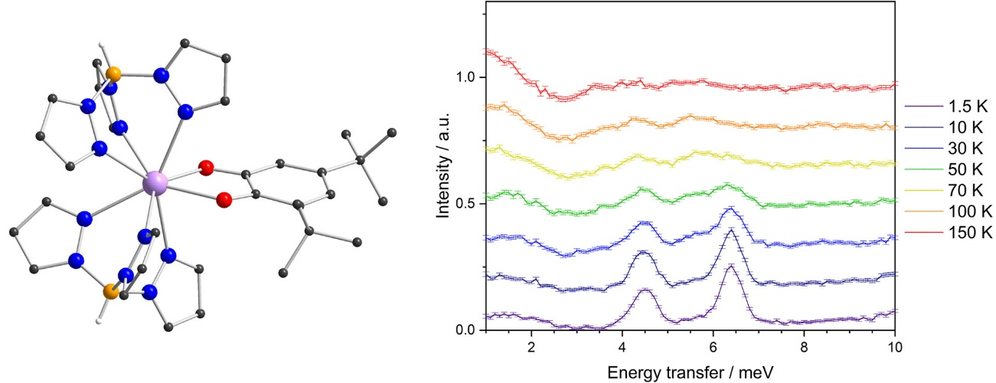
Figure 1. Left: [Ln(dbsq)Tp₂]. Right: Temperature dependence of CF transitions in Ho analogue.

1. S. T. Liddle, J. van Slageren, Chem. Soc. Rev. 2015, 44, 6655–69.
2. S. Demir et al., Coord. Chem. Rev. 2015, 289–290, 149–176.
3.A. Caneschi et al., Dalton Trans. 2004, 24, 1048–1055.

7. The role of casein protein structure on digestibility

^{1,2}*Bayrak, M., ²Conn, C.E., ³Floury, J., ⁴Mata, J., ¹Logan, A.
*meltem.bayrak@csiro.au
¹CSIRO Agriculture and Food
²RMIT University
³UMR-STLO INRA-Agrocampus Ouest
⁴Australian Nuclear Science and Technology Organisation

The nutritional quality of food cannot be solely based on individual contents in nutrients as food structure will strongly modulate the bioaccessibility of nutrients upon digestion. Despite increasing interest to modulate food structure as a potential way of controlling food breakdown, the underlying mechanisms are not still fully understood. In the present work, casein is used as a model system to form a range of gel structures with identical composition, but differing by the coagulation mode.

The devolution of the micellar casein dairy gel microstructure that is submitted to simulated gastric digestion is investigated over time using small angle neutron scattering (SANS), small angle x-ray scattering (SAXS) and electron microscopy. In this presentation, the appliance of INFOGEST digestion method and the applicability of the hierarchical model of casein micelle by Bouchoux et al. (2009) will be discussed for the casein gel structure disintegration. Our microstructural analysis approach for the two casein gel digesta, rennetted gel and transglutaminase-linked acid gel will be outlined. Besides, the microstructure of samples observed by SEM will be addressed to provide complementary insights into the devolution of the casein gel structure.

8. Using neutron reflectometry to understand MLKL’s membrane permeabilisation mode

¹Davies, K.A.*, ¹Robin, A., ²Wilde, K, ¹Petrie, E.J., ¹Murphy, J.M. ³Le Brun, A., ¹Czabotar, P.E.
*davies.k@wehi.edu.au
¹The Walter and Eliza Hall Institute of Medical Research
²National Deuteration Facility
³Australian Nuclear Science and Technology Organisation

Necroptosis is a form of programmed cell death characterized by lack of caspase activity and a loss of plasma membrane integrity. Morphologically similar to necrosis, in the act of necroptosis, the plasma membrane is disrupted, causing release of cellular components to the extracellular fluid and an ensuing inflammatory response. Necroptosis proceeds via a regulated kinase cascade involving Receptor Interacting Protein Kinases RIPK1 and RIPK3. Mixed Lineage Kinase domain-Like protein (MLKL), a pseudokinase, is the final known obligate effector essential for the execution of necroptosis. Whilst the MLKL pseudokinase domain is incapable of catalysing phosphotransfer reactions, it is the site of RIPK3 phosphorylation. This phosphorylation event is thought to be integral to flipping a molecular switch regulated by the pseudokinase domain, resulting in activation of MLKL. Upon activation, MLKL oligomerises and translocates to the plasma membrane, and is there thought to play a destabilising role. Details of MLKL’s molecular mechanism of action, such as the stoichiometry of oligomerisation and how it interacts with the plasma membrane, remain unknown.

We have used a variety of techniques to examine MLKL’s interactions with membranes. Direct visualisation of recombinant MLKL’s interaction with small uni-lamellar vesicles using cryo-electron microscopy has revealed that MLKL stably binds to the membrane and forms small pores. To complement our microscopy work, we have used neutron reflectometry to examine MLKL’s activity on floating supported bilayers. Our results have allowed us to answer some outstanding questions in the field, such as does MLKL form a proteinaceous or toroidal pore, and how deeply can the MLKL protein insert into the membrane.

9. Observing the synthesis of a polymer brush, molecule by molecule

¹*Gresham, I.J., ²Johnson, E.C., ³Nelson, A., ¹Prescott, S.W.
*i.gresham@unsw.edu.au
¹ University of New South Wales
² University of Newcastle
³ Australian Nuclear Science and Technology Organisation

Coating an interface with densely tethered soluble polymers imbues it with lubricating and antifouling properties. To create these surfaces with the required thicknesses and grafting densities a grafting-from approach, wherein polymers are grown from surface-attached initiators, must be used to assemble the layer. However, the implications of growing polymers from an initiator-rich surface (as opposed to initiators in free solution) are not well understood. Simulation and experiment predict that there is a high degree of cross-linking and chain termination in the early stages of the polymerisation, but up until now this has not been directly observed.

Here, we observe a surface-initiated atom transfer radical polymerisation (ATRP) using neutron reflectometry, which enables us to resolve the structure of the interface as the polymerisation takes place. We observe a dense interior layer form in the first few minutes of the experiment, after which the polymer growth appears to be linear. The experiment was performed on the Platypus reflectometer at the ACNS with a time-resolution of 60 seconds. This work will be of interest to those with a polymer background or who are interested in the evolution of interfacial structure over time scales of five minutes to several hours.

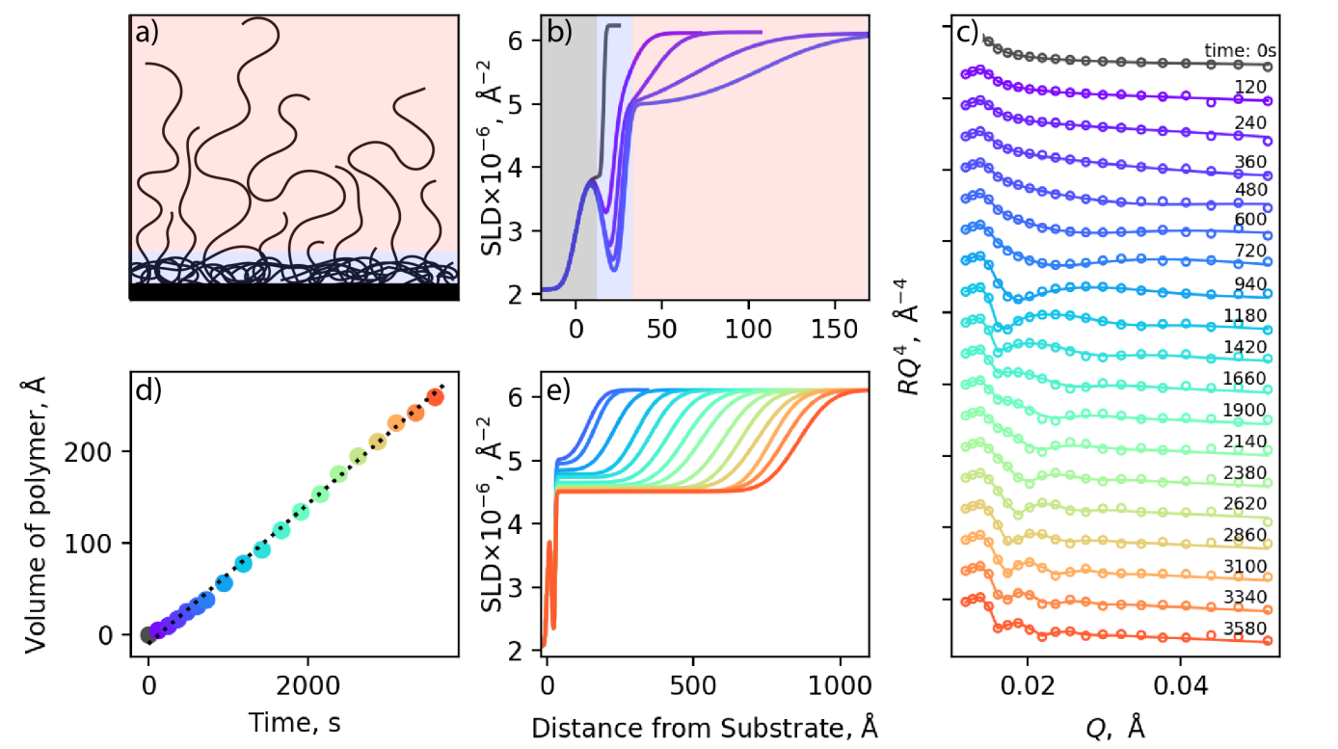

Figure 1. (a) Schematic of the dense interior layer (in blue) and diffuse brush layer (in red) along with (b) SLD profiles and (c) corresponding neutron reflectometry profiles showing its formation in the early stages of the polymerisation. (d) The total volume of the polymer in the brush layer can be derived from the (e) SLD profiles over the course of the polymerisation, allowing the rate of reaction to be tracked.

10. Layer gliding and distortions in K_{x}MnO₂ and influence of Co doping

^{1,2}*Didier, C., ¹Zhang, Q., ¹Zang, Z., ¹Mao, J., ¹Li, S., ¹Pang, W.K., ¹Guo, Z., ^{1,2}Peterson, V.
*christod@ansto.gov.au
¹ University of Wollongong
² Australian Nuclear Science and Technology Organisation

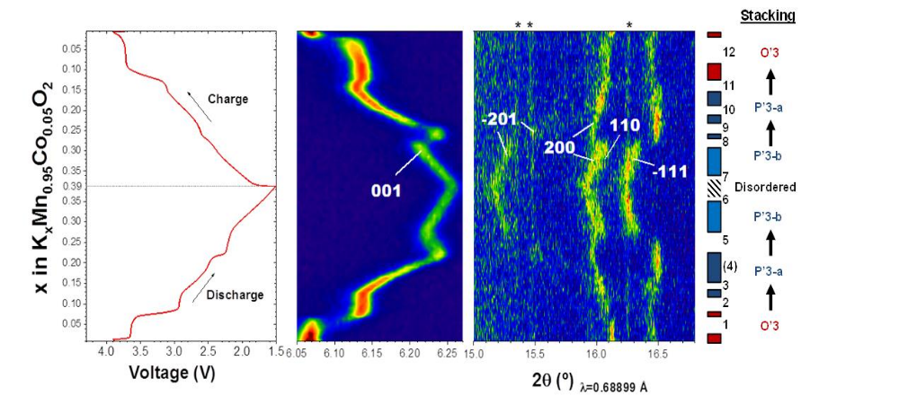
Figure 1.
Layered oxides have been used extensively as positive electrode materials and have been the object of countless improvements in order to realize today's high-performance lithium-ion batteries. Although progress can still be made towards improving Li-ion, the focus of recent studies is slowly shifting towards novel chemistries, such as potassium-ion. Knowledge of the fundamental aspects of potassium intercalation into layered oxides is currently lacking.

We present here our recent results on K_{x}MnO₂ and cobalt-doped K_{x}Mn_{0.95}Co_{0.05}O₂ as a positive electrode in non-aqueous potassium-ion batteries. The lattice of K_{x}MnO₂ is monoclinically distorted from the cooperative Jahn-Teller distortion of MnO₆ octahedra. Upon cobalt doping, the distortions are reduced and the diffusion rate is increased. Accordingly, the rate performance is greatly improved, perhaps due to the less distorted lattice facilitating ionic conduction. The reversible capacity is also higher in the doped sample.

A comprehensive phase diagram was obtained from in situ diffraction (Figure 1). Overall, most transitions involve layer gliding, with a switch between prismatic and octahedral coordination for K⁺ ions. Although strong alkali-alkali interactions are expected in potassium layered oxides due to the increased interlayer spacing and larger size of this alkali compared to Li⁺ or Na⁺, no ordering reflections were observed for pristine and doped K_{x}MnO₂, in contrast with sodium layered oxides for which phase transitions are often driven by alkali-vacancy ordering. Volume changes during cycling are smaller in the doped sample, which could explain the better long-term cyclability of the doped material. The maximum amount of K that can be inserted is only close to K_{0.5}MnO₂ and this insertion limit is fairly common in potassium layered oxides. Perhaps strong K⁺-K⁺ repulsions prevent easy insertion. This is supported by the increased in-plane disorder as shown from in situ XRD and higher polarization when approaching the limit.

11. Bismuth-NSAIDs as colorectal cancer chemopreventives

¹*Brown, T.E., ¹Dillon, C.T. ²Holt, S.A. & ³Andrews, P.C.
*tb957@uowmail.edu.au
¹ University of Wollongong, Wollongong
² Australian Nuclear Science and Technology Organisation
³ Monash University

To date, epidemiological studies, animal studies and clinical trials have indicated the potential of non-steroidal anti-inflammatory drugs (NSAIDs) for the chemoprevention of colorectal cancer (CRC)¹. Unfortunately, the use of NSAIDs for CRC chemoprevention is significantly limited due to the severe gastrointestinal (GI) side effects that have been associated with their long term use¹. It is hypothesized that the coordination of NSAIDs to bismuth, a heavy metal with proven gastrointestinal sparing properties², may allow the use of NSAIDs as chemopreventives for CRC while also combating their associated GI side effects. The present study investigates the interactions of bismuth-coordinated NSAIDs (BiNSAIDs) with eukaryotic membrane mimics with the aim of establishing the possible uptake mechanisms of these compounds. This knowledge has been extended by investigating the behaviour of BiNSAIDs in more complex systems, including CRC cells and a CRC animal model.

Electrical impedance spectroscopy and quartz crystal microbalance with dissipation monitoring studies, involving biological membrane mimics composed of POPC or POPC/cholesterol, have demonstrated that BiNSAIDs and their parent NSAIDs interact with biological membranes. Neutron reflectometry was also used to study the membrane interactions of BiNSAIDs and provided further evidence of the membrane interactions of BiNSAIDs, suggesting that passive diffusion is a likely method of uptake of these compounds³. The strength of these membrane interactions was an indicator of BiNSAID cytotoxicity against CRC cells. A CRC animal study has recently been completed, investigating the potential for aspirin to be used as a chemopreventive agent to prevent the development of CRC tumours in vivo. In conclusion, the aforementioned studies continue to highlight the potential of BiNSAIDs as candidates for further investigations into their potential for the chemoprevention of CRC.

1. Thun, M. J.; Henley, S. J.; Patrono, C. Non-steroidal anti-inflammatory drugs as anticancer agents: Mechanistic, pharmacologic and clinical issues. J. Natl. Cancer Inst., 2002, 94, 252-266
2. Sadler, P. J.; Li, H.; Sun, H. Coordination chemistry of metals in medicine: Target sites for bismuth. Coord. Chem. Rev., 1999, 185-186, 689-709
3. Brown, T. Bismuth-NSAIDs as colorectal cancer chemopreventives: Insights into their membrane interactions and uptake mechanisms, Bachelor of Medicinal Chemistry Advanced (Honours) Dissertation, University of Wollongong. 2016

12. Quantifying the effects of surface and bulk proton transport in Olivine

¹*Patabendigedara, S.
*sarath.pdn@gmail.com
¹Macquarie University & Australian Nuclear Science and Technology Organisation

Water plays an important role in various processes in the mantle of the Earth and may be present in different states. Water in nominally anhydrous minerals probably occurs as a proton or hydroxyl inclusion in the crystal structure or within grain boundaries. Olivine, in particular, has been studied intensively since it is the most abundant constituent of the upper mantle. Those studies were carried out to understand the effect of water on the structure and physical properties of olivine in order to interpret physical and chemical phenomenon in the interior of the Earth. However, incorporation, retention and dynamics of water in olivine is still not resolved.

Many kinds of ionic diffusion can be observed in nature and experimental setups. Depending on the nature of the diffusing species, diffusion can be categorised as self-diffusion and chemical diffusion or a mixture of the two. Self-diffusion is due to the thermally activated motion of particles (atoms or molecules) in a medium while chemical diffusion is driven by the chemical potential. We can use the Einstein (1905) theory about the relationship between diffusion and atomic mobility in order to differentiate microscopic and macroscopic diffusion in the frame of time and space.

In-grain and grain-boundary proton diffusion are separately measured using macroscopic and microscopic detection method to study effect of spatial temporal boundary conditions for controlling diffusion in polycrystalline mineral aggregates. The grain boundary diffusion is being studied using diffusion couple with neutron imaging while Quasi-Elastic Neutron scattering technique is applying to study in-grain diffusion of hydrogen. These results are presented here.

13. Residual Stresses, Metallurgical and Mechanical Properties of Laser Cladded Rail Components

^{1*}Kendall, O., ¹Abrahams, R., ²Paradowska, A.M.
*olivia.kendall@monash.edu
¹Monash University
²Australian Nuclear Science and Technology Organisation

Railway is relied upon as a main method of passenger and freight transport in Australia and consequently Australia supports one of the largest railway networks in the world. However, the growing dependency on railway transportation has resulted in increasingly demanding operating conditions of higher speeds, frequency and axial loading which produces rapid wear rates, deformation and Rolling Contact Fatigue (RCF) of the rail components. Common repair methods such as arc welding can be damaging as the large heat input produces a wide heat affected zone containing high tensile stresses that promote cracking.

Laser cladding is a potential, alternative repair technique which can regenerate the damaged surface of the rails by using a high energy laser to melt a metallic powder at the rail surface, forming a high-quality, metallurgically bonded cladding layer with enhanced mechanical and chemical properties. However, this laser cladding process can also produce a high internal residual stress state in the cladded rails due to the generation of high thermal gradients, repeated cycles rapid melting and solidification, thermal expansion coefficient mismatch and phase transformations. This is detrimental to the operation life of the rails as high residual stress in conjunction with large contact stresses between the wheel and rail results in increased likelihood of cracking, wear and reduced fatigue resistance.

Therefore, this project aims to develop a novel cladding alloy, SS415, that has a desirable combination of high abrasion resistance, hardness and toughness to withstand the harsh operation conditions. Fatigue resistance is highly dependent upon a low residual stress state in the cladded rail, therefore non-destructive neutron scattering techniques on the Kowari strain scanner have been performed to establish the residual stress distribution after the cladding process which is critical in assessing the fatigue life of the rail components (Figure 1). The outcomes from the preliminary stress study will be combined with in-depth microstructural analysis, wear and mechanical property evaluation to develop a new cladding alloy and optimise this laser cladding based maintenance strategy to prolong the service life of hypereutectoid rails. This technique can further be applied to other high wearing rail components such as switches and crossings to reduce wear and RCF.

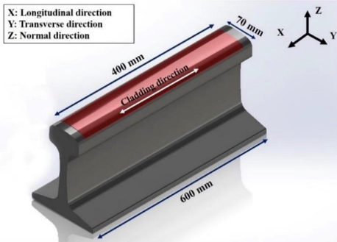
Figure 1. Schematic of the cladded rail section used for residual stress analysis.

14. Anti-cancer properties of flavonoids and bismuth flavonoids: Do their interactions with lipids mirror there in vitro cytotoxicity?

^{1*}Crapis, S.M.C., ¹Dillon, C.T., ²Holt, S.A., ³Andrews, P.C
*sc782@uowmail.edu.au
¹University of Wollongong, Wollongong
²Australian Nuclear Science and Technology Organisation
³Monash University

Cancer is responsible for one of the highest mortality rates in the western world¹. Recently, the anti-cancer potential of flavonoids has been documented²⁻⁴. The anti-oxidant properties of flavonoids play an important role in their anti-cancer properties². In addition, flavonoids are hydrophobic and have a tendency to accumulate in biological membranes where they can interact with the function of receptors and signal transducers². It has been reported that the flavonol ligand binds to metals, producing complexes which often exhibit enhanced anti-cancer activity. The metal of interest in our research is bismuth, a heavy metal with low toxicity in humans. To date our collaborators (Professor Philip Andrews and Ms Kirralee Burke, Monash University) have synthesised tris- and bis- bismuth complexes of various derivatives of 3-hydroxyflavonol. Subsequent, in vitro biological testing in leukemia (K562 cells) performed in our laboratory⁵, revealed enhanced cytotoxicity, when bismuth was complexed to the flavonols, whereby the IC50 values were up to an order of magnitude lower for the bismuth complexes.
This contrasts our previous studies that have shown that bismuth complexes of non-steroidal anti- inflammatory drugs exhibit comparable cytotoxicity to the NSAIDs^{6,7}, highlighting the fact that there must be different cellular processes occurring. It has previously been reported that metal coordination to flavonols often affects the mode of flavonoid lipid interactions². This then raises the question as to the role of Bi in Bi-flavonol complexes with respect to toxicity and membrane interactions. As such the aim of this study is to use Neutron Reflectometry (NR), QCM-D and EIS to investigate the flavonol and bismuth flavonol interactions with lipid membrane mimics. Our main goal is to determine whether the cytotoxicity of flavonols (lower toxicity) versus bismuth flavonols (higher toxicity) reflects the strength of their interactions with lipid bilayers, as well as how flavonols and bismuth-flavonols interact with the bilayers, and whether/how bismuth coordination influences the interaction.
1. World Health Organisation. Cancer (2018) https://www.who.int/news-room/fact- sheets/detail/cancer
2. Kasprzak, M. M.; Erxleben, A.; Ochocki, J. (2015) Properties and applications of flavonoid metal complexes. RSC Advances, 5, 45853-45877.
3. Duo, J., Ying, G.G., Wang, G.W. and Zhang, L. (2012). Quercetin inhibits human breast cancer cell proliferation and induces apoptosis via Bcl-2 and Bax regulation. Molecular medicine reports, 5, 1453- 1456.
4. Arif, H., Sohail, A., Farhan, M., Rehman, A.A., Ahmad, A. and Hadi, S.M. (2018). Flavonoids-induced redox cycling of copper ions leads to generation of reactive oxygen species: a potential role in cancer chemoprevention. Interntl J Biol. Macromolecules, 106, 569-578.
5. Vogt, H. (2018) Assessing the in vitro anti-cancer potential of bismuth flavonolates. CHEM915 Report, University of Wollongong.
6. Hawksworth, E.L.; Andrews, P.C.; Lie, W.; Lai, B.; Dillon, C.T. (2014) Biological evaluation of bismuth non-steroidal anti-inflammatory drugs (BiNSAIDs): Stability, toxicity and uptake in HCT-8 colon cancer cells. J. Inorg. Biochem., 135, 28-29.
7. Hawksworth, E.L. (2018) In vitro investigations of the potential chemotherapeutic and chemopreventive properties of bismuth(III) complexes of non-steroidal anti-inflammatory drugs. PhD Thesis, University of Wollongong, March, 2018.

15. Detailed Phonon Dynamics Approach Reveals Origins of the Hot Carrier Effect in Perovskites

^{1*}Dubajic, M., ¹Chan, K.Y., ¹Thapa, B., ²Jia, X., ³Rule, K., ¹Bremner, S., ¹Shrestha, S., ¹Conibeer, G.
¹University of New South Wales
²Changzhou University
³Australian Nuclear Science and Technology Organisation

Semiconductor materials relying on the hybrid organic-inorganic perovskites have been exhibiting impressive photovoltaic device performances, due to long electronics carrier diffusion lengths, low exciton binding energy, high absorption coefficient and low thermal conductance. Extensive work has been done in exploring additional promising features of these materials, namely, the hot carrier effect. Several mechanisms for the explanation of the effect have been proposed, most of which outline the importance of the electron-phonon and phonon-phonon interactions that induce the non-equilibrium phonon population to act as a thermal reservoir to reheat the electrons thus extending their lifetime. Our recent results also indicate long carrier lifetimes and hence propose a model that suggests a complex interplay between organic/inorganic optical and acoustic phonon modes that result in the confinement of the lowest energy acoustic modes and their subsequent up-conversion and reabsorption by higher energy modes and eventually by hot carriers, significantly extending the lifetime of the latter. However, in order to assess that hypothesis, an adequate understanding of phonon dynamics in addition to currently, well-understood electron dynamic is necessary. Thus, we choose neutron scattering over the other inelastic scattering techniques (due to much higher energy resolution achievable) to investigate the phonon contribution to the hot carrier effect.

We perform measurements on deuterated methylammonium lead iodide (D-MAPI) single crystal perovskite at ANSTO, using both cold and thermal triple axis spectrometer (SIKA and TAIPAN, respectively). We map the phonon dispersion and for the first time observe well resolved optical modes at lower temperatures. We determine momentum resolved lifetimes of both acoustic and optical phonons at three different crystal phases. Preliminary results also indicate the presence of non-equilibrium transverse acoustic phonons by measuring their occupancy number and creation and annihilation lifetimes in various directions in the Brillouin zone. This may be the clear experimental evidence for the previously proposed hypothesis of acoustic up conversion. Namely, it is evident that the population of TA modes is less than in equilibrium which indicates that those phonons must be scattering elsewhere. As TA modes occupy the lowest energy phonon band the only scattering path is towards higher energies.

Furthermore, we observe strong phonon dumping when the system undergoes order to disorder transition (orthorhombic to tetragonal phase) which is an indication of a coupling of the organic cation with other phonon modes. Moreover, acoustic phonon lifetimes at room temperature are an order of magnitude lower than expected, leading to the conclusion that their inability to dissipate heat from the system leads to their up-conversion which we eventually observe through long-lived hot carrier population.

16. Understanding Mg doping effects on spinel LiNi_{0.5}Mn_{1.5}O4 high-voltage cathode for lithium-ion batteries

¹Liang, G., ^{1**}Pang, W.K, ²Lu, C., ³Peterson, V.
*wkpang@uow.edu.au
¹University of Wollongong
²Industrial Technology Research Institute Taiwan.
³Australian Nuclear Science and Technology Organisation

Spinel LiNi_{0.5}Mn_{1.5}O₄ (LNMO) is promising to replace the current LiCoO₂ cathode material in the next-generation high-energy-density lithium-ion batteries due to its high operating voltage (~4.7V vs Li), high energy density (650 Wh kg⁻¹), environmental friendliness, and low fabrication cost¹ However, this material suffers from the issues of inferior cycle stability and rapid capacity fade, limiting its further application² To solve these problems, we successfully introduced Mg doping as interstitial ions in LiNi_{0.5}Mn_{1.5}O₄ spinel structure and found that the electrochemical performance of the spinel was significantly improved. In this work, we combine the transmission electron microscopy (TEM), high-resolution neutron powder diffraction, and both in operando synchrotron and neutron powder diffraction to investigate the origins of the enhanced electrochemical performance of the Mg-doped LNMO. In short, in operando synchrotron and neutron powder diffraction reveal that the Mg doping could effectively relief the two-phase behaviour of LNMO at high-voltage charge, thus contributing to stable cycling performance.

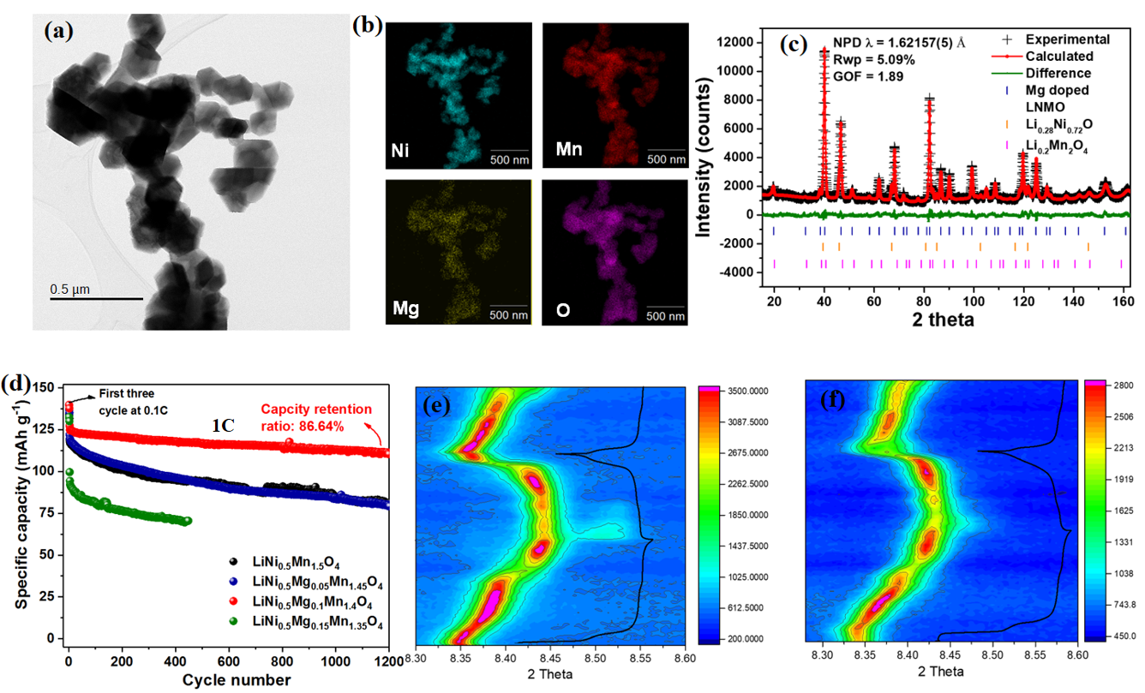
Figure 1. (a) TEM image of LiNi_{0.5}Mg_{0.1}Mn_{1.4}O₄ and (b) the corresponding energy dispersive spectroscopy (EDS) results; (c) Rietveld refinement profiles for LiNi_{0.5}Mg_{0.1}Mn_{1.4}O₄ NPD data; (d) cycling performance of different LNMOs at 1C (1C=147 mAh g⁻¹); contour plots of synchrotron XRD in the selected 2-theta region of (e) LNMO and (f) LiNi_{0.5}Mg_{0.1}Mn_{1.4}O₄, showing the evolution of (111) reflection

1. Advanced Functional Materials 2018, 28, 1704808.
2. Frontiers in Energy Research 2018, 6.
3. Journal of Power Sources 2014, 246, 464.

17. Developing Modified Layered Oxides for Sodium Battery Application

^{1,2*}Stansby, J., ¹Avdeev, M., ²Sharma, N., ³Gonzalo, E., ³Rojo, T.
j.stansby@unsw.edu.au
¹Australian Nuclear and Science Technology Organisation
²University of New South Wales
³CICenergigune, Parque Tecnológico de Álava

The commercialization of Na-ion batteries requires optimization of the positive electrode. Among Na-ion battery cathode materials, layered transition metal oxides (Na_{x}MO₂; M = Ti, V, Cr, Mn, Fe, Co, Ni or mixture of 2-3 of these elements) are particularly promising candidates because they are relatively easy to synthesize, have high theoretical capacities and may utilise inexpensive transition metals. Of this family of materials, Mn rich layered oxides are attractive due to their environmental benignity. However, the parent material, NaMnO₂, is prone to rapid capacity fade due to Jahn-Teller distortion associated with high spin Mn³⁺.¹ The structural stability and electrochemical performance of NaMnO₂ can be improved through small substitutions of Mn. This talk will showcase a number of Mn-rich materials such as Na_{2/3}Mn_{0.9}Fe_{0.05}Ti_{0.05}O₂, Na_{2/3}Mn_{0.8}Fe_{0.1}Cu_{0.1}O₂, Na_{2/3}Mn_{0.8}Ni_{0.1}Fe_{0.05}Ti_{0.05}O₂ and Na_{2/3}Mn_{0.7}Ni_{0.2}Fe_{0.05}Ti_{0.05}O₂ for which promising electrochemical properties have been reported.²

Battery performance is directly affected by the structural evolution of the cathode during (de)intercalation.³ The structural evolution upon cycling using operando synchrotron X-ray diffraction data of the compositions outlined above will be discussed in detail. The use of neutron scattering to gain an insight into transition metal ordering is also explored. A better understanding of how the structural evolution of these layered materials affects the electrochemical performance will facilitate the design and development of improved battery materials in the future.

1. N. Ortiz-Vitoriano, et al., Energy Environ. Sci. Energy Environ. Sci 2017, 10, 1051-1074.
2. E. Gonzalo, et al., Journal of Power Sources 2018, 401, 117-125.
3. W. M. Dose, et al., Chemistry of Materials 2017, 29, 7416-7423.

18. Linking structure to rheology for wormlike micelles during shear via rheo-SANS

¹*King, J.P., ¹William, A.P., ²Campo, L.D., ²Sokolova, A.V., ¹Tabor, R.F.
*josh.king@monash.edu
¹Monash University, Clayton, Australia
²Australian Nuclear and Science Technology Organisation

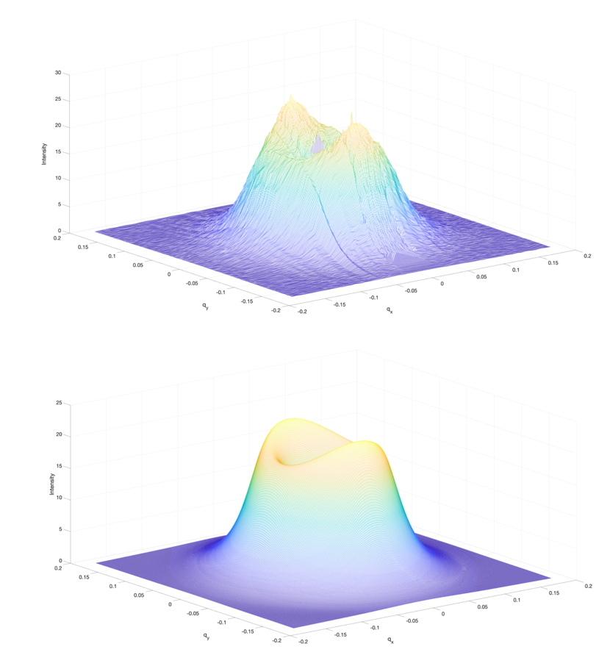
Wormlike micelles (WLMs) are elongated, thread–like surfactant aggregates that form thermodynamically under certain conditions. At sufficiently high concentrations, WLMs overlap and entangle with each other and this change in microstructure causes a rapid increase in viscoelasticity and zero–shear viscosity. Moreover, it provides significant shear–thinning character, a type of ‘non–Newtonian’ flow behaviour. These properties are very useful in a variety of industries and products, including as personal care products, drag reducing agents and fracturing fluids for oil and gas field stimulation. Despite their ubiquity, very few studies have investigated mild, non–toxic WLMs (like those found in personal care products) at concentrations relevant to industry formulations. Moreover, no model exists that is able to incorporate and link the known microstructural features of WLMs to the bulk rheological properties to which they give rise.

Here, we are seeking to investigate and link the microstructure and bulk rheology of WLMs formed by cocamidopropyl betaine (CAPB) and sodium laureth sulfate (SLES) surfactants. To do so, we have conducted small–angle neutron scattering (SANS) measurements on CAPB/SLES WLM samples whilst at an applied shear rate, a technique known as rheo–SANS. From this study we have been able to observe shear–induced alignment of WLMs via anisotropy in the 2D scattering pattern and, for the first time, we are attempting to fit full 2D scattering patterns, as shown in figure 1. This will allow us to quantitatively determine the degree of alignment of WLMs with the direction of shear, as well as other physical parameters within the SANS range including cross–sectional radius and persistence length. By way of analysis and comparison of these data with bulk rheology data, we aim to establish structure–function relationships for predictive and self–consistent modelling of WLM rheology.
Figure 2. Experimental (top) and simulated (bottom) scattering patterns for 15 wt% CAPB/SLES (66:34) with 2 wt% NaCl at a shear rate of 100 s⁻¹. The height of the plots represents the intensity of scattering.

19. Phase transitions and the evolution of the ferroic orders in the coupled honeycomb system (Fe, Co, Mn)₄Ta₂O₉

^{1,2*}Narayanan, N., ³Faske, T., ¹Lu, T., ¹Liu, Z., ²Li, L., ¹Brennan, M., ²Hester, J., ²Avdeev, M., ⁴Senyshin, A., ⁵Mikhailova, D., ⁶Ehrenberg, H., ⁷Hutchison, W. D., ²Mole, R., ³Fuess, H., ²McIntyre, G. J., ¹Liu, Y.,²Yu, D.
*narendin@ansto.gov.au
¹The Australian National University
²Australian Nuclear Science and Technology Organisation
³Darmstadt University of Technology
⁴Heinz Maier-Leibnitz Zentrum
⁵Leibniz Institute for Solid State and Materials Research
⁶Karlsruhe Institute of Technology
⁷The University of New South Wales

Recently, the ground state properties of frustrated magnetic systems are subjected to extensive research. This is due to exotic phenomena such as spin liquid, spin-orbital entities, magnetic order induced multiferroicity (type II) or quantum criticality found in these systems. Here, the ground state(s) is determined by the geometry, competing interactions, spin fluctuation and the coupling of the spin to the orbital, charge and lattice degrees of freedom. One of the most investigated lattices is the honeycomb lattice. The Kitaev model on a honeycomb is the most investigated model for quantum spin liquids^{1,2}. Here we are interested in the coupled honeycomb system M₄A₂O₉ (M=Fe, Co and Mn and A=Nb, Ta). These compounds have two crystallographically distinct M sites, which are in the distorted octahedral oxygen cages. These cages form edge-shared coplanar and corner-shared buckled honeycombs respectively which are interconnected by face-shared octahedral, facilitating competing exchange paths. The M=Co and Mn members were magnetoelectrics with Co₄Nb₂O₉ exhibiting a large magnetoelectric coupling constant, whereas Fe₂Ta₂O₉ was reported to exhibit both magnetoelectric and multiferroic phases depending on the temperature^{3,4}. Magnetoelectrics and multiferroics are of high technical importance such as in MRAMs and sensors with the coupling mechanism between the orders still not completely understood⁵. Furthermore, the magnetic structure of Co₄Nb₂O₉ is controversially discussed based on different symmetry analysis methods. Therefore, it is evident that the above diversities of the properties are determined by the magnetic structure, which is related to its electronic structure. In this work, we systematically investigate the magnetic and electronic structure of the (Fe, Co, Mn)₄Ta₂O₉ system, which we hope will help to understand the emergence of different ground states and the diverse properties in this family of materials. We combined several different techniques of neutron powder diffraction, inelastic neutron scattering, heat capacity, electronic band structure calculations and spin wave modelling based on linear spin wave theory. For the magnetic structure determination and the related issues, we used both the magnetic space groups and the representation theory for a comparison.

1. H. Tagaki et al., Nat. Rev. Phys. 1, 264 (2019)
2. A.P. Ramirez, Annu. Rev. Mater. Sci. 24, 453 (1994),
3. N. D. Khanh et al., PRB 93, 075117 (2016),
4. A. Maignan et al., PRM 2, 091401(R) (2018). [5] S.-W. Cheong et al., Nat. Mater. 6, 13 (2007).

20. Transition Metal Metaphosphates as Novel Electrode Materials for Lithium & Sodium Ion Batteries

^{1*}Xia, Q., ¹Ling, C.D., ^{1,2}Avdeev, M.
* qxia7880@uni.sydney.edu.au
¹The University of Sydney
²Australian Nuclear Science and Technology Organisation

Technology improvements in rechargeable batteries are currently being driven by electric vehicle (EV) industry and smart-grid technologies based on renewable energy sources. By virtue of the unbeatable benefits (i.e., much higher energy density, flexible and lightweight design, and longer lifespan) compared to other battery systems, lithium-ion batteries (LIBs) have now absolutely dominated the rechargeable battery market. Meanwhile, in order to get rid of increasingly evident restriction of Li-supply shortage, sodium-ion batteries (NaIBs) are being vigorously developed to replace LIBs in some large-scale applications where kinetics (power) and weight are not the primary considerations. The existing electrode materials in both LIBs and NaIBs, however, are struggling to satisfy the ever-increasing demand and higher performance requirements of above emerging applications. A series of transition metal metaphosphates have recently been investigated for the first time as electrode candidates with high energy densities in our study. These metaphosphates not only can reversibly deliver a high capacity of 300-500 mAh/g by reacting with Li/Na through the conversion reactions, but also their working voltages can be adjusted by changing their compositions. Both anode and cathode materials have been found in the metaphosphate system. The electrochemical performances of these novel electrode materials have also been further optimized by material modification strategies, e.g., carbon coating and fabrication of solid-state solutions.

The reaction mechanism of the metaphosphate electrodes has been disclosed by a combination of ex situ XANES, in situ Synchrotron XRD, and HRTEM characterization which draws a clear picture of the chemical and structural (or phase) changes that happen during the discharge and charge. A direct conversion reaction takes place during the first lithiation/sodiation, accompanied by the amorphization of crystalline metaphosphate, and the formation of metallic metal nanograins with a width of less than 10 Å embedded in a glassy LiPO₃ matrix. The good lithium conducting property of LiPO₃ glass, combined with the dynamically favourable small size and fine dispersion of the metal nanograins, leads to both high reversibility and fast kinetics for the conversion reaction. Finally, we note that metaphosphates are based on the naturally abundant element Mn and Fe and can be synthesised easily by a facile solid-state reaction, which makes them appealing for use in the emerging applications of rechargeable batteries.

Figure 1 HRTEM images and bright-field images (inserts) of (a) as-prepared Mn(PO₃)₂ powders, (b) carbon coated Mn(PO₃)₂/C powders, (c) fully lithiated Mn(PO₃)₂ electrode, and (d) inverse fast Fourier transform (IFFT) (coloured) of the yellow square area in the HRTEM image of fully lithiated Mn(PO₃)₂ electrode.

21. Non-monotonic structure of pH and temperature responsive copolymer brushes as determined by neutron reflectometry

^{1*}Johnson, E.J., ²Gresham, I.J., ³Willott, J.D., ⁴Murdoch, T.J., ¹Humphreys, B.A., ²Prescott, S.W., ⁵Nelson, A., ¹Webber, G.B., ¹Wanless, E.J.
*edwin.johnson@uon.edu.au,
¹University of Newcastle
²University of New South Wales
³University of Twente
⁴University of Pennsylvania
⁵Australian Nuclear Science and Technology Organisation

Stimulus responsive synthetic materials represent an exciting area of scientific interest¹ A subset of these materials include polymers with properties which are responsive to multiple stimuli. Grafting these multi-responsive polymers in a brush regime to a surface allows for modification of the interfacial properties of a material through the application of internal and/or external stimuli² Understanding the behaviour, and in particular the structure of these multi-responsive brushes, is an important a step towards examining complex, natural systems. Multi-responsive statistical copolymer brushes comprising of thermoresponsive Poly(2-2(-methoxyethoxy)ethyl methacrylate (PMEO₂MA)^{3,4} and the weak polybase poly(2-(diethylamino)ethyl methacrylate ) (PDEA)[5] were synthesised using surface initiated ARGET ATRP. The temperature and pH response of these coatings tracked with ellipsometry and compared to numerical self-consistent field theory (nSCF) predictions of brush behaviour. The neutron reflectivity of a poly(2-(2-methoxyethoxy) ethyl methacrylate-stat-2-(diethylamino)ethyl methacrylate) (P(MEO₂MA-stat-DEA)) 80:20 mol% brush was measured at various temperatures and pH’s and modelled to reveal non-monotonic volume fraction profiles. nSCF simulations suggest that the depletion region present in the profile is the result of a vertical monomer gradient throughout the brush.

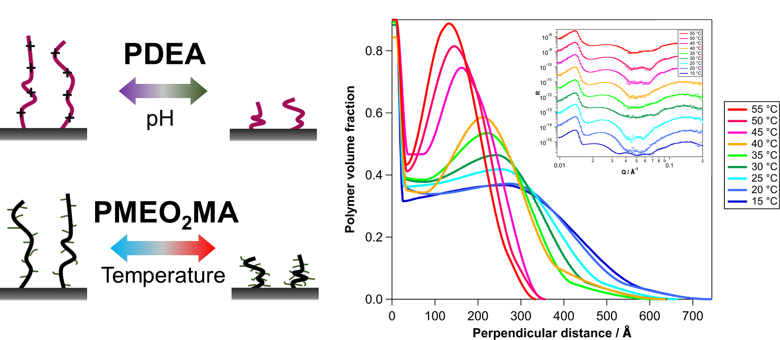
Figure 1. Schematics indicating responsive behaviour of PDEA and PMEO₂MA homopolymers. Right hand figure shows the polymer volume fraction profiles of a P(MEO2MA-stat-DEA) 80:20 mol% brush as a function of temperature at pH 4. Inset shows measured (data points) and modelled (lines) reflectivity data.

1. P. Schattling, F. D. Jochum, P. Theato, Polymer Chemistry, 2014, 5, pp 25-36.;
2. C. Marschelke, N. Puretskiy, I. Raguzin, I. Melnyk, L. Ionov, A. Synytska, Macromolecular Chemistry and Physics, 2019, pp 1900030.
3. J.-F. Lutz, Ö. Akdemir, A. Hoth, Journal of the American Chemical Society, 2006, 128,40, pp 13046-13047.
4. T. Murdoch, B. Humphreys, J. Willott, S. Prescott, A. Nelson, G. Webber, E. Wanless, Journal of Colloid and Interface Science, 2017, 490, pp 869-878
5. J. Willott, T. Murdoch, G. Webber, E. Wanless, Progress in Polymer Science, 2017, 64, pp 52-75

22. Initiation of Localised Degradation of Rail Flash Butt Welds in Heavy Haul Railways

¹*Su, H., ¹Pun, C.L, ¹Mutton, P., ²Paradowska, A.M.,¹Yan, W.
*hang.su@monash.edu
¹Monash University
²Australian Nuclear Science and Technology Organisation

The application of premium high strength steel rails with hardness levels of 400 HV and above, which can effectively mitigate rail degradation such as wear and rolling contact fatigue, has improved the rail performance in Australian heavy haul railway systems. However, these benefits can be offset by the potential of localised degradation in rail flash butt welds. The increasing potential for damage in such welds is mainly caused by the variability of microstructure and mechanical properties between the heat-affected zones generated from the welding thermal input in the weld and the parent rail. The exist of the heat-affected zones which exhibit lower hardness levels than the parent rail, may lead to severe localised plastic deformation and therefore result in higher sensitivity to degradation in rail heads. If such damage is not addressed at an early stage, it can facilitate the development of transverse defects and increase the risk of rail failures when combined with the higher dynamic loading in wheel-rail interface and the residual stress from welding process which typically occur at rail welds. It is known that rail degradation will primarily initiate where the ratcheting strain (accumulated cyclic plastic strain) reaches the limiting ductility of rail materials. According to the reasons above, it is considered necessary to understand the mechanical response, particularly the ratcheting behaviour, of flash butt welds under actual wheel–rail contact situations. It is expected that the obtained results will provide useful information for rail operators to further develop the rail maintenance techniques. The research work consists of both experimental study and numerical simulations. The experimental study will investigate the ratcheting behaviour of rail (R400HT steel grade) flash butt welds by uniaxial and biaxial cyclic tests. The results will be used to establish the cyclic plasticity constitutive model of the welds. With the help of Kowari at the Australian Nuclear Science and Technology Organization, residual stress will be measured in the rail head region up to approximately 25 mm below the running surface as the cracks observed in rail welds can propagate up to the depth of about 15 mm. Combined with the wheel-rail welds contact forces in service, finite element simulation will be finally performed to understand the initiation of localised degradation in rail welds. The project overview is illustrated in the following flow chart:

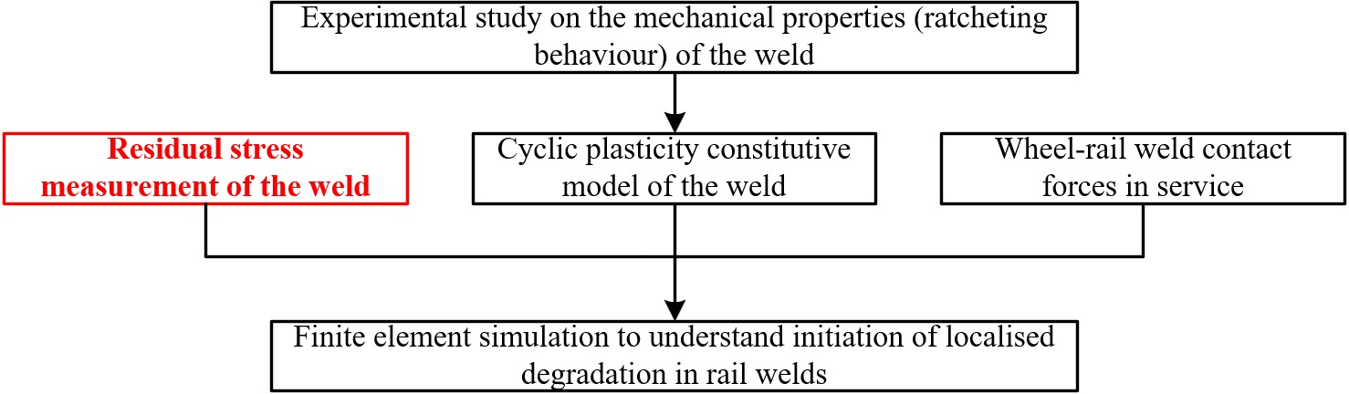

23. Diffusion in Modified Solid Ionic Conductors for Energy Applications: Structure and Dynamics

^{1*}Cheung, E.A., ²de Souza, N.R., ¹Sharma, N.
*e.a.cheung@unsw.edu.au
¹University of New South Wales
²Australian Nuclear Science and Technology Organisation

Increasing energy demands have generated widespread interest in the development of sustainable systems for energy storage. Most notably, all solid-state sodium-ion batteries (SIBs) have been proposed as a safe and cost-effective alternative system for large scale energy storage¹. This has motivated work in the development and characterization of numerous classes of materials as candidate electrode and solid-state electrolytes, including layered metal oxides and the ionic plastic-phase materials respectively. In both cases, the overall performance of these materials for their respective functions has been shown to be significantly improved by chemical doping^{2,3}. This is typically demonstrated in a macroscopic picture using bulk techniques such as electrochemical impedance spectroscopy. However, the specific effect of doping on the structure of the material in question as well as the impact this has on the diffusion mechanism often lacks a quantitative explanation.

In this work, we have selected candidate modified energy materials which have been shown to be amongst the best performing for their purpose. We use quasi-elastic neutron scattering spectroscopy to gain insight into the diffusion mechanisms at an atomic level with aid of average structure models based on Rietveld refined models of high-resolution powder diffraction data. We consequently aim to form a complete understanding of the ionic conductivity in these materials.

1. V. Palomares, P. Serras, I. Villaluenga, K. B. Hueso, J. Carretero-Gonzalez and T. Rojo, Energy Environ. Sci. 5 (3), 5884-5901 (2012).
2. M. H. Han, N. Sharma, E. Gonzalo, J. C. Pramudita, H. E. A. Brand, J. M. Lopez del Amo and T. Rojo, J. Mater. Chem A 4 (48), 18963-18975 (2016).
3. M. Samiee, B. Radhakrishnan, Z. Rice, Z. Deng, Y. S. Meng, S. P. Ong and J. Luo, J. Power Sources 347, 229-237 (2017).

24. Interaction of Antimicrobial peptides and cell membrane

¹*Mohd Darbi, N.M., ¹De Zoysa, H., ¹Sarojini, V., ²Sokolova, A., ¹McGillivray, D.
*nmoh237@aucklanduni.ac.nz
¹The University of Auckland
²Australian Nuclear Science and Technology Organisation, Australia

Antimicrobial peptides (AMPs) have been widely investigated because of their potential solution to the encroaching ‘antibiotic crisis but information about mechanism of action of the peptides is still scarce.¹ Bacterial cell membranes will always be the initial point of contact for AMPs due to electrostatic interactions between the anionic molecules on the bacterial cell surface and the cationic residues within the AMPs.² The interaction can be investigated using model system such as liposomes. Liposomes are made from glycerophospholipids, with a similar ratio to that found in real membranes, through sonication or extrusion. Both techniques can produce liposomes but at different sizes as shown in Error: Reference source not found.

Small angle X-Ray and Neutron scattering techniques (SAXS and SANS) can be used to investigate the effect of AMPs on the thickness, curvature of the membrane and also identifying the location of the peptide between the membranes.^{3,4} However, the weakness of the model system is the high ratio of peptide to vesicles that is required to rupture the membrane, which may not represent the actual system.⁵ In the future, a comparison between model and real system will be made in scattering measurement to assess this problem.

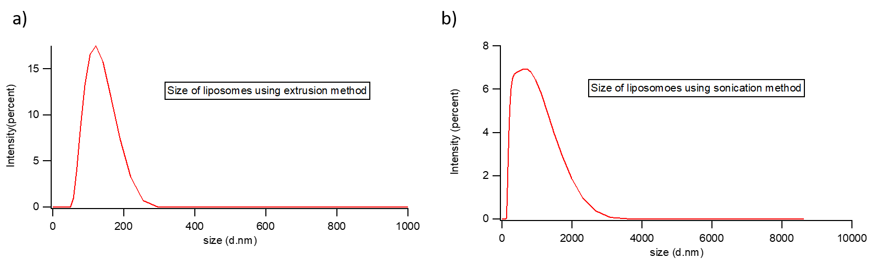
Figure 3. On the left, (a) is intensity distribution of particle sizes for extrusion method, the average hydronamic diameter and PDI are 117.1 nm and 0.097.On the right, (b) is the distribution graph for sonication vesicles, the average hydronamic diameter and PDI are 455.4 nm and 0.247.

1. Gregory, S. M., et al., Biophysical journal, 2008, 94 ,1667-1680.
2. Haney, E. F., Mansour, S. C., & Hancock, R. E. In Antimicrobial Peptides, 2017, 3-22.
3. Grage, S. L., Afonin, S., Kara, S., Buth, G., & Ulrich, A. S. Frontiers in cell and developmental biology, 2016, 65.
4. Schmidt, N.W., Mishra, A., Lai, G.H., Davis, M., Sanders, L.K., Tran, D., Garcia, A., Tai, K.P., McCray Jr, P.B., Ouellette, A.J. and Selsted, M.E., Journal of the American Chemical Society, 2011, pp.6720-6727.
5. Hale, J. D., & Hancock, R. E., Expert review of anti-infective therapy 2007, 5, 951-959

25. Theoretico – Experimental Study of the Electronic Structure of Lanthanoid-Dioxolene Single-Molecule Magnets

^{1,2*}Calvello, S., ¹Atkin, A., ²Mole, R., ¹Boskovic, C., ¹Soncini, A.
*simone.calvello@unimelb.edu.au
¹University of Melbourne
²Australian Nuclear Science and Technology Organisation

Single Molecule Magnets (SMMs) are molecular materials that exhibit a slow relaxation of the magnetization of molecular origin¹. This property makes them promising targets for several important technological applications, such as spintronic devices and molecular memories. The first reported SMMs in the literature featured clusters of transition metal ions², in an attempt to maximize the total spin of the molecule and, as a result, the height of the energy barrier for the inversion of the molecular spin. Over the last fifteen years, however, complexes of trivalent lanthanoid ions have received considerable attention within the molecular magnetism community, mainly due to their ability to display remarkable SMM behaviour at higher temperatures than their analogues based on transition metal ions.

Given the strong influence that the electrostatic crystal field induced by the ligands on the lanthanoid ion plays in determining the electronic and magnetic properties of lanthanoid-based SMMs, it is of paramount importance to thoroughly understand such magneto-structural correlations, so as to develop molecules which will display SMM behaviour at sufficiently high temperatures to warrant commercial applications. In this regard, ab initio calculations have proven to be valuable methods to study the electronic structure of SMMs³ and improve the understanding of their effect on magnetic properties and relaxation mechanisms.

In this work, we have performed a theoretical study, employing the CASSCF/RASSI–SO computational method⁴, on a family of lanthanoid complexes, [Ln(bpy)₂(Cl₄Cat)(Cl₄CatH)(MeOH)]·0.8MeOH (Ln = Tb, Dy, Ho), which are expected to display SMM behaviour due to their structural similarity to other SMMs previously described in literature. The experimental magnetic susceptibility has been recorded with a SQUID magnetometer, while the low–lying energy spectrum has been determined with Inelastic Neutron Scattering (INS) for the Tb^{III} and Ho^{III} analogues. We show that our theoretical predictions are in good agreement with the experimental data measured for these complexes, therefore confirming the validity of such computational methods for the prediction of electronic and magnetic properties of lanthanoid-based SMMs.

1. D. Gatteschi, R. Sessoli, and J. Villain, Molecular Nanomagnets, Oxford University Press, 2006.
2. A. Caneschi, D. Gatteschi, R. Sessoli, A. L. Barra, L. C. Brunel and M. Guillot, J. Am. Chem. Soc., 1991, 113, 5873.
3. L. Ungur and L. F. Chibotaru, Lanthanides and Actinides in Molecular Magnetism, Wiley–VCH, 2015, 153.
4. P.-Å. Malmqvist, B. O. Roos and B. Schimmelpfennig, Chem. Phys. Lett., 2002, 357, 230.

26. QENS Study of Diffusion in Superionic Compound Cu_{2-x}Se

^{1*}L. S. Li, ¹M. Wang, ²D. H. Yu, ³H. Liu, ²S. Danilkin
¹lilisi@mail2.sysu.edu.cn, Sun Yat-Sen University, China
²ACNS, Australian Nuclear Science and Technology Organisation, Australia
³Shanghai Institute of Ceramics, Chinese Academy of Sciences, China

Copper chalcogenides received attention due to a high ionic conductivity and outstanding thermoelectric properties^{1,2}. Liquid-like mobility of Cu ions in the lattice leads to the low lattice thermal conductivity that results in the record high zT values. In particular, Cu_{2-x}Se undergoes a structure phase transition from , the low temperature phase, to , the high temperature phase, in which the Se atoms site in face-centred cubic positions and Cu atoms distributed over the large number of interstitial sites some of which are vacant. In superionic phase the Cu ions can move between interstitial sites randomly in Se lattice like in liquids. In spite of number of investigations, the details diffusion mechanism of Cu ions is still under discussion. Recently, D. J. Voneshen et al³, presented the results on the QENS study of the Diffusion and Phonon Density of State on Cu₂Se. But the quality of their results seems no good enough to do the fitting for NNN jump length and they vaguely express their fitting method. Therefore, the high resolution experiments still request to give a further insight on the diffusion of Cu ions.

In this paper, we present a new incoherent quasi-elastic scattering experiment result of powder samples of Cu_{1.8}Se, Cu_{1.96}Se and Cu₂Se measured on the Time of Flight Spectrometer Pelican with temperatures 300K, 370K, 430K, 550K, 650K for probing the diffusion of Cu ions. So, we can get the more comprehensive picture of the temperature dependence and the composition dependence on the diffusion of Cu ions.

1. S. A. Danilkin, et al. Ionics. 80 17-75 (2011).
2. Huili Liu, et al. Nature Material. 11 422 (2012).
3. D. J. Voneshen, et al. Phys. Rev. Lett. 118 145901 (2017)

